Bryan Caddy
3313 S 2nd Way
Ridgefield, WA 98642
360-989-6284
bryank7bat@gmail.com
Date: November 18th, 2025
To:
City of Ridgefield – Community Development & Code Enforcement
230 Pioneer St
Ridgefield, WA 98642
CC:
Clark County Community Development – Building Safety
Clark County Code Enforcement
Washington State Building Code Council
Washington State Department of Ecology
Ridgefield Mayor & City Council

Re: Formal Unified Complaint – Retaining Wall Violations, Surcharge Hazards, Unauthorized Excavation, Encroachment, Trespass, and Failure of the City of Ridgefield to Enforce Required Codes
To Whom It May Concern,
This letter serves as a formal, comprehensive complaint regarding a series of escalating violations by my neighbor that have created a significant structural hazard to my property and personal safety. Despite prior notifications, the City of Ridgefield has not taken appropriate action.
Today I discovered new violations, including unauthorized excavation up to my fence, unpermitted block material leaning against my soil, and construction materials stored on my fence—constituting trespass and structural tampering.
The situation now represents a compounded and immediate life-safety hazard, and the City’s lack of enforcement violates several state and local codes.

1. Summary of Violations
The neighbor’s actions violate:
Clark County Code (CCC)
- CCC 14.06.105.2 – Retaining walls supporting a surcharge require permits
- CCC 14.12.030 – Duty of Building Official to enforce safety codes
- CCC 40.440 – Habitat Conservation Area violations (if applicable)
- CCC 40.260 – Accessory building and shed requirements
Washington Administrative Code (WAC)
- WAC 51-16-080 – Non-exempt retaining walls when there is a surcharge
- Adoption of IBC standards requiring permitting and engineering
International Building Code (IBC) – adopted by WA State
- IBC 105.2(4) – Retaining walls with surcharge require permit
- IBC 1610.1 – Surcharge loads must be engineered
- IBC 1807 – Retaining wall design requirements
- IBC 3302–3307 – Protection of adjoining property; excavation restrictions
- IBC 3303.3 – Storage of materials must not encroach on adjacent property
Washington RCW
- RCW 9A.52.080 – Criminal trespass
- RCW 64.12.030 – Injury to property of another
- RCW 7.40 – Injunction against continued interference
- RCW 4.24 – Liability for unsafe excavation and construction
- Common-law trespass to land and chattel

2. Violations Related to the Retaining Wall and Surcharge
The neighbor added a shed containing thousands of pounds of materials directly above a retaining wall. This shed constitutes a surcharge, a load that significantly increases pressure on the wall.
Per CCC 14.06.105.2 and WAC 51-16-080:
Any retaining wall supporting a surcharge requires a permit and engineering.
Under IBC 1610.1:
Surcharge loads include structures, stored materials, and other added loads.
No permit or engineering has been verified by the City, despite multiple requests.
This violates:
- CCC 14.06.105.2
- WAC 51-16-080
- IBC 105.2, 1610, 1807

3. New Violations Discovered Today – Unauthorized Excavation and Tampering
Today I discovered the neighbor has:
A. Excavated soil directly up to my fence line
This destabilizes the soil supporting my property and fence and constitutes:
- Unsafe excavation (IBC 3307.1)
- Negligent endangerment of adjoining property
- Violation of RCW 4.24 (liability for damages caused by unsafe excavation)
B. Placed loose block material leaning outward against my soil
These blocks:
- Are nonengineered retaining elements
- Are not permitted
- Increase the risk of sudden soil failure
- Push against the soil supporting my fence
- Are expressly unlawful under CCC 14, WAC 51-16-080, and IBC 105.2/1807
This is an attempt to create a retaining system without permit, design, or right.
C. Built over my fence and stored construction materials on my fence
My fence:
- Is not owned by the neighbor
- Was not constructed by the neighbor
- Was paid for by my lessee
- Cannot legally be used as a construction support or storage platform
This constitutes:
- Trespass (RCW 9A.52.080)
- Damage to property (RCW 64.12.030)
- Unlawful encroachment (common-law trespass)
- IBC 3303.3 violation – storing construction materials on adjoining property without permission
- IBC 3302.1 – failure to protect adjacent property
These actions have further destabilized the slope, increased risk of collapse, and violated property boundaries.

4. Habitat and Critical Area Violations (CCC 40.440)
Our subdivision is documented as lying within a Habitat/Species Conservation Area.
Any new structure, grading, or disturbance requires:
- Critical area review
- Setback adherence
- Additional permitting and environmental compliance
The shed, excavation, and block placement all appear to violate CCC 40.440.

5. Failure of the City of Ridgefield to Act
Despite previous reports, the City has not:
- Inspected the retaining wall
- Verified permits
- Enforced surcharge requirements
- Responded in writing
- Enforced critical area protections
- Issued a stop-work order
- Required engineering review
This inaction violates CCC 14.12.030, which requires enforcement of safety codes to protect the public.
The City is now on notice that continued failure to act may constitute municipal negligence.

6. Formal Requests for Immediate Action
Given the escalating danger, I am requesting the following immediately:
- Emergency site inspection
- Stop-work order issued under CCC Title 14
- Verification of all required permits (retaining wall and shed)
- Structural engineering assessment by a Washington-licensed engineer
- Critical areas compliance review under CCC 40.440
- Removal of all block material, soil restraints, and stored items from my fence
- Restoration of the excavated area to pre-disturbance conditions
- Written findings within 48 hours
7. Notice of Potential Escalation and Liability
If corrective action is not taken, I will escalate this matter to:
- Washington State Building Code Council
- Washington Department of Ecology
- Ridgefield Mayor and Council
- Insurance risk and claim authorities
- Legal counsel for injunction and damages
The City has been repeatedly notified of a dangerous, unpermitted, code-violating condition.
Further delay increases both my risk and the City’s liability.

Conclusion
The combined violations—including unpermitted surcharge, unsafe retaining wall conditions, unauthorized excavation, property encroachment, and structural tampering—represent an imminent and preventable hazard. The City of Ridgefield has a legal obligation to enforce the building and safety codes listed herein.
I request immediate corrective action and a written response.
Sincerely,

Bryan Caddy

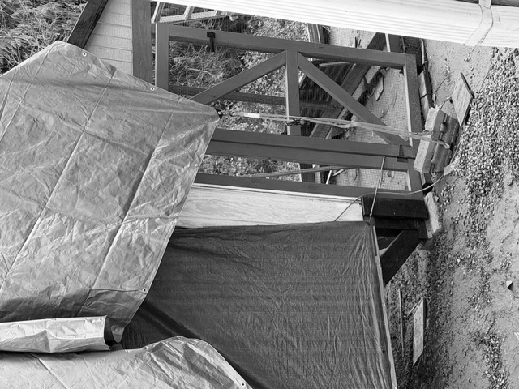
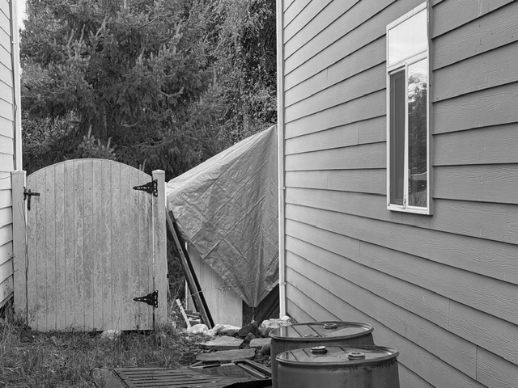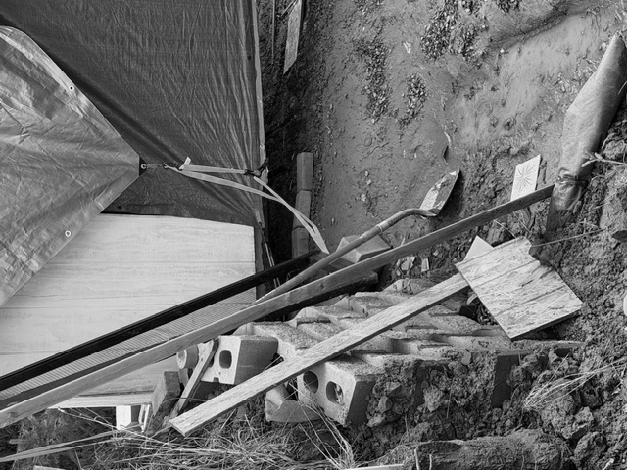
My property / Fence held back by this wall. My backyard is to the left.
