Chapter 18.206 RESIDENTIAL USE STANDARDS

18.206.010 Purpose.
To provide standards for the development and design of residential uses.
(Ord. No. 1339, § 2(Exh. A), 5-27-2021)

18.206.020 Single-family design standards.
A. Purpose. The purposes of these standards are to ensure compatibility and continuity between and within developments, as well as variety in architecture. The standards are intended to complement the site with quality building design.
B. Applicability. The standards of this section apply to new single-family development in the RLD zones and the RMD-16 zone.
C. Small Single Family Dwelling Incentives.
1. In developments in RLD zones, single family dwellings with less than one thousand six hundred square feet of floor area (excluding garages with up to five hundred square feet) may be counted as one-half a dwelling unit for the purpose of calculating density. Once the cap is reached, such units are counted as one unit.
This bonus is available for a limited percentage of each development's total dwelling units as follows. Once the percentage cap is reached, such dwelling units are counted as one full dwelling unit.
a. RLD-4: Up to ten percent of qualifying small single family dwelling units qualify.
For example, a subdivision on a net ten-acre parcel has a default maximum capacity of forty units. If four of the units are small single family dwellings, the calculated density is thirty-eight units, but the functional total is forty-two units (a bonus of two units).
b. RLD-6: Up to fifteen percent of such units qualify.
c. RLD-8: Up to twenty percent of such units qualify.
2. Where such small single family dwellings are integrated with other housing types qualifying for density bonuses, RDC 18.210.025.F.2 sets forth the cumulative limitations to the percentage of qualifying bonus dwelling units in a development.
3. For plat recording requirements, see RDC 18.210.025.F.3.
D. Every home shall contain the following features:
1. All wall openings, regardless of visibility from a public right-of-way, shall have:
a. Contrasting trim (minimum three inches wide);
b. Recess (windows) at least one and one-half-inches from the façade; or
c. Other design treatments that add depth, richness, and visual interest to the façade.
2. Roof overhang (minimum six inches);
3. Porch or other covered entry at least three feet deep for the primary entrance.
4. A front door visible from the street (applies only to front-loaded lots less than fifty feet wide).
5. Minimum useable open space [see standards in subsection (E) below].
6. Minimum front façade window transparency: At least ten percent. This applies to all vertical surfaces of the façade elevation (excluding rooflines). Windows and their frames shall be used in the calculations, while trim may not be included. Garage door windows may be used to meet up to fifty percent of the minimum transparency requirement.

Figure 18.206.020-D
Example of required design features.
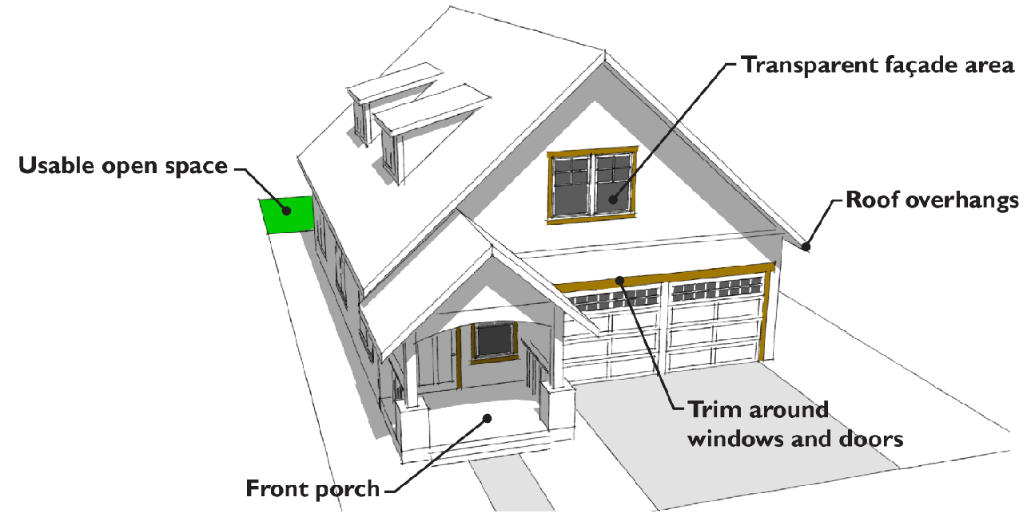
E. Architectural design. To ensure variety in architecture and to reduce the dominance of garages on the streetscape, applicants for new residential developments shall demonstrate compliance with the following provisions at the time of building permit application:
1. Front façade variety. Dwellings with the same front façade located on the same side of a street shall be separated by no less than four lots, and dwellings with the same front façade located on opposite sides of a street shall be separated by no less than four lots, with the lot directly across the street not included in the four-lot calculation. In this context, the lot "directly across the street" means the lot with which the greatest portion of frontage aligns with the frontage of the subject lot.
a. Structural elements.
i. Covered porch area with a minimum of fifteen square feet.
ii. Dormers.
iii. Gables.
iv. Hipped, gable, gambrel, mansard or similar pitched roof.
v. Bay windows.
vi. Twelve-inch offset from one exterior wall to another.
vii. Balconies.
viii. Roofline offset of at least two feet from the top surface of one roof to the other.
ix. Vertical breaks/horizontal walls.
x. Recessed building entry at least two feet deep by four feet wide.
xi. Other structural element that adds comparable visual interest to the features above, as approved by the community development director.
b. Decorative elements.
i. Decorative garage doors.
ii. Pillars/posts.
iii. Decorative eave or barge boards with two material variations.
iv. Decorative shingles or varied siding in gables.
v. Decorative siding (shingles, shake, batten board, wainscoting, or similar).
vi. Brick, stone or cedar accents covering at least ten percent of the front facade wall surface area.
vii. Variable siding; the use of two or more types of siding.
viii. Fiber-cement horizontal lap siding between three and seven inches wide.
ix. Shed roof above window(s).
x. Belly Band cladding.
xi. Functional shutters or louvers.
xii. Corner boards/posts.
xiii. Knee or eave braces.
xiv. Enlarged trim on garage door headers at least six inches wide.
xv. Other architectural elements, other than color, glass or lighting, approved by the community development director.

Figure 18.206.020-E.1
Example of front façade features.
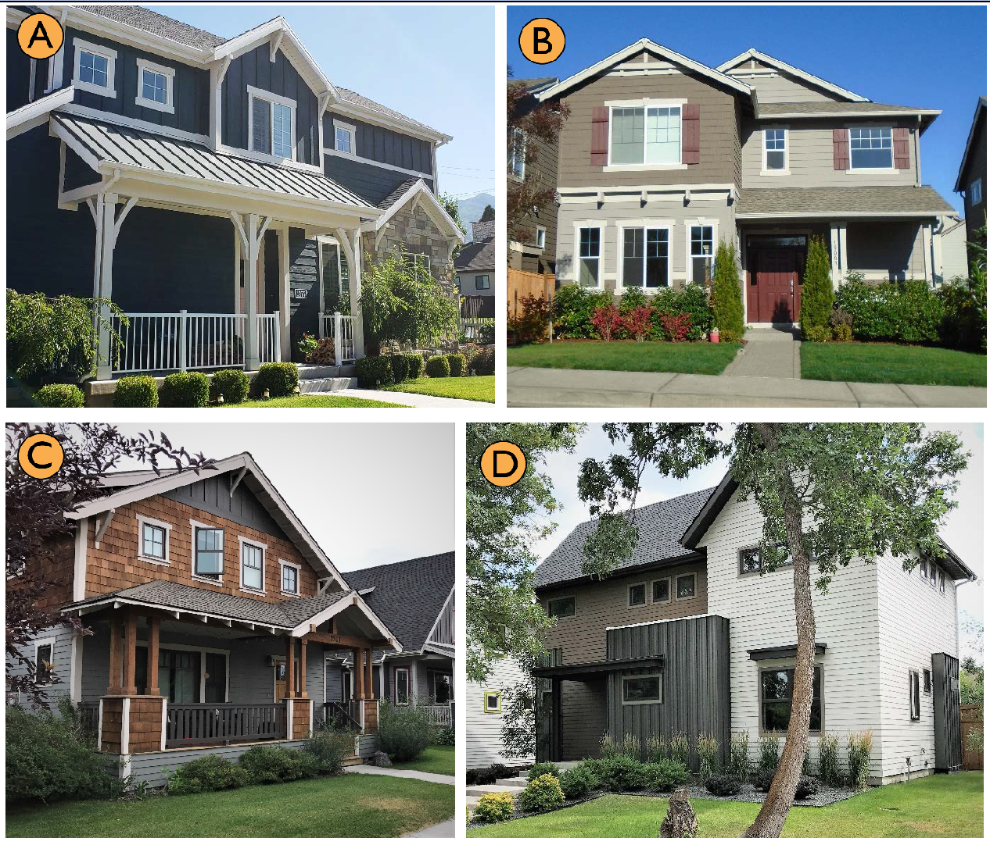
A. Covered porch, dormer, pitched roof, pillars/posts, stone accents, variable siding, belly band cladding, knee/eave braces.
B. Covered porch, pitched roof, exterior wall offsets, roofline offsets, pillars/posts, variable siding, and "other" decorative elements being window trim keystones and extruding joists.
C. Covered porch, pitched roof, pillars/posts, variable siding, decorative windows/trim, and knee/eave braces.
D. Pitched roof, covered porch, exterior wall offsets, variable siding, and decorative window treatments.
2. Garage design and integration. Garages or carports detached from or attached to the main structure and facing the street shall comply with at least one of the following features listed below. For lots less than fifty feet wide and featuring driveways wider than twelve feet wide and/or two-car garages facing the street, see the garage design and integration standards in subsection (E)(3) of this section.
a. Set back the garage or carport from the front building facade or front face of a covered porch, by a minimum of four feet. To qualify as a porch under this subsection, the porch must extend along a minimum of fifty percent of the street-facing building facade that is not devoted to the garage, and must be at least six feet wide.
b. Provide enhanced architectural details. Under this option, the front façade shall contain a minimum of six elements from elements lists under subsection (E)(1) of this section, including at least two elements from the structural elements list and at least two elements from the decorative elements list.

Figure 18.206.020-E.2
Garage design integration examples.
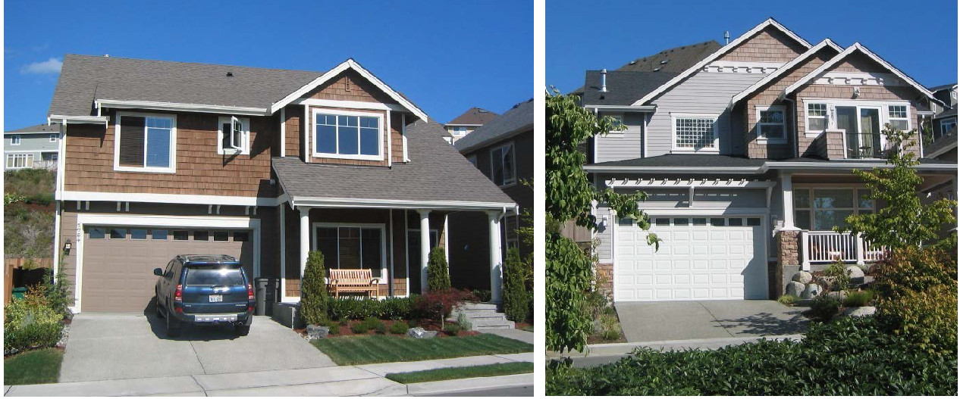
Left: Garage set back from the front covered porch at least four feet. Right: Garage set back less than four feet, and the front façade includes enhanced architectural details including a covered porch, variable siding, pillars/posts, balcony, and other details.
3. Garage design and integration for lots less than fifty feet wide and featuring driveways wider than twelve feet wide and/or two-car garages facing the street. Standards:
a. The home must feature at least one of the following massing elements:
i. Upper floor living space and/or covered deck that projects at least eighteen inches in front of ground level street façade surrounding the garage. The projecting living space and/or covered deck area must occupy a space at least seventy-five percent of the width of the garage door.
ii. An upper floor living space that is recessed from the ground level street façade surrounding the garage by at least eighteen inches. A roofline must separate the first floor from the façade of the second floor. The second floor roofline must be modulated (one continuous roofline is not allowed).
iii. Other massing designs that effectively deemphasize the garage doors and add visual interest to the streetscape.
See Figure 18.206.020-E.3 for acceptable and unacceptable examples of both subsections (i) and (ii).
b. The home must also comply with at least one of the following design/detail options:
i. Minimum front façade window transparency: At least twelve percent. This applies to all vertical surfaces of the street façade elevation (excluding rooflines). Windows and their frames shall be used in the calculations, while trim may not be included. Garage door windows may be used to meet up to fifty percent of the minimum transparency requirement.
ii. Provide enhanced architectural details on the street facade, using minimum of eight elements from elements lists under subsection (E)(1) of this section, including at least three elements from the structural elements list and at least three elements from the decorative elements list.
c. Any balconies over the driveway should have structural design, materials, and color that is well-integrated into the composition of the façade.
d. The front door must be located on the street façade elevation. Front doors that are tucked behind the garage door do not meet this requirement. For clarification, the homes in images C and D in Figure 18.206.020-E.3 meet this requirement, while the homes in images E and F do not meet this requirement.
e. Garage doors are encouraged to be colored consistent with the body of the house. Transparent and semi-transparent garage doors are an exception.

Figure 18.206.020-E.3
Garage design integration examples on narrow lots.
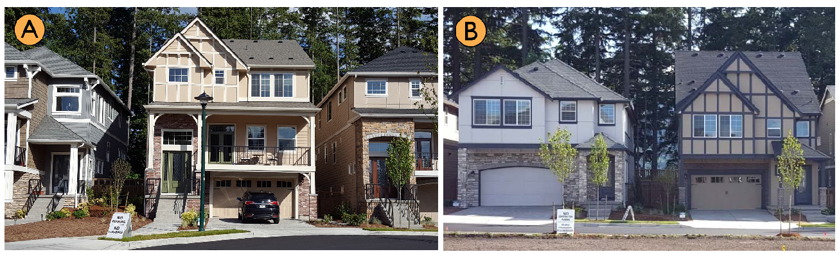
A. Acceptable: Covered deck projects over garage/driveway. The prominent entry, mix of materials, detailing, and roofline modulation also help emphasize the living areas over the garage.
B. Acceptable: Living areas project over the garage/driveway. The mix of materials, detailing, and roofline modulation also help.
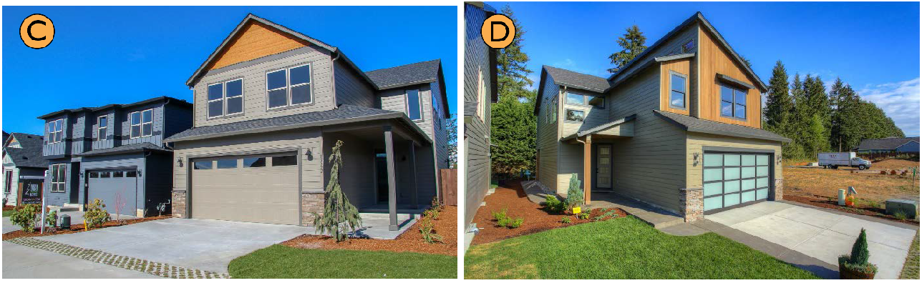
C and D. Acceptable: Upper floor living area is recessed behind garage-wall and separated by rooflines in both examples. While the front doors are set back from the street, they are facing the street and visible from the street. The mix of materials, detailing, and roofline modulation also help. Images courtesy of urbannw.com.
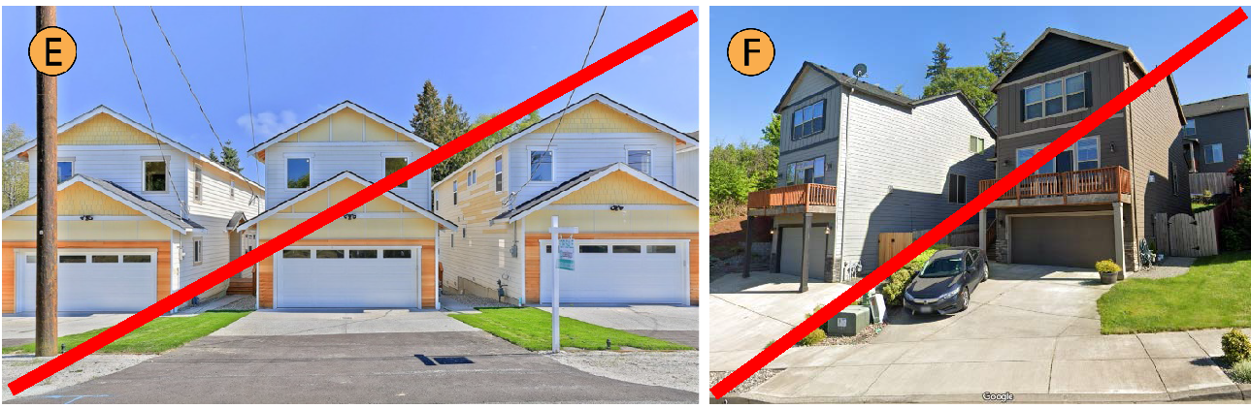
E. NOT acceptable: The front door is tucked behind the garage and largely not visible from the street. While the recessed second floor, rooflines, material changes and detailing help, the garage takes up the entire ground level of the street façade. Also, the façade transparency does not meet the minimum twelve percent threshold.
F. NOT acceptable: These homes feature flat street facades with the garage door dominating the ground level elevation. While the balcony helps, it's not covered and appears tacked-on to the façade. Also, the front doors are not visible from the street.
4. Where houses are served by alleys, all garages and on-site parking shall be accessible from the alley and the facade of the house facing the street shall be designed as the front of the house including, but not limited to, a primary building entrance consisting of inward swinging door(s), porch(es), window(s) and pathway(s) to the street.
F. Minimum Useable Open Space.
1. Every home shall provide a minimum one hundred-square-foot covered outdoor area at the side or rear of the dwelling.
2. Every lot shall provide a useable open space equivalent to at least ten percent of the lot area, with a minimum dimension of fifteen feet on all sides of the useable open space. For example, a four thousand-square-foot lot would require a contiguous open space of at least four hundred square feet. Porches, patios, and the covered outdoor area required above may be used to fulfill this requirement provided they are part of an open space that meets the minimum dimension requirement.
3. If the rear edge of the usable open space is within five feet of an alley, any fence between the rear edge and the alley shall be limited to four feet in height except where the portion of the fence between four and six feet in height is at least fifty percent transparent. Vegetative matter which functions as a fence has no height limit.
4. Driveways shall not count in the calculations for usable open space.
5. Additions must not create or increase any nonconformity with this standard.

Figure 18.206.020-F.1
Examples of how to integrate minimum useable open space on small lots.
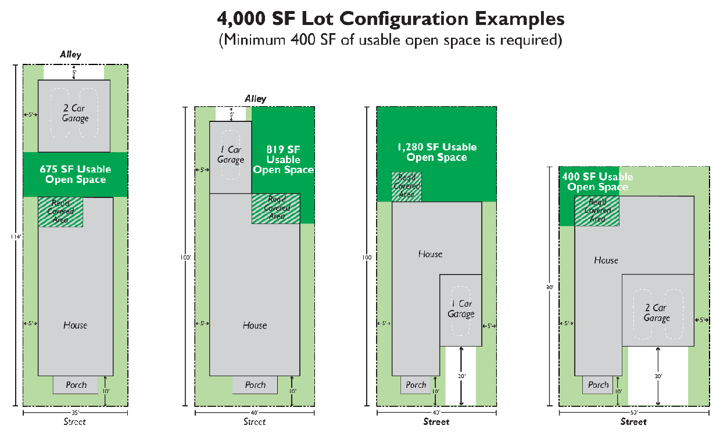

Figure 18.206.020-E.2
Good and bad examples of useable open spaces.
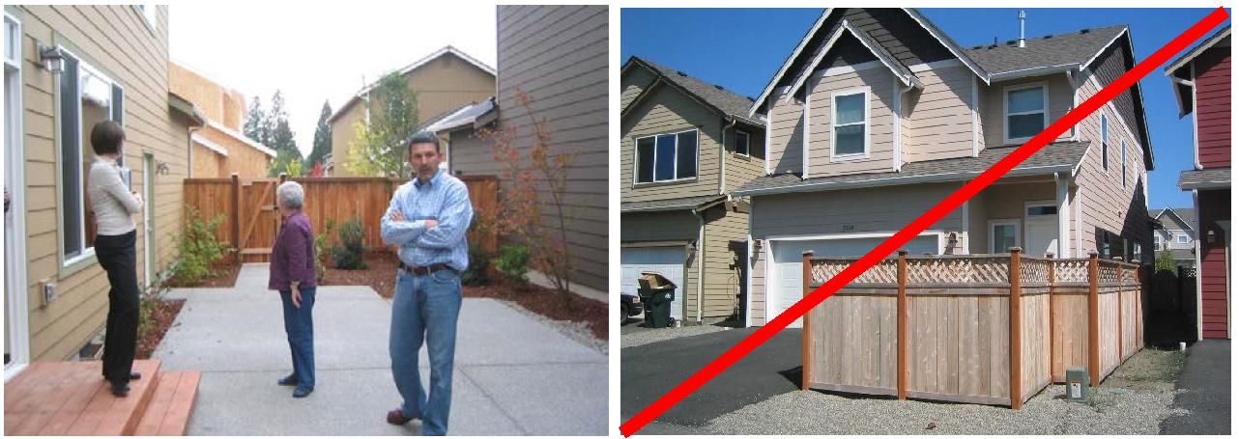
Left: Alley loaded lot that uses a zero-lot line configuration that allows for a wider/consolidated side yard (at least fifteen feet wide) where the adjacent home excludes windows on the facing wall. Right: Open space that is both too narrow and awkwardly located to be useable.
G. Driveway standards. The following standards apply to driveways on lots less than fifty feet wide with vehicular access from the street.
1. Driveways are limited to twelve feet in width, except as provided in subsection (2) below.
2. Driveways may be up to twenty feet in width when on-street parking is prohibited on the near side of the street and the subject homes comply with the design provisions of subsection (E)(3) of this section.
H. Tree Standards. Trees shall be integrated on new lots at the time of occupancy as provided below.
1. Lots less than seven thousand square feet in area: Minimum three trees.
2. Lots seven thousand square feet in area or greater: Minimum four trees.
3. Where one or more existing native trees (as set forth in RDC 18.830.050) are preserved and integrated into the design of the development, the community development director will allow for credits of up to four required trees for each preserved tree depending on the size, health, and maturity of the tree.
4. See RDC Chapter 18.725 for related landscaping plans, installation, and maintenance standards.

Figure 18.206.020-G
Examples of integrating existing trees into a new subdivision.
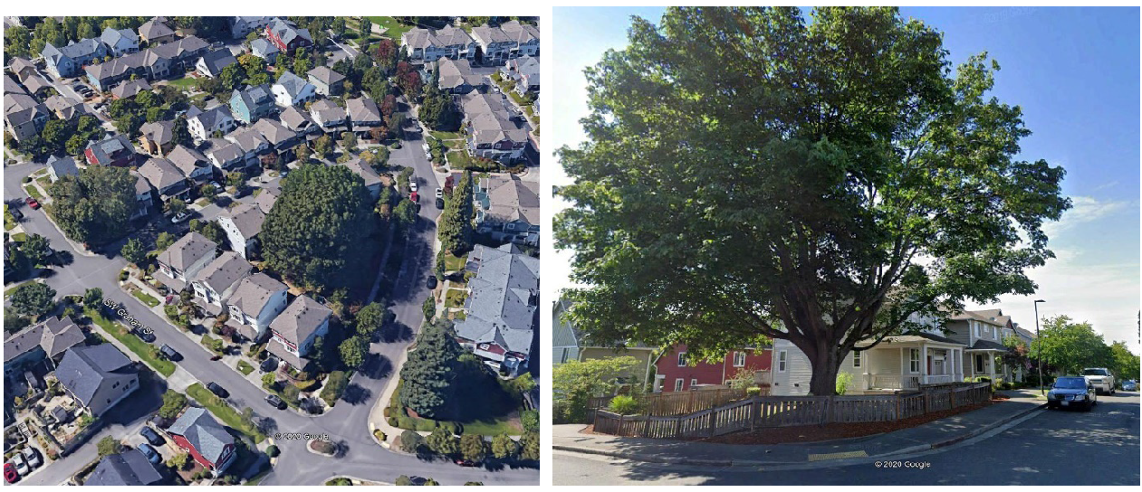
Right: Google Streetview showing one of those large trees, where the lot pattern was shifted to accommodate the tree.
(Ord. No. 1339, § 2(Exh. A), 5-27-2021; Ord. No. 1406, § 2(Exh. A), 7-13-2023; Ord. No. 1426, § 2(Exh.), 7-25-2024)

18.206.030 Accessory dwelling units (ADU).
A. Purpose.
1. To add affordable units and make housing units available to moderate-income people who might otherwise have difficulty finding homes within the city.
2. To promote the development of additional housing options in residential neighborhoods that are appropriate for people at a variety of stages of their lives.
3. To provide homeowners with a means of obtaining, through tenants in either the accessory dwelling unit or the principal residence, rental income, companionship, or security.
4. To protect neighborhood stability, property values, and the character of the neighborhood.
B. Standards.
1. No lot may have more than one accessory dwelling.
2. The accessory dwelling unit may be located in the principal residence or in a detached structure on a lot that is at least five thousand square feet in area.
3. Accessory dwelling units, whether attached or detached, shall be designed in the same style as the primary dwelling and shall use like kind materials on exterior elements.
4. The accessory dwelling unit shall not be larger than fifty percent of the living area of the primary residence.
5. An accessory dwelling unit in a detached structure shall be located behind the primary street facade of the primary dwelling.
C. Accessory Dwelling Unit Incentive. For every five single family homes that integrate an ADU, those homes count as only four dwelling units, for density purposes.
D. Ownership. The accessory dwelling unit shall not be subdivided or otherwise segregated in ownership from the primary residence.
E. Approval Criteria. The community development director shall process a request for accessory dwelling approval as Type II review consistent with RDC 18.310.070.
1. An application for an accessory dwelling shall include a dimensioned site plan showing the location of the proposed dwelling on the subject property and its relationship to all property lines and easements on-site.
2. In addition to the notice requirements of RDC 18.310.070, the city shall provide the applicable homeowner's association and/or the neighborhood association with notice of the application for accessory dwelling.
3. Prior to approval of an accessory dwelling the community development director shall make the following findings:
i. The location of the accessory dwelling complies with the underlying zoning district setbacks, height restrictions, lot area coverage requirements, and other applicable zoning district standards.
ii. Location of the accessory dwelling shall not interfere with any proposed public facilities or services or with private easements.
iii. The proposed accessory dwelling does not adversely affect public health, safety, or welfare.
(Ord. No. 1339, § 2(Exh. A), 5-27-2021)

18.206.040 Cottage housing.
A. Purpose.
1. Provide opportunities for creative, diverse and high-quality infill development that is compatible with existing neighborhoods.
2. Promote housing affordability and greater choice by encouraging smaller and more diverse home sizes in accordance with the Ridgefield Urban Area Comprehensive Plan.
3. Support compatibility with existing neighborhoods by promoting high-quality design.
4. Support more efficient use of urban residential land.
5. Enhance the character of the residential neighborhood.
6. Provide usable open space for residents.
7. Create a sense of community among residents.

Figure 18.206.040-A
Cottage housing site plan example.
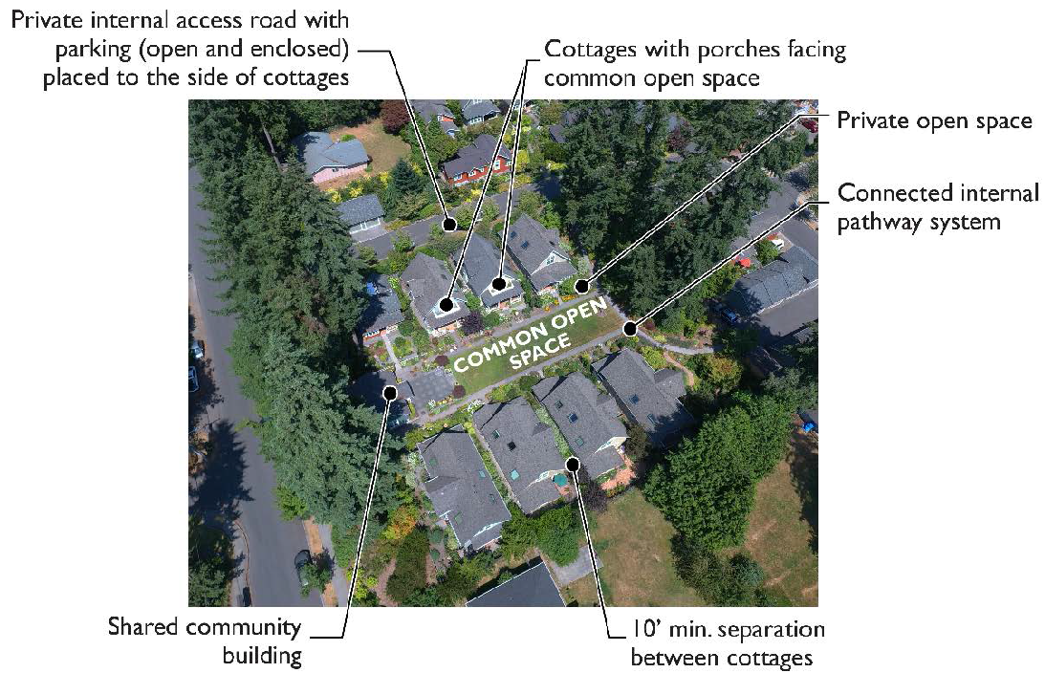
B. Standards.
1. Lot Standards.
a. Cottages are exempt from minimum lot area and lot width standards, provided they comply with density and design standards herein.
b. Impervious surface is calculated for the entire development and must meet the standard for the zone.
2. Cottage size.
a. Cottages must contain no more than one thousand two hundred square feet gross floor area in total, not including attached garages. A covenant restricting any increases in unit size after initial construction shall be recorded against the property. Vaulted space may not be converted to habitable space.
b. Garages attached to cottages shall not exceed three hundred square feet.
3. Density.
a. Due to the smaller relative size of cottage units, each cottage may be counted as one-half a dwelling unit for the purpose of calculating density. For example, a cluster of six cottages would be equivalent to three dwelling units.
b. Where cottage dwellings are integrated with other housing types qualifying for density bonuses, RDC 18.210.025.F.2 sets forth the cumulative limitations to the percentage of qualifying bonus dwelling units in a development.
4. Minimum and maximum number of cottages.
a. Cottage housing developments must contain a minimum of three cottages.
b. Three to twelve cottage structures may make up a cluster. There is no limit on the number of clusters, provided all other standards are met.
c. In the RLD-6, RLD-8, and RMD-16 zones, attached duplex cottages are allowed. In the RMD-8 and RMD-16 zones, attached triplex cottages are allowed.
d. Existing single-family detached dwelling units may remain on the subject property and each will be counted as one dwelling unit for the purpose of density calculations.
5. Setbacks and separation.
a. The minimum setbacks of the zone apply to the development frontage and external side and rear property lines of the entire cottage development.
b. Individual cottages must be separated from other cottages by at least ten feet. Permitted projections into required side yard setbacks in RDC 18.210.040 and 18.220.040 apply.
c. Cottages must be set back at least five feet from any internal pedestrian path. Permitted projections into required front yard setbacks in RDC 18.210.040 and 18.220.040 apply.
d. Cottages must be set back at least ten feet from any internal access lanes that provide access to four or more cottages. For access lanes serving less than four cottages, at least five feet of separation is required between access lanes and cottages. Permitted projections into required front yard setbacks in RDC 18.210.040 and 18.220.040 apply for setbacks to internal access lanes.
6. Building height.
a. Cottages have a maximum building height of twenty-five feet. All parts of the roof above eighteen feet must be pitched with a minimum roof slope of 6:12.
b. Accessory structures in cottage housing developments are subject to the standards of the underlying zone.
7. Design features. Each cottage shall contain the following features:
a. Contrasting trim measuring a minimum of three inches wide on all wall openings.
b. Roof overhang measuring a minimum of six inches.
c. Clear and obvious pedestrian access between the sidewalk (or the street if there is no sidewalk) and the cottage entry.
d. Covered pedestrian entry with minimum weather protection of three feet by three feet (a covered porch or recessed entry).
e. Transparent windows and/or doors are required on at least ten percent of facades featuring the primary entrance and facing streets and common open spaces. For corner lots, this standard is only applied to the elevation containing the primary entrance.
8. Design variety. Cottages within a cluster shall have a cohesive design signature, however, adjacent cottages may not be identical to one another.
9. Common open space.
a. Minimum Size. Common open space must be at least four hundred square feet per cottage.
b. Minimum Dimensions. Common open space must have no dimension less than fifteen feet. Areas used to meet private open space requirements may not be double-counted as common open space.
c. Elements. Common open space may include a lawn, courtyard, plaza, garden, or other shared central open space and may not include parking areas. Common open space must be usable and may not include critical areas, critical area buffers, or slopes greater than fifteen percent. LID stormwater BMPs, like rain gardens, may be integrated in up to twenty-five percent of the minimum required usable open space area.
d. Orientation. Common open space must have cottages abutting on at least two sides. At least fifty percent of the cottages in each cottage housing cluster must abut common open space. Cottages abutting the common open space must be oriented around and have the primary entrance face the common open space.
e. Access. Cottages must be within one hundred feet walking distance of the common open space and feature a direct pedestrian connection to the common open space.
f. Fences. Fences are not allowed within required open space areas unless required as a condition of approval.
g. Landscaping. Landscaping located in common open space areas shall be designed to allow for easy access and use of the space by all residents, and to facilitate maintenance needs (see related standards in RDC 18.725.090). Integration of existing trees into common open space is encouraged (see related standards in RDC Chapter 18.840).
10. Shared community buildings.
a. A shared community building may be integrated into the required common open space but it must not be included in the minimum common open space area calculations.
b. Nonresidential use. A shared community building may include uses such as, but not limited to, a multi-purpose entertainment space, recreation center, kitchen, library, storage space, workshop, or similar amenities that promote shared use and a sense of community. Commercial uses other than daycare I are prohibited (see RDC 18.205.030.K).
c. Height. Shared community buildings have a maximum building height of twenty-five feet. All parts of the roof above eighteen feet must be pitched with a minimum roof slope of 6:12.
d. Size. Shared community buildings have a maximum ground floor footprint of one thousand two hundred square feet.
e. Other standards. Except for the height and size exceptions identified in subsections (10)(c)—(d) of this section, shared community buildings are subject to the accessory structure standards of the underlying zone.
11. Private open space.
a. Minimum size. The minimum private open space adjacent to each cottage must be at least two hundred square feet.
b. Minimum dimensions. The private open space must have no dimension less than ten feet.
c. Access. The private open space must have direct access from the cottage via a door or porch.
d. The required porch [see subsection (12)(e) of this section)] does not count as private open space for the size or dimension requirements of this section. The private open space is encouraged to be located between the cottage and the common open space.
e. Porches. Cottage facades facing the common open space or common pathway must feature a roofed porch at least seventy square feet in size with a minimum dimension of seven feet on any side. Cottages sited between a street and the common open space are also subject to the entry requirements in subsection (B)(7) of this section.
f. Private open space must be usable and may not include critical areas or critical area buffers, including slopes greater than fifteen percent.
12. Access and parking.
a. See the Ridgefield Engineering Standards for driveway and access requirements.
b. Off-street parking standards, including guest parking provisions, are set forth in RDC Chapter 18.720.
c. Parking areas must be located to the side or rear of cottage clusters. Parking must not be located between the street and cottages nor between cottages and common open space.
d. Parking and access lanes must be screened from adjacent residential uses by landscaping or architectural screens. For parking areas and access abutting residential uses, at least five feet of Type L1, L2, or L3 landscaping (see RDC 18.725.030) must be provided between the parking area and the abutting residential use.
e. Parking is encouraged to be consolidated under cover. Shared detached garage structures may not exceed four single-wide garage doors per building, a total of one thousand two hundred square feet. The massing, materials, and roof pitch of shared detached garages must be similar and compatible to the dwelling units within the development.
f. Uncovered parking must be located in clusters of not more than six adjoining spaces (except where adjacent to an alley). Driveway space in front of private garages is exempt from this provision.
g. Attached garages must not be located adjacent to the common open spaces. This requirement may be waived provided the combination of the common open space design, garage location and design, and landscaping/architectural design features helps to create a common open space that meets the purposes of the standards and the design mitigates the impact of the garages on the common open space.
13. Impervious surface standards. The maximum impervious surface standards of the base zone apply to the whole cottage development rather than for individual cottage dwellings.
14. Tree standards. Trees shall be integrated into cottage developments at the time of occupancy as provided below.
a. A minimum of two deciduous and one and one-half evergreen trees are required per cottage.
b. Required trees shall be distributed around the site in front, side, and rear yards, adjacent to parking areas, within private open space adjacent to cottages, and/or within common areas.
c. Where one or more existing native trees (as set forth in RDC 18.830.050) are preserved and integrated into the design of the development, the community development director will allow for credits of up to four required trees for each preserved tree depending on the size, health, and maturity of the tree.
d. See RDC Chapter 18.725 for related landscaping plans, installation, and maintenance standards.
15. Accessory dwelling units are not permitted in cottage housing developments.
(Ord. No. 1339, § 2(Exh. A), 5-27-2021; Ord. No. 1426, § 2(Exh.), 7-25-2024)

18.206.050 Duplex and triplex.
A. Purpose.
1. Provide opportunities for creative, diverse and high-quality infill development that is compatible with existing neighborhoods.
2. Promote housing affordability and greater choice by encouraging smaller and more diverse home sizes in accordance with the Ridgefield Urban Area Comprehensive Plan.
3. Support compatibility with existing neighborhoods by promoting high-quality design.
4. Support more efficient use of urban residential land.
5. Enhance the character of the residential neighborhood.
6. Provide usable open space for residents.
B. Duplex and Triplex Density Calculations and Incentives. RDC 18.210.025.F.2 sets forth the cumulative limitations to the percentage of qualifying bonus dwelling units in a development.
1. On existing lots (created as of ADD ADOPTED DATE OF THIS ORDINANCE), duplexes and triplex units may be counted as one-half a dwelling unit, for the purpose of calculating density, provided the dwelling units within each building average no more than one thousand square feet. A covenant restricting any increases in unit size after initial construction shall be recorded against the property. Vaulted space may not be converted to habitable space.
2. On all corner lots in subdivisions, duplex units may be counted as one-half a dwelling unit for the purpose of calculating density. This incentive may not be combined with subsection (3).
3. In subdivision developments in RLD zones, each duplex or triplex unit less than one thousand four hundred square feet in gross floor area and not on a corner lot may be counted as one-half a dwelling unit for the purpose of calculating density. This bonus is available for a limited number of units as follows. Once the cap is reached, additional duplex and triplex units are counted as one unit.
a. RLD-4 zone: Up to twelve percent of dwelling units may be duplex units using the density bonus, and up to eight percent of the units may be triplex units using the density bonus.
For example, a subdivision on a net ten-acre parcel has a default maximum capacity of forty dwelling units. If thirty-six dwelling units are single-family homes, up to two duplexes (four dwelling units) and one triplex (three dwelling units) could be integrated. The calculated density is thirty-nine and one-half units, but the functional total is forty-three units (a bonus of three units).
b. RLD-6 zone: Up to eighteen percent of dwelling units may be duplex units using the density bonus, and up to twelve percent of units may be triplex units using the density bonus.
c. RLD-8 zone: Up to twenty-five percent of dwelling units may be duplex units using the density bonus, and up to twenty-five percent of units may be triplex units using the density bonus.
d. Where duplex or triplex dwellings are integrated with other housing types qualifying for density bonuses, RDC 18.210.025.F.2 sets forth the cumulative limitations to the percentage of qualifying bonus dwelling units in a development.
4. For plat recording requirements, see RDC 18.210.025.F.3.
C. Required Design Features.
1. All wall openings, regardless of visibility from a public right-of-way, shall have:
i. Contrasting trim (minimum three inches wide);
ii. Recess (windows) at least one and one-half-inches from the façade; or
iii. Other design treatments that add depth, richness, and visual interest to the façade.
2. Roof overhang (minimum six inches) or other design feature with comparable visual impact that adds depth and richness to the home design.
3. Covered entry at least three feet deep for the primary entrances.
4. Minimum useable open space [see standards in subsection (E) below].
5. Minimum front façade window transparency: At least ten percent. This applies to all vertical surfaces of the façade elevation (excluding rooflines). Windows and their frames shall be used in the calculations, while trim may not be included. Garage door windows may be used to meet up to fifty percent of the minimum transparency requirement.
D. Architectural Design Guidelines and Standards.
1. Character. Generally, duplexes and triplexes should maintain the traditional character and quality of detached single-family dwelling units by using similar traditional design elements and materials such as wood siding, trim, porches, and chimneys. More detailed standards are provided throughout this section.
2. Front façade articulation. Duplexes and triplexes shall utilize a combination of roofline and façade modulation to distinguish each unit located on the ground floor that faces the street. This is not required for stacked unit configurations or front-and-rear configurations that appear as a single-family home with only one entry facing the street.
3. Front façade features. Every front façade of a duplex and triplex shall contain a minimum of three elements from the lists, including at least one element from the structural elements list and at least one element from the decorative elements list.
a. Structural elements. Qualifying features shall be integrated on the façade of each dwelling unit.
i. Covered porch area with a minimum of fifteen square feet.
ii. Dormers.
iii. Gables.
iv. Hipped, gable, gambrel, mansard or similar pitched roof.
v. Bay windows.
vi. Twelve-inch offset from one exterior wall to another.
vii. Balconies.
viii. Roofline offset of at least two feet from the top surface of one roof to the other.
ix. Vertical breaks/horizontal walls.
x. Recessed building entry at least two feet deep by four feet wide.
xi. Other structural element that adds comparable visual interest to the features above, as approved by the community development director.
b. Decorative elements. Qualifying features shall be integrated on the façade of each dwelling unit.
i. Decorative garage doors. Standard squares on a garage door will not qualify as a decorative detail.
ii. Pillars/posts.
iii. Decorative eave or barge boards with two material variations.
iv. Decorative shingles or varied siding in gables.
v. Decorative siding (shingles, shake, batten board, wainscoting, or similar).
vi. Brick, stone or cedar accents covering at least ten percent of the front facade wall surface area.
vii. Variable siding; the use of two or more types of siding.
viii. Fiber-cement horizontal lap siding between three and seven inches wide.
ix. Shed roof above window(s).
x. Belly Band cladding.
xi. Functional shutters or louvers.
xii. Corner boards/posts.
xiii. Knee or eave braces.
xiv. Enlarged trim on garage door headers at least six inches wide.
xv. Other architectural elements, other than color, glass or lighting, approved by the community development director.

Figure 18.206.050-D
Examples emphasizing façade articulation and details.
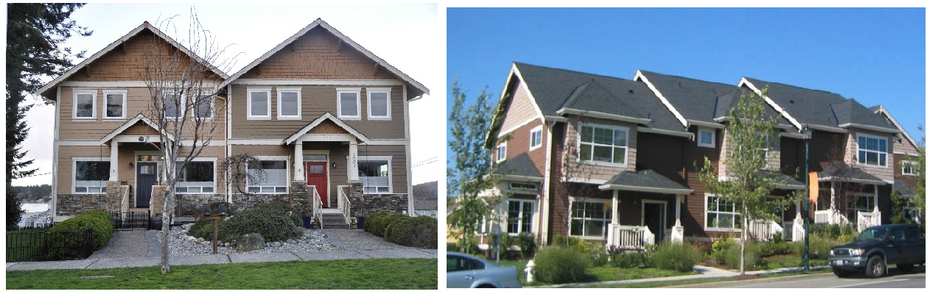
Left example: Duplex with covered entry, separate gabled roofs, pillars/posts, decorative shingles, stonework, and eave braces.
Right example: Triplex with covered porches, pillars/posts, roofline offsets, variable siding, projecting window bays and multi-paned windows.
4. Pitched roof. Roofs must be pitched with slopes between 2:12 and 15:12, and along street frontages roof design for a duplex or triplex building shall not repeat unless separated by three different types of roofs (a design is determined by the predominate axis and pitch of the roof form together with intersecting secondary roof forms). Porches and dormers are exempt from this standard.
5. Exterior materials. Building exteriors shall be constructed from quality and durable materials such as stone, brick, wooden lap siding, fiber cement siding, or similar materials. Insubstantial materials, such as fiberglass, and materials such as mirrored glass, corrugated siding, exposed concrete block, and plywood or T-111 siding are not permitted.
E. Garage Location and Design.
1. Garages or carports detached from or attached to the main structure and facing the street shall comply with at least one of the following:
a. Set back the garage or carport from the front building facade or front face of a covered porch, by a minimum of four feet. To qualify as a porch under this subsection, the porch must extend along a minimum of 50 percent of the street-facing building facade that is not devoted to the garage, and must be at least six feet wide.
b. Provide enhanced architectural details. Under this option, the front façade shall contain a minimum of six elements from elements lists under subsection (D)(3) of this section, including at least two elements from the structural elements list and at least two elements from the decorative elements list.
2. No more than fifty percent of any ground floor façade may be occupied by a garage, and detached garages and all carports shall not protrude beyond the front building façade. This limit may be increased to a maximum of sixty-five percent provided at least three of the following design details are utilized:
a. A decorative trellis over at least the entire width of the garage door(s).
b. A window or windows are placed above the garage on a second story or attic wall.
c. A balcony that extends out over the driveway.
d. Utilizing all single-vehicle car doors as an alternative to wider garage doors suitable for two-car garages.
e. Windows in the garage door.
f. Decorative details on the garage door. Standard squares on a garage door will not qualify as a decorative detail.
F. Driveways and Access.
1. Where the dwellings are served by alleys, all garages and on-site parking shall be accessible from the alley and the façade(s) facing the street shall be designed as the front of the dwellings including, but not limited to, a primary building entrance consisting of inward swinging door(s), porch(es), window(s) and pathway(s) to the street.
2. When no alleys are present, the following apply:
a. Side- and rear-facing parking areas and garages are encouraged.
b. When located on a corner lot, both streets must be utilized for vehicle access, unless one street is designated as an arterial. Such driveways must be located as far from the street corner as feasible.
c. Driveways for duplexes are limited to:
i. One twenty-foot wide (maximum) driveway; or
ii. Two twelve-foot wide (maximum) driveways, provided the driveways are spaced at least twenty feet apart.

Figure 18.206.050-F.2.b
Duplex corner lot driveway location examples.
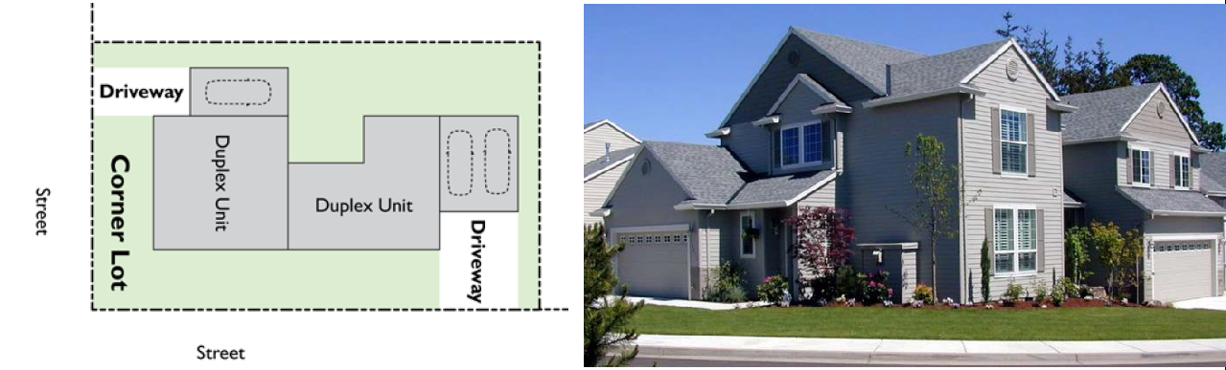

Figure 18.206.050-F.2.c
Duplex driveway and garage example.
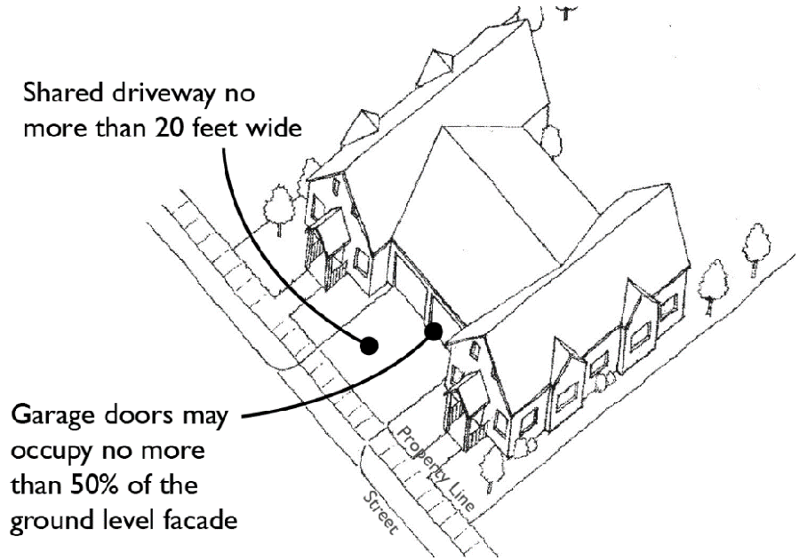
G. Open Space Standards.
1. All new duplex and triplex developments shall provide usable open space with a collective size equal to ten percent of the lot area. For example, an eight thousand square-foot lot would require at least eight hundred square feet of usable open space. Usable open space may be a single large space or separate spaces.
2. All useable open space shall a minimum dimension of fifteen feet on all sides.
3. Where the usable open space is located within a front yard setback, the open space must be defined with a fence, hedge, or wall between eighteen and thirty-six inches tall (meeting the standards of RDC Chapter 18.740). See Figure 18.206.050-G for an example.
4. If the rear edge of the usable open space is within five feet of an alley, any fence between the rear edge and the alley shall be limited to four feet in height except where the portion of the fence between four and six feet in height is at least fifty percent transparent. Vegetative matter which functions as a fence has no height limit.
5. Unenclosed decks, porches, patios, and entries may be used as a part of the usable open space, provided they are a part of a space that meets the standards herein.
6. Driveways shall not count in the calculations for usable open space.
7. Additions shall not create or increase any nonconformity with this standard.

Figure 18.206.050-G
Duplex front yard open space example.
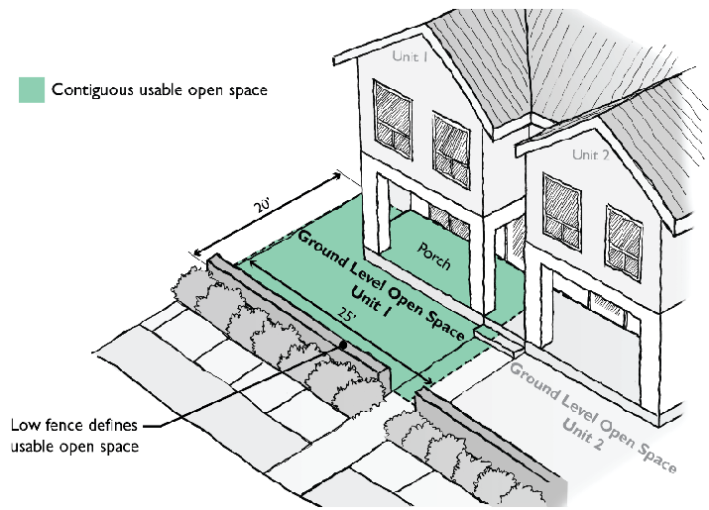
H. Tree Standards. Trees shall be integrated on new lots at the time of occupancy as provided below.
1. Lots less than seven thousand square feet in area:
a. Minimum two deciduous trees.
b. Minimum one evergreen tree.
2. Lots seven thousand square feet in area or greater:
a. Minimum two deciduous.
b. Minimum two evergreen trees.
3. Where one or more existing native trees (as set forth in RDC 18.830.050) are preserved and integrated into the design of the development, the community development director will allow for credits of up to four required trees for each preserved tree depending on the size, health, and maturity of the tree.
4. See RDC Chapter 18.725 for related landscaping plans, installation, and maintenance standards.

Figure 18.206.050-H
Example of integrating tree preservation into a duplex/triplex housing development.
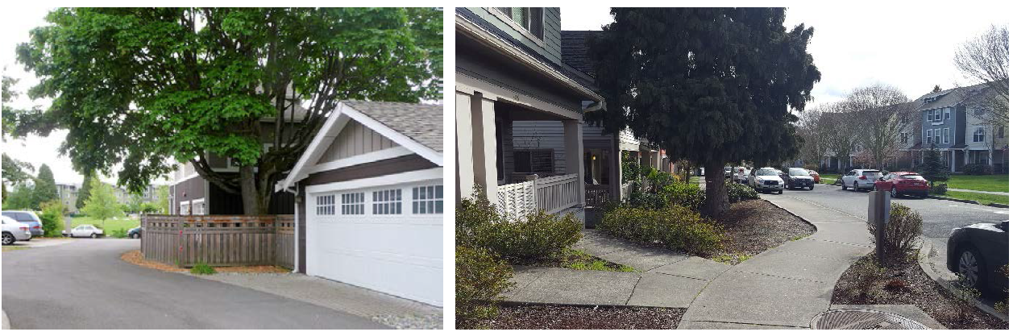
(Ord. No. 1339, § 2(Exh. A), 5-27-2021)

18.206.060 Townhouse.
A. Purpose.
1. Provide opportunities for creative, diverse and high-quality infill development that is compatible with existing neighborhoods.
2. Promote housing affordability and greater choice by encouraging the integration of townhouses into new subdivisions.
3. Support compatibility with existing neighborhoods by promoting high-quality design.
4. Support more efficient use of urban residential land.
5. Enhance the character of residential neighborhoods.
6. Provide usable open space for residents.
B. Townhouse Density Calculations and Incentives in the RLD-6-8 Zones.
1. In subdivision developments in RLD-6 and RLD-8 zones, each townhouse unit less than one thousand four hundred square feet in gross floor area may be counted as one-half a dwelling unit for the purpose of calculating density. This bonus is available for a limited number of units as follows. Once the cap is reached, additional townhouse units are counted as one unit.
a. RLD-6 zone: Up to fifteen percent of dwelling units may be townhouse units using the density bonus.
For example, a subdivision on a net ten-acre parcel has a default maximum capacity of sixty dwelling units. If fifty-five dwelling units are single-family homes, up to nine townhouses could be integrated. The calculated density is fifty-nine and one-half units, but the functional total is sixty-four units (a bonus of four units).
b. RLD-8 zone: Up to twenty-five percent of dwelling units may be townhouse units using the density bonus.
2. Where townhouses are integrated with other housing types qualifying for density bonuses, RDC 18.210.025.F.2 sets forth the cumulative limitations to the percentage of qualifying bonus dwelling units in a development.
3. For plat recording requirements, see RDC 18.210.025.F.3.
C. Dimensional Standards. The townhouse standards in Table 18.206.060-A supersede the dimensional requirements for the RLD-4, -6, and -8 and RMD-16 zones in RDC 18.210.030 and 18.220.030, respectively, provided the applicable density standards are met. Other standards of the base zone apply.
Table 18.206.060-A
Townhouse dimensional standards.
 | RLD-4, -6,  and -8 | RMD-16
Min. Lot Width | 30 feet in the RLD-4 zone;  No minimum in other zones | No minimum
Min. Lot Area | 2,500 square feet in the RLD-4 zone;  No minimum in other zones | No minimum
Min. Front Yard Setback | 15 feet in the RLD 4 and 6 zones;  10 feet in the RLD-8 zone | 10 feet
Min. Rear Yard Setback | 10 feet | 10 feet
Min. Side Yard Setback | 0 to 5 feet | 0 to 5 feet
Min. Street Side Yard Setback | 10 feet | 10 feet

1. Reduced side yards. The minimum side yard for a townhouse shall be zero feet for the side yard where the townhouse attaches to another townhouse and five feet where the townhouse is not attached to another townhouse, which shall not be reduced through the PUD or adjustment or variance process. For zero-lot line development, eaves may project across the property line if the developer or property owners record an easement expressly describing the purpose, dimensions, and duration of the easement.
2. Major corridors. See RDC 18.210.060 for special setback and design requirements along major corridors.
3. Building separation. The minimum building separation between townhouse buildings shall be ten feet.
D. Required Design Features:
1. All wall openings, regardless of visibility from a public right-of-way, shall have:
i. Contrasting trim (minimum three inches wide);
ii. Recess (windows) at least one and one-half-inches from the façade; or
iii. Other design treatments that add depth, richness, and visual interest to the façade;
Where no wall openings exist on a façade, contrasting materials must be incorporated.
2. Roof overhang (minimum six inches) or other design feature with comparable visual impact that adds depth and richness to the home design.
3. Covered entry at least three feet deep for the primary entrances [see related standards in subsection (E)(3) of this section].
4. Minimum useable open space [see standards in subsection (E) below].
5. Minimum front façade window transparency: At least ten percent. This applies to all vertical surfaces of the façade elevation (excluding rooflines). Windows and their frames shall be used in the calculations, while trim may not be included. Garage door windows may be used to meet up to fifty percent of the minimum transparency requirement.
E. Architectural Design Standards.
1. Articulation.
a. Townhouse buildings must include façade articulation features at intervals to create a human-scaled pattern. The maximum horizonal length of the intervals is the width of individual townhouse units.
b. Articulation is required on all facades facing a street, common or other shared open space, and common parking areas.
c. At least three of the following articulation features must be employed with each articulation interval, and at least two of these features shall be substantially different from the features on abutting units:
i. Use of windows and/or entries.
ii. Use of weather protection features (such as covered porches).
iii. Change in roofline, such as vertical or horizontal offsets or variations in roof pitch.
iv. Dormers.
v. Change or decorative use of building material, siding style, and/or window pattern (applies to all floors of the façade).
vi. Pillars or posts.
vii. Providing vertical building modulation of at least twelve inches in depth if tied to a change in roofline or a change in building material, siding style, or color.
viii. Balconies that are recessed or projected from the facade by at least eighteen inches.
ix. Other design techniques that effectively reinforce a pattern of small facades compatible with the building's surrounding context.
2. Repetition with variety.
a. No townhouse building shall have the same front façade design as any other townhouse building within two hundred linear feet, on either side of the street, as measured from the nearest point of the subject property lines. If a rear facade is visible from a public right-of-way and there is not a buildable lot fully between the nearest point of the rear property line of the subject property and the nearest point of a public right-of-way or private street, the rear facade of the subject dwelling shall also comply with this standards.
b. Townhouse developments shall employ one or more of the following "repetition with variety" articulation methods:
i. Reversing the elevation of dwellings.
ii. Providing different building elevations for external townhouses (units on the end or corner of a building) by changing the roofline, articulation, windows, and/or building modulation patterns.
iii. Adding a different dwelling design or different scale of the same design, such as adding a two-story version of the basic dwelling design where three stories are typical.
iv. Other design treatments that add variety or provide special visual interest, such as different cladding materials, window sizes and groupings, roof slopes, porch designs, balconies, etc. While the variable use of color on buildings can be effective in reducing the perceived scale of the building and adding visual interest, color changes alone are not sufficient to meet the purpose of the standards.
c. The community development director may allow relief from the repetition with variety provisions above where high-quality materials (such as brick) are employed and combined with effective details and or other site features that reduce monotony and add a sense of depth and richness to the building and development.

Figure 18.206.060-C.2
Repetition with variety examples.
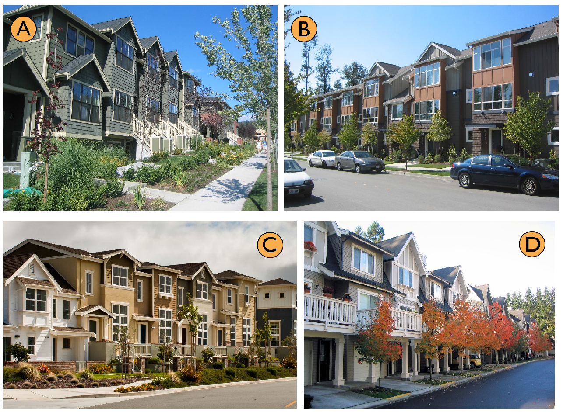
A. Different elevation for end units.
B. Alternating roofline.
C & D. Alternating articulation (roofline, siding style, color, and window fenestration).
3. Entries.
a. Clear and obvious pedestrian access between the street and the building entry is required for new dwellings.
b. All new dwellings must provide a covered pedestrian entry with minimum weather protection of three feet by three feet (a covered porch or recessed entry). This entry may be integrated into usable open space required under subsection (G) of this section.
c. For townhouses where the primary pedestrian access to the dwelling is from an alley or private internal vehicular access, buildings must emphasize individual pedestrian entrances over private garages by using both of the following measures:
i. Enhance entries with a trellis, small porch, or other architectural features that provide cover for a person entering the unit and a transitional space between outside and inside the dwelling.
ii. Provide a planted area in front of each pedestrian entry of at least 20 square feet in area, with no dimension less than four feet.
4. Exterior materials. Building exteriors shall be constructed from quality and durable materials such as stone, brick, wooden lap siding, fiber cement siding, or similar materials. Insubstantial materials, such as fiberglass, and materials such as mirrored glass, corrugated siding, exposed concrete block, and plywood or T-111 siding are not permitted.
F. Parking and Garage Location and Design.
1. Rear parking. Individual garages facing the street are not allowed for townhouse dwellings. Garages shall be provided to the rear of the dwelling via alley access or a shared driveway as depicted in Figure 18.206.060-F.1, and the following standards apply.
Exception: This standard does not apply for townhouse buildings with two units, and such buildings shall comply with the duplex driveway standards of RDC 18.206.050.E-F.
a. Garages that take vehicle access from an alley shall be set back a minimum of three feet from an alley right-of-way.
b. Internal drive aisles must meet minimum widths and other standards such as turning radii of the city-adopted International Fire Code.
c. Minimum building separation along internal drive aisles must be twenty-four feet. Projections into this minimum building separation standard are permitted for each building consistent with the side yard setback projections allowed under this title. The purpose is to provide adequate vehicular turning radius, allow for landscaping elements on at least one side, and provide adequate light and air on both sides of the dwelling units and vehicle areas, which often function as usable open space for residents.
d. Street-access driveways leading to townhouse garages shall not be considered parking lots for the purposes of RDC 18.220.100.C.

Figure 18.206.060-F.1
Townhouse driveway examples.
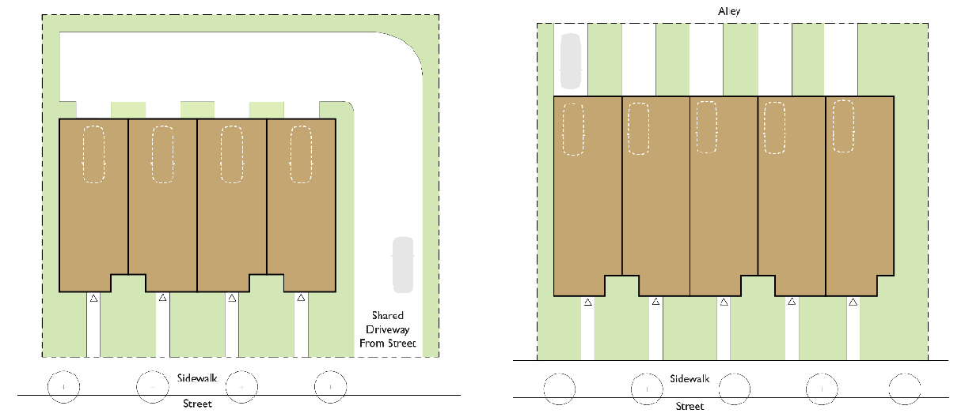
Both examples show a driveway with private garages placed to the rear of units. In the left image, there is no alley and access is provided from the street. In the right image, access from an alley is available and access is provided from the alley.

Figure 18.206.060-F.2
Acceptable and unacceptable townhouse driveway/orientation.
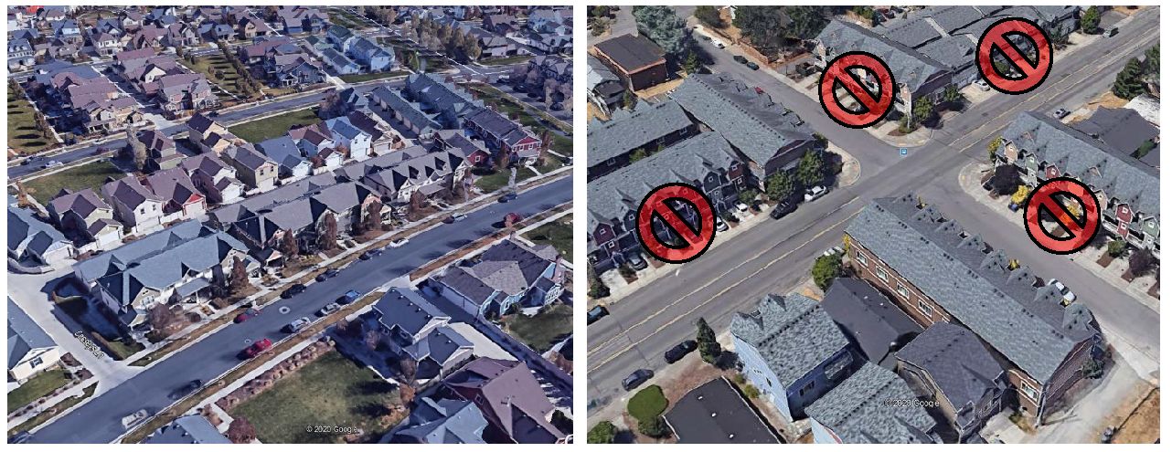
Left: Alley loaded townhouses (South Jordan, Utah) allow for landscaped front yards and inviting streetscapes. Right: The front-loaded townhouse examples are unacceptable because they degrade the streetscape and pedestrian environment and increase safety conflicts on public streets.
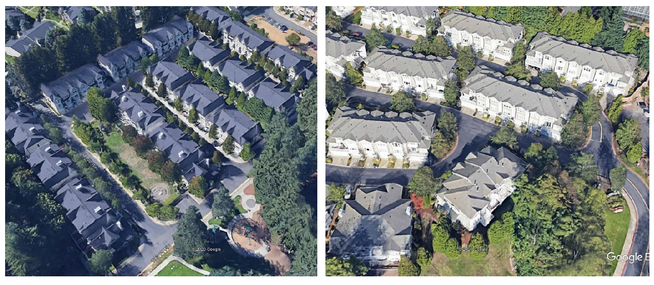
For larger townhouse developments, units can front onto smaller private access streets. Note the use of landscaped areas between each driveway in both examples. Both examples above also illustrate how trees can successfully be integrated into such developments.
2. Street-facing driveways and garages.
a. Individual garages and driveways facing the street [if allowed by exception under subsection (F)(1) of this section] are limited to twelve feet in width. Shared driveways, which have a maximum width of twenty feet, may be required by the community development director.
b. Garages must be set back a minimum of twenty feet from the back of the sidewalk.
c. No more than forty percent, as measured in square feet, of the wall area of the front elevation of an individual townhouse unit facing a street shall be dedicated to garage door space.
d. Twenty percent of the garage wall area facing a street shall contain windows or doors placed to create the impression of habitable residential space.
e. In each townhouse building, no more than fifty percent of the garages may extend beyond the front plane of the primary facade of the associated dwelling unit.
3. If common parking areas other than driveways and garages are provided, the following access and location standards shall be met:
a. Access to parking areas shall be provided from alleys where possible.
b. Parking areas shall be located behind or to the side of buildings.
c. Common parking areas must provide pedestrian connections to dwelling units.
G. Open Space Standards. All townhouse dwelling units must provide open space at least equal to ten percent of the gross floor area of the unit. The required open space may be provided by one or more of the following:
1. Private ground level open space that is directly adjacent and accessible to dwelling units.
a. Such space must have minimum dimensions of at least twelve feet on all sides and be configured to accommodate human activity such as outdoor eating, gardening, toddler play, etc.
b. Front yard setbacks may be used to meet this standard, provided they are defined with a low fence (meeting standards of RDC Chapter 17.740, Fences and Walls).
c. Outdoor covered areas may be used to meet up to half of the required area if is located anywhere except the front of the lot.
d. Driveways shall not count in the calculations for usable open space.
2. Balconies, roof decks, or porches.
3. In PUD subdivisions, shared open space that meets the design requirements of a main facility under RDC 18.401.080.B may be used to meet the useable open space requirement, provided such space is visible and directly accessible to the subject townhouse dwelling units.

Figure 18.206.060-G
Townhouse open space example.
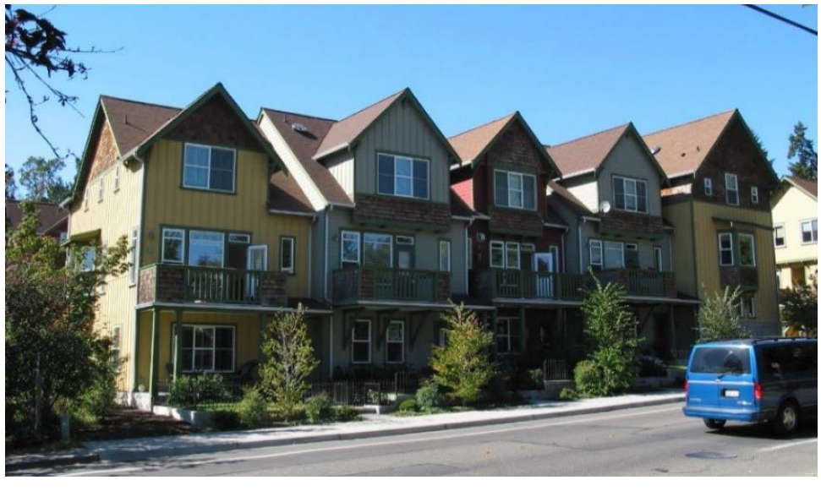
These townhouses utilize a combination of decks and ground-level yards to meet the required open space standard.
H. Tree standards. Trees shall be integrated into townhouse developments at the time of occupancy at the rate one tree per townhouse unit.
a. Trees may be either evergreen or deciduous.
b. Required trees shall be distributed around the site in front, side, and rear yards, adjacent to parking areas, and/or within private open space adjacent to townhouses.
c. Where one or more existing native trees (as set forth in RDC 18.830.050) are preserved and integrated into the design of the development, the community development director will allow for credits of up to four required trees for each preserved tree depending on the size, health, and maturity of the tree.
d. See RDC Chapter 18.725 for related landscaping plans, installation, and maintenance standards.
(Ord. No. 1339, § 2(Exh. A), 5-27-2021)

18.206.070 Multifamily design standards.
A. Applicability. This section applies to multifamily development in the RMD-16 zone and when referenced by other sections of this code.
B. Exterior Materials. Building exteriors shall be constructed from quality and durable materials such as stone, brick, wooden lap siding, fiber cement siding, or similar materials. Insubstantial materials, such as fiberglass, and materials such as mirrored glass, corrugated siding, exposed concrete block, and plywood or T-111 siding are not permitted.
C. Facade Standards.
1. All new residential building facades shall feature at least three of the following design features per dwelling unit that makes up the facade:
a. Windows and door treatments which embellish the facade, such as trim a minimum of two inches wide around the windows facing a public street;
b. Porches or covered entries;
c. Dormers;
d. Fascia boards at least six inches wide;
e. Bay windows;
f. Cupolas or towers;
g. Pillars or posts;
h. Eaves, with a minimum six-inch projection;
i. Balconies;
j. Decorative patterns on exterior finish (e.g., scales/shingles, wainscoting, ornamentation, and similar features);
k. Use of contrasting materials, such as brick or stone, on a minimum of twenty-five percent of the facade;
l. Other architectural elements, other than color, glass or lighting, including varying texture and materials within the same building, or massing, window voids, trellis or arcade, or other elements the Director finds compatible with the residential character of the zone.
2. Large buildings shall be broken into smaller components to reflect the character and scale of the surrounding neighborhood through repetition of roof lines, patterns of door and window placement, and use of the characteristic entry features.
3. Continuous building facades longer than fifty feet which face the street or low density residential zones shall incorporate modifications to the vertical plane of the facade. The facade shall incorporate building elements such as embellished entrances, courtyards, bays, balconies, and other architectural elements to visually divide the facade every thirty feet or less.
4. Blank walls shall be articulated in one or more of the following ways:
a. Installing a vertical trellis in front of the wall with climbing vines or planting materials.
b. Providing a landscaped planting bed a minimum of five feet wide in front of the wall with plant materials that can obscure at least fifty percent of the wall's surface within three years.
c. Providing texture or artwork (mosaic, mural, sculpture, relief, etc.) over the blank wall surface.
d. Other equivalent method that provides for enhancement of the wall.
D. Rooflines. Buildings shall avoid straight, unvaried rooflines exceeding sixty lineal feet and shall employ devices such as various elevations, gables, dormers, and chimneys. Roofline variation shall be achieved using one or more of the following methods:
1. Vertical offset in ridge line;
2. Horizontal offset in ridge line;
3. Variations in roof pitch;
4. Gables;
5. Dormers;
6. Decorative cornices and rooflines (e.g., for flat roofs).
E. Garages or carports either detached from or attached to the main structure shall not protrude beyond the primary building facade.
F. Open Space and Recreation Areas.
1. A minimum twenty-five percent of the net developable acres of each multifamily development shall be provided as landscaped open space or common recreation areas. Open space and recreation areas developed to satisfy this section may also be credited towards the PUD open space requirements of RDC 18.401.080.B. The standards of this section and the PUD section must be met.
2. Common recreation areas shall be provided as follows:
a. Minimum one hundred seventy square feet per three-bedroom unit or larger.
b. Minimum one hundred thirty square feet per two-bedroom unit.
c. Minimum one hundred square feet per studio or one-bedroom unit.
3. Common recreation areas must be accessible by all residents and may include the following:
a. Outdoor common recreation areas including parks, trails, and sports facilities.
b. Play areas at least four hundred square feet in size. Any play apparatus that is provided must meet consumer product safety standards for equipment, soft surfacing, and spacing.
c. Community garden plots. The community garden area must be fenced, and must include a shared tool shed and water source for irrigation. Community gardens are not subject to the requirements of the city's community garden program.
d. Indoor common recreation areas including community centers and recreation rooms.
e. Common roof decks, balconies, and patios.
f. Indoor or outdoor swimming pools.
g. Other active recreation facilities as defined by RDC 18.100.
h. Other features determined by the community development director to be materially similar to the above-listed common recreation areas.
4. Common recreational areas shall be centrally located, and visibly accessible from dwelling units and sited away from arterial streets and parking areas, with a grade and surface suitable for their intended use, and have a smallest minimum dimension (length or width) of twenty feet, except for trail segments.
5. Recreation areas shall be connected by trail or walkway to dwelling units and to any existing or planned public park, open space or trails on adjoining properties.
6. Open space and common recreational areas shall be fully described and made a condition of approval. Such areas shall be maintained by a homeowner's association or equivalent mechanism approved by the city.
(Ord. No. 1339, § 2(Exh. A), 5-27-2021)

Chapter 18.210 RESIDENTIAL LOW DENSITY DISTRICTS (RLD-4, RLD-6, RLD-8)

18.210.010 Purpose.
The RLD districts are intended to implement the provisions of the RUACP. In addition, these districts are intended to:
A. Recognize and maintain established low density residential areas, while encouraging appropriate infill and redevelopment;
B. Establish higher densities close to employment centers and transit corridors;
C. Create energy-efficient residential areas which provide community services in a more economical manner, and facilitate energy-efficient design;
D. Provide for additional related uses such as schools, parks and utility uses necessary to serve immediate residential areas;
E. Encourage traditional pedestrian-oriented neighborhoods, similar in basic design to existing neighborhoods.
(Ord. No. 1132, § 2(Exh. A), 7-11-2013)

18.210.015 Applicability.
A. The city shall follow the RUACP comprehensive plan map to designate low density residential zones. The RLD-4, RLD-6, RLD-8 zoning districts shall implement the residential/urban low (UL) comprehensive plan designation.
B. The city shall place an urban holding (UH) overlay on all lands which are not adequately served by necessary capital facilities. The UH overlay shall limit residential densities to one unit per lot, or one unit per ten acres, whichever is greater, until urban services, consistent with the adopted capital facility plan and RUACP, are available to the UH site or until all financing necessary to construct or bond for the necessary urban services is secured.
(Ord. No. 1132, § 2(Exh. A), 7-11-2013; Ord. No. 1290, § 2(Exh. A), 4-25-2019)

18.210.020 Uses.
A. All uses shall comply with the provisions of RDC 18.205.
B. Home occupation uses shall comply with the provisions of RDC 18.205.030.
C. Uses Approved Through the PUD Process.
Additional commercial uses are allowed in the RLD zone that are permitted, limited, or conditional uses in the CNB district through the PUD process provided they directly support a residential development of at least one hundred units.
1. The maximum ratio of developed commercial acreage to developed residential acreage shall be 1:20; that is, no more than one acre of commercial land may be approved for each twenty acres of developed residential land, exclusive of open space.
2. The maximum commercial acreage for uses otherwise prohibited in the RLD zone which may be approved through the PUD process, without a plan amendment, is three acres.
3. All commercial uses otherwise prohibited in this zone will be reviewed as conditional uses as part of the PUD process, and must satisfy the requirements of Chapter 18.340, Conditional Uses.
(Ord. No. 1132, § 2(Exh. A), 7-11-2013)

18.210.030 Dimensional and density standards.
A. Dimensions shall be consistent with Table 18.210.030-1. Adjustments for townhouse developments are in RDC 18.206.060.
B. The maximum lot area does not apply to existing lots, the remaining parent parcel after a land division, and lots created for non-residential uses such as parks and trails, utilities, and critical areas.
1. For a two-lot short plat with one existing residence, a one-time exemption may be allowed wherein neither the existing lot with the residence nor the remainder lot must meet the maximum lot area permitted in the underlying zone. Any further partitioning of the parent parcel or the oversized lot must comply with the lot size requirements of the underlying zone.
C. Development in the RLD-4 zone may be rounded to a minimum of three and one-half dwelling units per net developable acre and a maximum of four and one-half dwelling units per net developable acre.
D. See RDC 18.210.060 for special setback and design requirements along major corridors.
E. Minimum side yard setbacks shall not be reduced through the adjustment or variance process.
Table 18.210.030-1
RLD dimensional and density standards.
Standard | RLD-4 | RLD-6 | RLD-8
Min. Lot Width | 50 ft | 50 ft | 50 ft
Min. Lot Area | 10,890 sq ft | 7,200 sq ft | 5,000 sq ft
Max. Lot Area | 16,355 sq ft | 10,800 sq ft | 7,500 sq ft
Min. Density: Dwelling Units/Net Developable Acre | 4 du/ac | 4 du/ac | 6 du/ac
Max. Density: Dwelling Units/Net Developable Acre [see subsection (F) of this section for density bonus options] | 4 du/ac | 6 du/ac | 8 du/ac
Min. Front Yard Setback | 15 ft | 15 ft | 10 ft
Min. Rear Yard Setback | 10 ft | 10 ft | 5 ft
Min. Side Yard Setback | 5 ft | 5 ft | 5 ft
Min. Street Side Yard Setback | 15 ft | 15 ft | 10 ft
Max. Height | 30 ft (35 ft with pitched roof) | 30 ft (35 ft with pitched roof) | 35 ft
Max. Impervious Surface | 60% | 60% | 65%

F. Housing Type Diversity Bonus Option.
1. Density bonus incentives are available for the following "missing middle" housing types:
i. Small detached single-family dwellings per RDC 18.206.020.C.
ii. Accessory dwelling units per RDC 18.206.030.C.
iii. Cottages per RDC 18.206.040.B.2.
iv. Duplexes and triplexes per RDC 18.206.050.B.
v. Townhouses per RDC 18.206.060.B.
2. Limitations. The maximum combined percentage of applicable small detached dwellings, cottages, and duplex, triplex, and townhouse dwelling units in development that qualify for the density bonus option herein are set forth by zone. Figure 18.206.025-F illustrates an example of how this works.
i. RLD-4: twenty percent.
ii. RLD-6: thirty percent.
iii. RLD-8: forty percent.
Individual cottage developments are exempt from this limitations. However, for larger developments that include cottages and other housing types, such cottages will be included in the calculations and the subject development shall comply with these limitation standards herein.
3. Any use of a density bonus under this section and the referenced sections of RDC Chapter 18.206 shall be recorded on the face of the plat noting the maximum total number of units, the designated types and number of units for each lot, and if applicable the maximum floor area of units.

Figure 18.206.025-F
Illustrating an example of a subdivision integrating missing middle housing types
to allow for a modest density bonus.
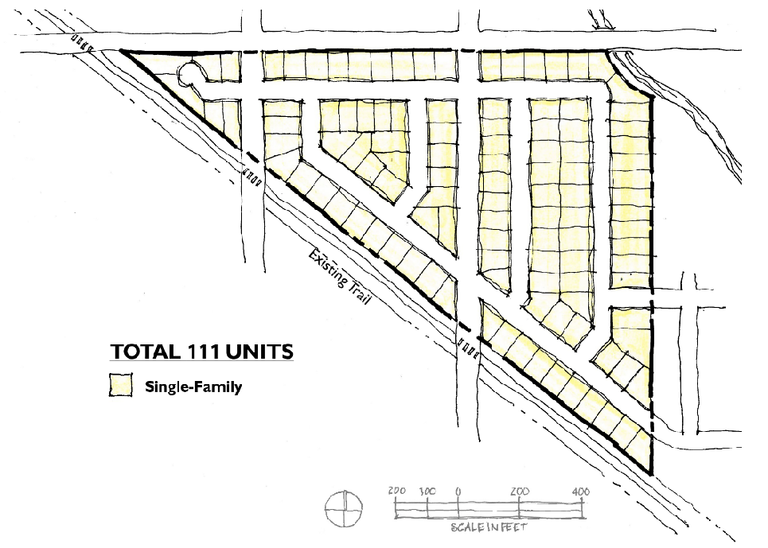
Example standard subdivision example with one hundred percent of lots single family.
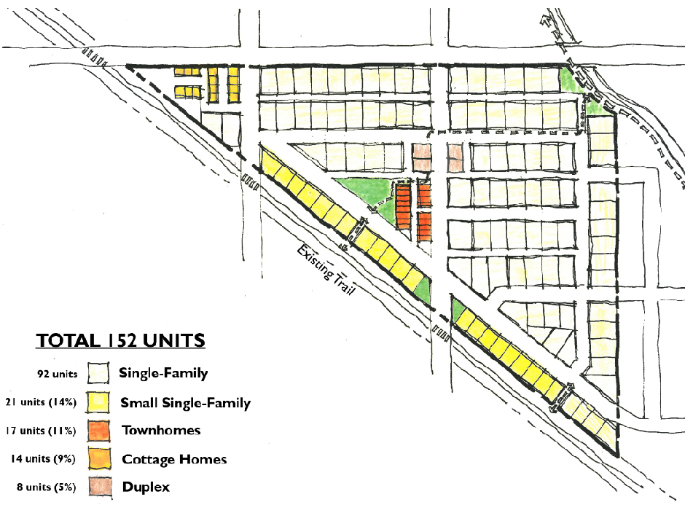
Example subdivision integrating missing middle housing types to achieve a density bonus. Using the calculations for available density bonuses for these housing types, the one hundred fifty-two dwelling units represented here would equate to one hundred twenty-three dwelling units for the purpose of density calculations. Missing middle housing types represent thirty-nine percent of the total dwelling units in this example - a percentage that would be acceptable in the RLD-8 zone.
(Ord. No. 1339, § 2(Exh. A), 5-27-2021; Ord. No. 1352, § 2(Exh. A), 11-4-2021)
Editor's note(s)—Ord. No. 1339, § 2(Exh. A), adopted May 27, 2021, amended § 18.210.030 in its entirety to read as herein set out. Former § 18.210.030 pertained to lot requirements and derived from Ord. No. 1132, § 2(Exh. A), adopted July 11, 2013; and Ord. No. 1207, § 2(Exh. A), adopted May 26, 2016.

18.210.035 Reserved.
Editor's note(s)—Ord. No. 1339, § 2(Exh. A), adopted May 27, 2021, repealed § 18.210.035, which pertained to green design and derived from Ord. No. 1254, Exh. 3, adopted Dec. 7, 2017.

18.210.040 Setbacks—Exceptions.
A. Reserved.
B. Setbacks from Regional Utility Corridors.
1. In subdivisions and short subdivisions, areas used as regional utility corridors shall be contained in separate tracts.
2. In other types of land development permits, easements shall be used to delineate such corridors.
3. All buildings and structures shall maintain a minimum distance of five feet from property or easement lines delineating the boundary of regional utility corridors, except for utility structures necessary to the operation of the utility corridor.
C. Projections into Setback.
1. The following projections may extend into yard setbacks:
a. Gutters;
b. Fixtures with a footprint not exceeding three square feet in area (e.g., overflow pipes for sprinkler and hot water tanks, gas and electric meters, alarm systems, and air duct termination; i.e., dryer, bathroom, and kitchens);
c. On-site drainage systems;
d. Fireplace structures, bay or garden windows, enclosed stair landings, closets, or similar structures may project into setbacks, that are greater than seven feet, provided such projections are:
i. Limited to two per facade;
ii. Not wider than ten feet;
iii. Not more than twenty-four inches into a side yard setback which is greater than seven feet; or
iv. Not more than thirty inches into a front and rear yard setback.
e. Eaves shall not project more than:
i. Eighteen inches into a required side yard setback; and
ii. Thirty-six inches into a front yard and/or rear yard setback.
f. Uncovered porches and decks not exceeding eighteen inches above the finished grade may project up to five feet into the rear yard setbacks in the RLD-4 and RLD-6 zone. For PUD subdivisions, refer to the setback modulation requirements in RDC 18.401.090.J.
g. Covered but unenclosed porches may project up to three feet into the front yard.
h. Building stairs associated with entrances and porches less than three feet and six inches in height are allowed to project into the front yard setback.
i Arbors are allowed in a yard setback if:
i. Their footprint is less than forty square feet, including eaves,
ii. They are eight feet or shorter from finished grade, and
iii. Both sides and roof are at least fifty percent open, or, if latticework is used, there shall be a minimum opening of two inches between crosspieces.
j. Fences are allowed in a yard setback if they meet the requirements of RDC 18.740. Fences may not be placed in the public right-of-way.
k. Retaining walls are allowed in a yard setback.
2. No projections are allowed into a regional utility corridor.
3. No projections or vertical structures are allowed into an access or stormwater easement.
D. The front yard setback requirements are specified in Section 18.210.025, except as provided for below.
1. The front yard setback may be reduced to the average front setback of the two adjacent lots; provided the applicant documents and demonstrates that the average setback of adjacent houses is less than fifteen feet. However, the minimum setback is ten feet. If the subject lot is a corner lot, the setback may be reduced to the average setback of the lot abutting the proposed house on the same street and the fifteen feet required setback. This provision shall not be construed as requiring a greater front yard setback than fifteen feet. Additionally, for corner lots the front yard setback along the longer side of the lot may be reduced to seven feet as long as this setback does not interfere with the site-triangle of the intersection.
E. Alley-loaded lots. If the rear faces on an alley and automobile access is taken exclusively from the alley, the following exceptions apply:
1. Minimum rear yard setback: zero feet.
2. Minimum front yard setback: five feet. When the ground level of a dwelling unit is closer than ten feet from the front property line, the ground level shall be elevated a minimum of thirty inches above the average grade of the adjacent sidewalk.
3. Lots intended for these reduced setbacks shall be noted on the plat.
4. See related standards in RDC 18.210.090.C.
F. Setbacks for flag lots shall be determined by the orientation of the house. The front setback shall be met for the side of the lot towards which the main entrance of the house is oriented, and rear and side yard setbacks shall be established in relationship to the front. All setbacks shall be measured from the property lines for the flag portion of the lot, and not from the pole portion of the lot. If the garage door is oriented towards the pole portion of the lot, it shall be set back eighteen feet from the property line of the flag portion of the lot to comply with RDC 18.210.090.B to allow sufficient driveway length to prevent parking in the pole portion of the lot.
(Ord. No. 1339, § 2(Exh. A), 5-27-2021; Ord. No. 1406, § 2(Exh. A), 7-13-2023)
Editor's note(s)—Ord. No. 1339, § 2(Exh. A), adopted May 27, 2021, amended § 18.210.040 in its entirety to read as herein set out. Former § 18.210.040 pertained to dimensional standards and derived from Ord. No. 1132, § 2(Exh. A), adopted July 11, 2013; Ord. No. 1178, § 2(Exh. A), adopted Feb. 12, 2015; Ord. No. 1207, § 2(Exh. A), adopted May 26, 2016; and Ord. No. 1234, § 2(Exh. A), adopted June 22, 2017.

18.210.045 Reserved.
Editor's note(s)—Ord. No. 1339, § 2(Exh. A), adopted May 27, 2021, repealed § 18.210.045, which pertained to setbacks and exceptions and derived from Ord. No. 1132, § 2(Exh. A), adopted July 11, 2013; Ord. No. 1178, § 2(Exh. A), adopted Feb. 12, 2015; Ord. No. 1207, § 2(Exh A), adopted May 26, 2016; and Ord. No. 1232, § 2(Exh. A), adopted April 27, 2017.

18.210.050 Green design.
A. The purpose of this section is to ensure best practices of environmental stewardship within the city of Ridgefield and to protect, to the extent practicable, our natural environment for future residents.
B. Development of single family residential uses within Ridgefield shall choose at least two practices from the list below during construction:
1. Landscape with drought-tolerant, native plants
2. Install water-conserving drip, micro-mist, or sub-surface irrigation systems
3. Recycle, salvage, or donate excess or unwanted materials
4. Recycle materials for use in walls, fences, trails, or other amenities that are integral to the development.
5. Rain gardens to accommodate storm water on-site, particularly roof drains, rather than conveyance to a community system.
6. Other green design practices that are acceptable to the community development director.
C. See related standards for green building under RMC Chapter 14.32.
(Ord. No. 1339, § 2(Exh. A), 5-27-2021)
Editor's note(s)—Ord. No. 1339, § 2(Exh. A), adopted May 27, 2021, amended § 18.210.050 in its entirety to read as herein set out. Former § 18.210.050 pertained to density requirements and derived from Ord. No. 1132, § 2(Exh. A), adopted July 11, 2013; and Ord. No. 1234, § 2(Exh. A), adopted June 22, 2017.

18.210.060 Design provisions along major corridors.
A. The following standards apply to all lots abutting or adjacent to the public rights-of-way of major corridors, which are defined as Hillhurst Road, Pioneer Street (east of the Gee Creek crossing), and Royle Road. Adjacent, when used in this section, means, separated by a street, tract, open space, or similar intervening element. These standards may not be modified through the Planned Unit Development (PUD) process. The six-foot height requirement for the fence or wall may not be modified through the administrative adjustment or variance processes.
B. Setbacks. All yard setbacks for applicable lots are twenty-five feet from the major corridor right-of-way.
C. Fencing and Walls. All residential lots shall comply with the following fencing and wall standards in addition to RDC 18.210.110 and Chapter 18.740.
1. Install a fence or wall continuously along major corridors as listed in subsection (A) of this section, and located directly behind the planting strip required in subsection (D) of this section. The fence or wall must comply with the site clearance provisions of Section 2.15 of the city engineering standards.
2. The fence or wall must be a minimum of six feet high and be constructed to give the appearance of earth tone stone with columns or physical indentations in the fence or wall at least every fifty lineal feet to reduce the massing effect of the fence material. The fence or wall design shall be compatible with nearby fences and walls along the major corridors and shall match the design of any previous fences or walls in the same subdivision. The design shall be approved by the community development director.
3. The property owner, developer or homeowners association is responsible for the maintenance of the fence or wall.
4. The fence or wall shall not be built until the city issues a fence permit consistent with RDC 18.740.050, the city issues a building permit for a wall, or grants approval through the development review process.
D. Landscaping. The following standards are in addition to the requirements in RDC 18.725. Figure 18.210.065-D is an example of design adhering to these standards.
1. A minimum five-feet wide planting strip shall be required between the property lines of abutting lots, tracts or parcels and the required fence listed in subsection (C) of this section. Vegetation within this planting strip shall satisfy the following standards:
a. Proposed vegetation shall be detailed in a landscape plan, consistent with the requirements of RDC 18.725.070, that addresses plant location, plant type, quantity, initial and mature planting sizes and method of irrigation.
b. The planting strip shall be planted with a diverse mixture of evergreen trees, native shrubs and groundcover. Water features (creeks, fountains, etc.) may augment or replace the landscaping feature.
c. All plantings shall remain fifty percent opaque year round.
d. An in-ground irrigation system shall be installed to ensure the growth and long-term viability of planted materials.
e. The perpetual maintenance and operation of the planting strip shall be the responsibility of a homeowner's association and/or the developer.

Figure 18.210.060-D
Major corridor plan-view example.
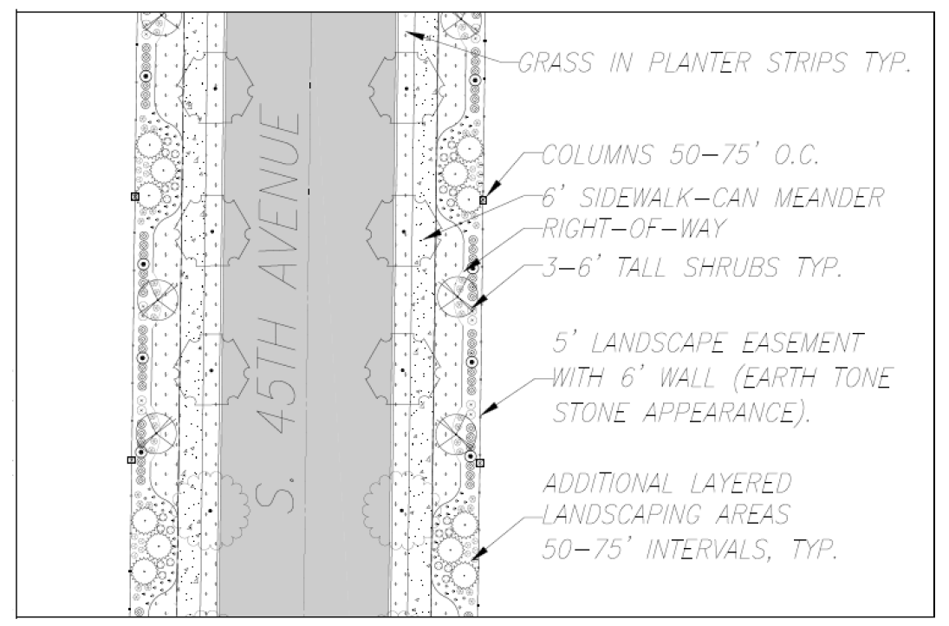

Figure 18.210.060-D.2
Major corridor cross section example.
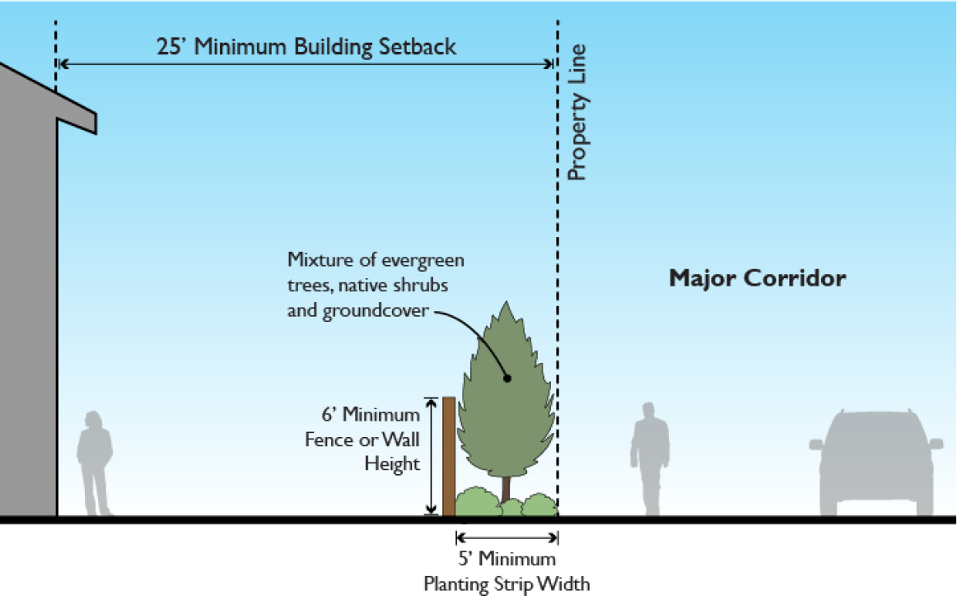
(Ord. No. 1339, § 2(Exh. A), 5-27-2021; Ord. No. 1426, § 2(Exh.), 7-25-2024)
Editor's note(s)—Ord. No. 1339, § 2(Exh. A), adopted May 27, 2021, amended § 18.210.060 in its entirety to read as herein set out. Former § 18.210.060 pertained to neighborhood design standards and derived from Ord. No. 1132, § 2(Exh. A), adopted July 11, 2013; Ord. No. 1232, § 2(Exh. A), adopted April 27, 2017; Ord. No. 1253, § 2(Exh. A), adopted Dec. 7, 2017; and Ord. No. 1325, § 2(Exh. A), adopted Sep. 24, 2020.

18.210.065 Reserved.
Editor's note(s)—Ord. No. 1339, § 2(Exh. A), adopted May 27, 2021, repealed § 18.210.065, which pertained to additional design provisions along major corridors and derived from Ord. No. 1132, § 2(Exh. A), adopted July 11, 2013; Ord. No. 1178, § 2(Exh. A), adopted Feb. 12, 2015; Ord. No. 1207, § 2(Exh. A), adopted May 26, 2016; Ord. No. 1225, § 2(Exh. A), adopted Dec. 1, 2016; Ord. No. 1232, § 2(Exh. A), adopted April 27, 2017; Ord. No. 1234, § 2(Exh. A), adopted June 22, 2017; and Ord. No. 1253, § 2(Exh. A), adopted Dec. 7, 2017.

18.210.070 Signs.
A. The city shall permit signs that comply with the provisions of Chapter 18.710.
(Ord. No. 1132, § 2(Exh. A), 7-11-2013)

18.210.075 Exterior lighting.
A. Lighting shall comply with the requirements of Chapter 18.715.
(Ord. No. 1132, § 2(Exh. A), 7-11-2013)

18.210.080 Vehicles in residential zones.
A. Purpose. Parking lots and outdoor storage of vehicles or recreational vehicles shall not be a primary use of any low density residential lot. Violation of this section is a public nuisance.
B. Applicability. These regulations apply to all residential uses in RLD-4, RLD-6, and RLD-8 zones.
C. Restrictions.
1. Off-street parking is only permitted on approved driveways, parking lots or in garages.
2. Passenger vehicles, light trucks and trucks under two ton gross weight may park in any approved parking area, including the street, or garage, so long as they do not pose an impediment to pedestrian or other vehicular traffic.
3. Motor homes, recreational vehicles and utility trailers shall not be parked on street for a period of two weeks or more during any calendar year.
4. Motor homes, recreational vehicles and utility trailers may be parked in off-street parking areas, including driveways, so long as no more than one is parked between the front lot line and the primary facade of the dwelling.
5. Recreational vehicles are further subject to the provisions of RDC 18.205.020 and 18.205.030.
(Ord. No. 1132, § 2(Exh. A), 7-11-2013; Ord. No. 1426, § 2(Exh.), 7-25-2024)

18.210.090 Off-street parking.
A. Off-street parking shall comply with this chapter and Chapter 18.720.
B. For individual garage or carport units facing a street, at least twenty linear feet of driveway shall be provided between any garage or carport entrance and the property line abutting the street , measured along the centerline of the driveway. This standard shall not be modified through the adjustment or variance process per RDC 18.350 or the PUD process per RDC 18.401.
C. For individual garage or carport units facing an alley, driveways shall not be any linear length between five feet and twenty feet from the garage or carport entrance to the edge of the alley; measured along the centerline of the driveway. The intent of this standard is to prevent parked cars from protruding into alleys. This standard shall not be modified through the adjustment or variance process per RDC 18.350 or the PUD process per RDC 18.401.
(Ord. No. 1132, § 2(Exh. A), 7-11-2013; Ord. No. 1207, § 2(Exh. A), 5-26-2016; Ord. No. 1339, § 2(Exh. A), 5-27-2021)

18.210.100 Landscaping.
A. Landscaping shall meet the requirements of Chapter 18.725.
(Ord. No. 1132, § 2(Exh. A), 7-11-2013)

18.210.110 Fences and walls.
A. In addition to the provisions of Chapter 18.740, the following special provisions shall apply.
1. The maximum height of fences located along a property line is six feet, subject to the sight clearance provisions of Section 2.16 of the city engineering standards. The maximum height of fences and walls located between the front yard building setback line and the front property line is three feet, six inches high.
2. All electric, razor wire, and barbed wire fences are prohibited.
(Ord. No. 1132, § 2(Exh. A), 7-11-2013; Ord. No. 1370, § 2(Exh. A), 9-8-2022)

18.210.120 Accessory structures and dwellings.
A. Accessory structures and dwellings must meet the lot requirements and dimensional standards in RDC 18.210.030 with the following exceptions:
1. Height.
a. Accessory structures other than recreational vehicle garages shall not exceed the lesser of eighteen feet in height or the height of the primary structure.
b. Recreational vehicle garages shall not exceed the lesser of twenty-four feet in height or the height of the primary structure.
2. Setbacks.
a. One uninhabited freestanding structure up to ten feet high and 120 square feet in footprint area, such as a storage shed or greenhouse, may be located within the required rear or side yard setback, provided:
i. The structure shall be located a minimum of three feet from property lines with eaves no greater than twelve inches.
ii. The structure shall retain a five-foot fire separation distance from other structures as specified in adopted building codes.
iii. The structures shall be setback at least five feet farther than the front façade of the house if the structure is located in the side yard. For corner lots, the structure shall be set back a minimum of ten feet farther than the front façade of the house on the street side, or outside of the Sight Obstruction area pursuant to Section 2.16 of the Engineering Standards.
B. Accessory structures greater than one hundred twenty square feet shall be visually compatible with the primary structure.
C. Accessory structures and dwellings are only permitted as accessory uses to a primary use and must be located on the same parcel as the primary use.
D. Accessory dwelling units are regulated by RDC 18.205.020, RDC 18.205.030 and RDC 18.206.030.
(Ord. No. 1132, § 2(Exh. A), 7-11-2013; Ord. No. 1325, § 2(Exh. A), 9-24-2020; Ord. No. 1339, § 2(Exh. A), 5-27-2021; Ord. No. 1370, § 2(Exh. A), 9-8-2022)

18.210.130 Downtown transition area.
A. Purpose. To accommodate potential future expansion of the CMU district, which encompasses the city's traditional commercial and civic core, the downtown transition area allows for limited commercial activity in the residential districts surrounding the CMU district.
B. District Boundaries. The Downtown Transition Area (DTA) shall be bounded by the centerline of Sargent Street extended to 8th Avenue, 8th Avenue south of Pioneer Street, 5th Avenue north of Pioneer Street, Division Street, and Railroad Avenue, exclusive of properties zoned RMD-16, CMU or P/OS. The district shall also include parcels abutting Division Street on the north side of the street between N Railroad Avenue and N 5th Avenue, and parcels abutting Sargent Street on the south side of the street between S 3rd Avenue and S 5th Avenue. The district shall also include all parcels adjacent to the district boundaries. The district boundaries shall be as illustrated in Figure 18.210.130-B.

Figure 18.210.130-B
Downtown transition area boundaries.
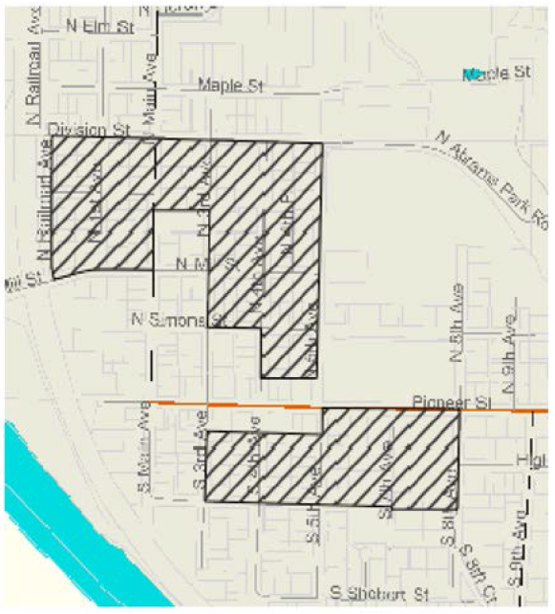
C. Residential Uses. Within the downtown transition area, the following modifications to land use, dimensional, and density standards apply:
1. Single family detached.
i. For the purpose of density calculations, single-family detached dwellings one thousand six hundred square feet or less in gross floor area may count as one-half of one unit provided the lot is at least two thousand five hundred square feet and all applicable setback, open space, and design standards are met.
ii. The density bonus available in this subsection shall not be combined with other density bonuses.
2. Duplexes.
i. Duplexes are allowed on all corner lots regardless of lot size or density requirements.
ii. Duplexes are allowed on all lots at least four thousand seven hundred square feet in area regardless of density requirements.
D. Nonresidential Uses. Within the downtown transition area, limited commercial and office activity may be allowed provided:
1. Use is located on a lot platted ten thousand square feet or less zoned RLD.
2. The building in which the use is located was lawfully established prior to the effective date of this ordinance. Existing buildings may be expanded by no more than twenty percent of the existing total floor area. Non-residential SDCs, impact fees, and building and life safety codes may apply to proposed alterations or expansions.
3. Use meets the definition of general office, general retail trade/services, eating and drinking establishment use types as defined in RDC 18.100.
E. Review. The community development director shall review applications for uses in the downtown transition area not allowed by the underlying zoning as well as proposed expansions and alterations consistent with RDC 18.210.130.C through a minor site plan review as described in RDC 18.500.030.B.
F. Development Standards. The parking, landscaping, lighting, and sign standards for the CMU zone shall apply to proposed nonresidential uses in the DTA.
G. Adjustment of Dimensional Standards for Building Expansions. The city will attempt to allow flexibility in lot coverage and dimensional standards set forth in RDC 18.210.030 so long as the adjustments to the standards are consistent with the character of the downtown transition area as follows:
1. The burden of demonstrating that the proposed relaxation of the base zone dimensional standards is consistent with the character of the DTA lies solely on the applicant and shall be supported by substantial evidence, including, but not limited to, demonstrating consistency with the "14 Essential Guidelines for Downtown Ridgefield."
2. Building setbacks to the street may be reduced if the proposed structure is of the same, or substantially similar, scale, mass, height and composition of materials as fifty percent of like types of buildings within a distance of two blocks of the proposed structure on the same street.
3. The building height must meet the requirements for the underlying residential zone.
4. The request for flexibility may exceed twenty percent of the numeric base zone standard without application of RDC 18.350.030.G.
(Ord. No. 1339, § 2(Exh. A), 5-27-2021)
Editor's note(s)—Ord. No. 1339, § 2(Exh. A), adopted May 27, 2021, amended § 18.210.130 in its entirety to read as herein set out. Former § 18.210.130 pertained to special provisions for the downtown transition area and derived from Ord. No. 1132, § 2(Exh. A), adopted July 11, 2013; and Ord. No. 1178, § 2(Exh. A), adopted Feb. 12, 2015.

18.210.135 Special provisions for the Gee Creek Plateau sub-area (Cluster Development).
A. Purpose. The purpose of the Gee Creek Plateau cluster development is to accommodate urban densities of the underlying zoning district while allowing residential development to utilize less land area. These provisions aim to allow greater flexibility in the design of subdivisions to ensure development is in harmony with the natural characteristics onsite and to preserve features such as critical areas, open space, recreation areas, or scenic vistas.
B. District Boundaries. The Gee Creek Plateau sub-area cluster development area (hatched area in the figure below) is bounded by the S. 5th Way alignment to the north, approximately the S. 32nd Place alignment to the west, Gee Creek to the south, and approximately the alignment of S. 40th Street to the east. Cluster development within the district is required.
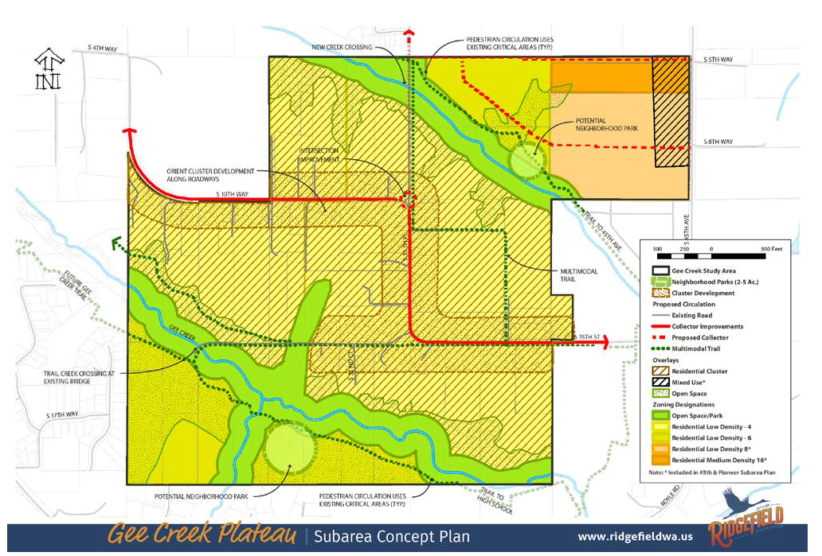
Figure 18.210.135-1
C. Uses. The underlying base zone for all cluster development is Residential Low Density - 4 (RLD-4). Uses are those permitted in the RLD-4 zone.
D. Review. The community development director shall review all development proposed under the Gee Creek Plateau cluster provisions as a planned unit development (RDC 18.401) and Procedures (RDC 18.310).
1. The Gee Creek Plateau cluster development standards shall be required for development within the district boundaries identified by Section 18.210.135.B.
2. The open space requirements in this section shall apply in lieu of the parks and open space requirements in Chapter 18.401.
3. Critical areas density transfer provisions shall not apply within the required cluster district.
4. The PUD process shall not be used to create lots exceeding these limits. The minimum lot size is six thousand square feet. The maximum lot size is fifteen thousand square feet.
E. Development Standards. The clustering provisions of this code are required for any proposed development on parcels one acre or larger in size. Subdivisions of land within the cluster overlay of four lots or less shall follow the procedure outlined in RDC 18.610.
1. Single family home lots shall be no less than six thousand and no more than fifteen thousand square feet with a minimum density of four dwelling units per acre based on net developable acres.
2. The remainder parcel subject to covenant shall be no less than ten percent of the net developable area. For the purposes of this section a "remainder parcel" means the remainder parcel of the cluster subdivision that contains the majority of the land within the development and is devoted to open space uses.
3. The remainder parcel shall be subject to a recorded covenant prohibiting any future development other than proposed trail development as identified in the parks and recreation capital facilities plan, or agricultural buildings. The purpose of the remainder parcel is to provide open space amenities to the development and preserve the unique nature of the Gee Creek Plateau.
a. The remainder parcel shall be contiguous.
1. The remainder parcel is encouraged to abut any critical area.
b. The remainder parcel shall be dedicated to, and maintained by, the required home owners association (HOA).
4. At minimum twenty-five percent of the road frontage of the parent parcel shall remain undeveloped in open space, except split rail fence, road and pedestrian improvements, and associated stormwater facilities.
a. Corner lots may calculate the required twenty-five percent open space frontage by adding the total of both frontages. This requirement shall not be construed to require twenty-five percent of both frontages separately.
F. This section becomes effective upon annexation.
(Ord. No. 1268, § 2(Exh. A), 10-25-2018; Ord. No. 1406, § 2(Exh. A), 7-13-2023)

18.210.140 Special provisions for the Carty Road subarea.
A. Purpose. The purpose of the Carty Road subarea is to respect the rural and agricultural heritage of the area by protecting existing land uses and preserving open spaces.
B. District Boundaries. The Carty Road subarea (outlined in red in the figure below) consists of approximately two hundred sixty-six acres in southern Ridgefield. The subarea is located east of the intersection of NW Hillhurst Road and South Royle Road and west of the Interstate 5 corridor. Northwest Carty Road functions as the southern boundary for a portion of the subarea. The subarea is located outside of the Ridgefield city limits within the city's urban growth area (UGA) in unincorporated Clark County. See figure 18.210.140-1.
Figure 18.210.140-1—Carty Road Subarea Preferred Concept Plan
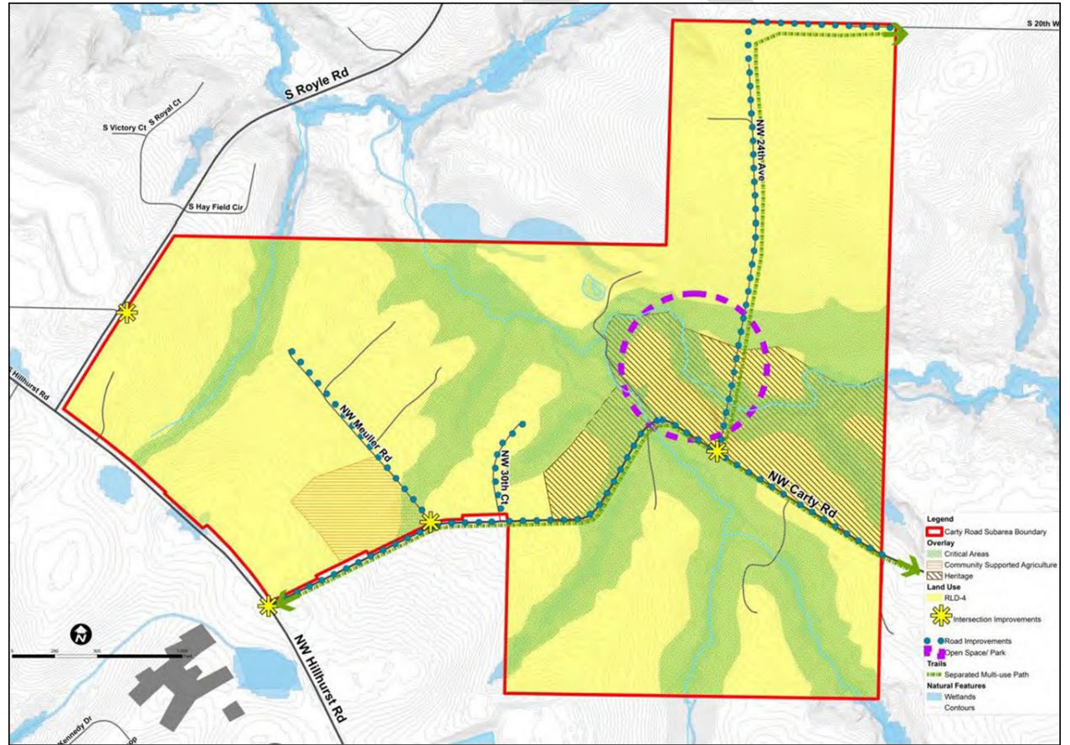
C. Guiding Principles. Development within the Carty Road subarea shall conform to the applicable Carty Road guiding principles:
1. Respect the rural and agricultural heritage of the areas by protecting existing land uses and conserving open space.
2. Create quality design through design standards and landscaping requirements.
3. Respect existing development patterns in the Carty Road area.
4. Protect natural areas and buffers along the Gee Creek corridor, including tributaries to Gee Creek.
5. Provide transportation options that promote the safety of all users (motorists, cyclists, and pedestrians) and improve emergency vehicle access and evacuation options.
6. Provide a range of development options for landowners that allow flexibility to retain existing uses and meet development regulations and state land use laws.
D. Zoning and Uses. The underlying base zone for development is Residential Low Density - 4 (RLD-4). See Figure 18.210.140-2 Carty Road Future Zoning Map.
Figure 18.210.140-2—Carty Road Subarea Zoning Implementation Map
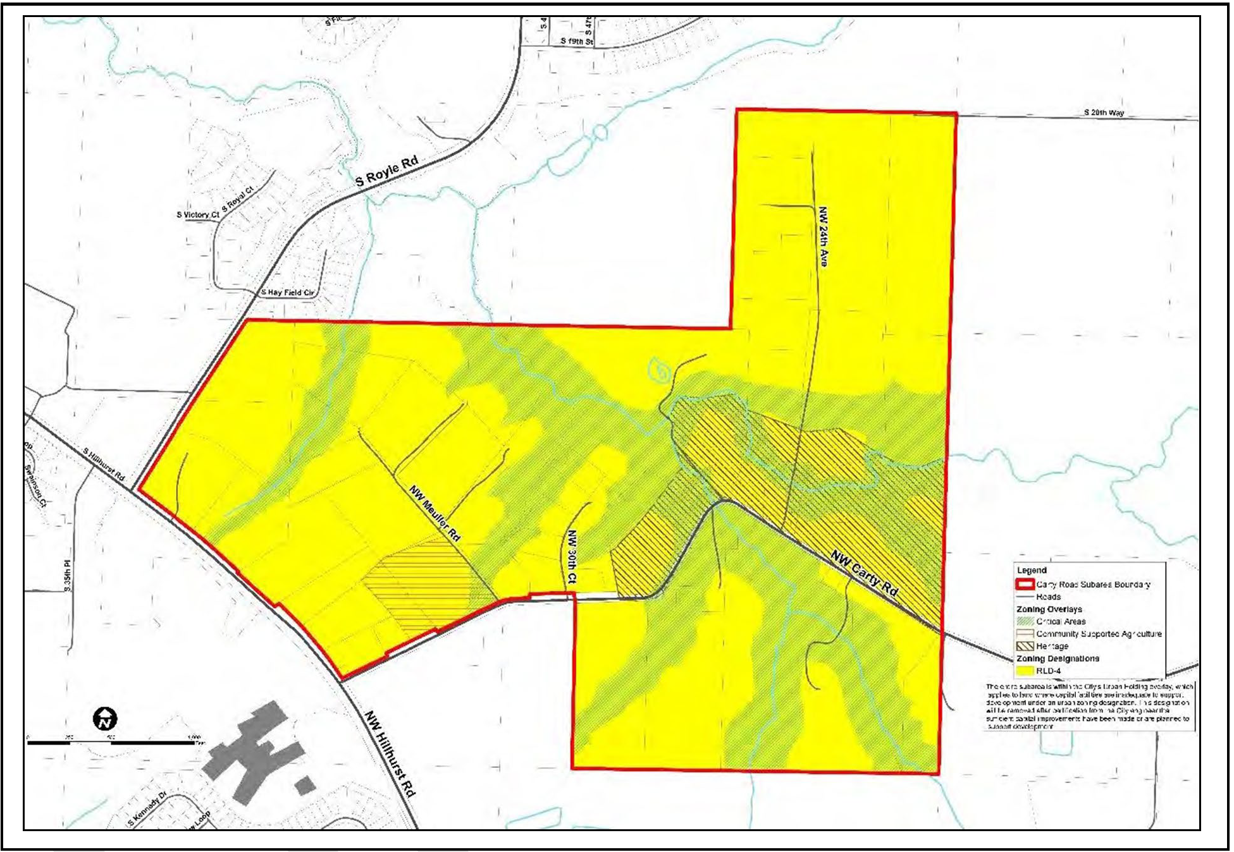
1. Uses. Permitted (P), Limited (P-L) and conditional (C) uses in the Carty Road Subarea are listed in Table 18.210.140-1. Unlisted primary uses are prohibited.
Table 18.210.140-1—Carty Road Subarea Uses
Specific Land Use | RLD-4 | RLD-4 with  CSA Overlay | RLD-4 with  Heritage Overlay
Residential Uses (1)
Existing Residential Uses | P | P | P
Single-Family Detached Residential | P | P | P
Accessory Dwelling Unit | P | P | P
Nonresidential Uses
Existing Nonresidential Uses | P | P | P
Cultural Institution | X | X | P
Religious Institution | X | X | P
Community Center | X | X | C
Park or Trail | P | P | P
Accessory Uses (3)
Food Distribution Membership | X | P | X
Farmers Market | X | P | X
Market Garden | X | P | X
Community Garden | X | P | P

Table Notes.
(1) Residential uses shall comply with the architectural design, garage/driveway, usable outdoor space, and tree standards in RDC 18.206, residential use standards. Residential uses shall comply with the development, density, and environmental protection requirements in Section 18.210.140.
(2) Accessory uses are only allowed on the same lot as a lawfully permitted primary use.
2. Subdivision. Residential development in the Carty Road subarea shall comply with the applicable general subdivision standards in RDC 18.600 through 18.640. Planned unit developments (PUDs), as described in RDC 18.401, do not apply in the Carty Road subarea. The special subdivision standards are instead as follows.
a. The minimum area of a new residential lot may not be less than nine thousand eight hundred square feet.
b. The maximum area of a new residential lot may not exceed sixteen thousand three hundred fifty-five square feet except under the one-time two-lot short plat exemption described in RDC 18.210.030.B.1.
c. The density of the subdivision shall be four units per net developable acre. Rounding is permitted.
d. The subdivision shall incorporate a twenty-foot wide perimeter compatibility landscape buffer.
i. The perimeter compatibility buffer is required between the subdivision and adjacent residential properties except where the adjacent property has been subdivided, is subject to an application for subdivision, or where the owner of the adjacent property certifies their intent to subdivide.
ii. The perimeter compatibility buffer shall be located in a separate tract or tracts which shall be owned and maintained by the HOA.
iii. One hundred percent of the plant material within the twenty-foot buffer shall be native plants. (See RDC 18.830.) The buffer shall be vegetated with the equivalent of dense evergreen shrubbery or evergreen understory trees at eight-foot on center, and trees at twenty-five feet on center. Existing native vegetation shall be retained to the extent practicable to meet this requirement.
iv. The twenty-foot wide perimeter compatibility landscape shall comply with the requirements for landscape plans, installation, and monitoring in RDC 18.725.
v. Trails are permitted in the perimeter compatibility buffer.
vi. Only a type B1 earthen berm or S1 site-obscuring fence may be permitted in the perimeter compatibility buffer.
vii. Walls, berms, or fences may not be used as a means to reduce the twenty-foot perimeter compatibility standards.
e. Any application for a subdivision shall include a master plan which complies with the standards in subsections 18.210.140.D.2.a through f and:
i. Identifies prominent view sheds from public rights-of-way and shall plat lots to maximize the identified view sheds.
ii. Identifies existing conditions, including but not limited to, native soil, existing tree cover, and topography, and shall preserve such existing conditions to the greatest extent practicable, as determined by the community development director.
iii. Provides a multi-modal trail network that connects to a public right-of-way which provides transportation and recreational opportunities throughout the Carty Road subarea and allows future connection to the larger Ridgefield and regional trail system.
3. Dimensional Standards. In addition to the standards enumerated in (2), the standards in Table 18.210.040-2 apply to individual lots in the Carty Road subarea.
Table 18.210.040-2—Carty Road Subarea Dimensional Standards
Standard (1)(2) | Carty Road Subarea
Minimum Lot Width | 65 feet
Minimum Front Yard Setback | 20 feet
Minimum Front Yard Setback - Heritage Overlay | 30 feet
Minimum Rear Yard Setback | 30 feet
Minimum Side Yard Setback | 12 feet
Minimum Setback Along NW Carty Road (3) | 25 feet
Maximum Height | 30 feet (35 feet with pitched roof)
Maximum Impervious Surface Coverage | 60%

Table Notes.
(1) Setbacks are measured from the property line of the subject lot.
(2) Setbacks may not be reduced to less than those provided for the RLD-4 zone in RDC 18.210.030.
(3) The twenty-five-foot setback along NW Carty Road may not be reduced.
4. Design Provisions Along Carty Road. A separate landscape tract(s) to be owned and maintained by the HOA shall be located between the back of the sidewalk and the property line.
a. The landscape tract shall be an average of fifteen feet wide. The width may vary to accommodate a meandering sidewalk.
b. The landscape tract shall be vegetated with a diverse mixture of native evergreen trees, native shrubs, and native groundcover. Existing native vegetation shall be retained to the extent practicable to meet this requirement. Proposed vegetation shall be detailed in a landscape plan consistent with the requirements of RDC 18.725.070.
5. Special Provisions for Carty Road Community Supported Agriculture (CR-CSA) Overlay.
a. Purpose. To encourage the creation of limited commercial uses or event facilities in tandem with residential uses that support the selling or promotion of local agricultural or ancillary products.
b. Special Provisions for Community Gardens.
i. Outdoor display related to the function of the community garden is allowed.
ii. A community garden may install one monument sign up to a maximum of ten square feet, subject to obtaining a city sign permit,
c. Special Provisions for Farmer's Markets.
i. Parking is required consistent with RDC 18.720, parking and loading, at a rate of one parking space for every two hundred fifty square feet of booths or stalls.
ii. Outdoor display related to the function of the farmer's market is allowed.
iii. A farmer's market may install one monument sign up to a maximum of thirty-two square feet, subject to obtaining a city sign permit,
iv. Sales are allowed only between seven a.m. and seven p.m.
v. Sales are allowed up to one hundred eighty days in each calendar year. A farmer's market must obtain a special event permit which shall be limited to a maximum of one hundred eighty days within a three hundred sixty-five-day period
vi. The operator of a farmer's market shall obtain a city business license and is responsible for compliance with applicable regulations.
d. Special Provisions for Food Distribution Membership.
i. Members may pick up items at the site only between seven a.m. and seven p.m.
ii. Deliveries are allowed between eight a.m. and five p.m.
iii. Exterior activities, except delivery and pick up, may not occur in the area between the primary building and any street lot line.
iv. The operator of a site shall obtain a city business license and is responsible for compliance with applicable regulations.
e. Special Provisions for Commercial Market Gardens.
i. Outdoor display related to the function of the market garden is allowed.
ii. A market garden may install one monument sign up to a maximum of ten square feet, subject to obtaining a city sign permit.
iii. Only food and value-added products made from materials grown and raised on-site may be sold.
iv. Sales are allowed only between seven a.m. and seven p.m.
v. The operator of a site shall obtain a city business license and is responsible for compliance with applicable regulations.
6. Special Provisions for the Carty Road Heritage (CR-H) Overlay.
a. The purpose of the CR-H overlay is to encourage the preservation and continued use of historic properties and structures listed on county, state, and national registers.
b. New development within the CR-H overlay shall provide a minimum thirty-foot wide front yard, perimeter compatibility landscape buffer between existing and new uses along the length of the front yard.
i. The thirty-foot wide buffer shall be planted with dense shrubbery, ground cover and trees planted at a minimum of twenty feet on center, similar to an L5 standard.
ii. The thirty-foot buffer may not be altered.
c. New cultural, religious, and community institutions are subject to the provisions of RDC 18.500, site plan review, including architectural design review.
d. Community gardens are subject to the provisions in RDC 18.210.140.D.4.b.
7. Carty Road Critical Areas (CR-CA).
a. The provisions of RDC 18.280, critical areas protection, apply; provided that:
i. Impacts to critical areas and buffers are prohibited with the following exceptions:
(A) Public right-of-way may impact critical areas when the applicant demonstrates that avoidance is not a reasonable option. Mitigation ensuring no net loss of function per RDC 18.280 is required.
(B) Approved essential public infrastructure including utilities, stormwater facilities, parks, and trails may be located in the outer twenty-five percent of a buffer. Mitigation ensuring no net loss of function per RDC 18.280 is required.
ii. Critical area buffer reduction is prohibited.
iii. Critical area buffer averaging in accordance with RDC 18.280 is permitted as part of a master plan demonstrating compliance with the Carty Road subarea plan.
E. Engineering. Development in the Carty Road subarea shall be subject to the requirements of the Ridgefield Engineering Standards for Public Works Construction including Transportation Details T-2.19 (Carty Road Subarea Collector Section) and T-2.20 (Carty Road subarea residential local A Section).
F. Applicability. Section 18.210.140 becomes effective upon annexation.
(Ord. No. 1440, § 2(Exh. A), 2-27-2025)
Editor's note(s)—Ord. No. 1339, § 2(Exh. A), adopted May 27, 2021, repealed § 18.210.140, which pertained to special provisions for townhouse developments and derived from Ord. No. 1132, § 2(Exh. A), adopted July 11, 2013. Subsequently, Ord. No. 1440, § 2(Exh. A), adopted February 27, 2025, enacted a new § 18.210.140 as set out herein.

18.210.150 Reserved.
Editor's note(s)—Ord. No. 1339, § 2(Exh. A), adopted May 27, 2021, repealed § 18.210.150, which pertained to special provisions for cottage, carriage and two/three unit homes and derived from Ord. No. 1132, § 2(Exh. A), adopted July 11, 2013; and Ord. No. 1207, § 2(Exh. A), adopted May 26, 2016.

Chapter 18.280 CRITICAL AREAS PROTECTION

18.280.010 Purposes.
A. This chapter complies with the Washington State Growth Management Act (GMA) specified in RCW 36.70.A pertaining to the designation, classification and protection of ecologically sensitive and hazardous areas more specifically referred to as critical areas within the existing and future municipal limits of the city of Ridgefield. For the purposes of this chapter critical areas are identified as wetlands, fish and wildlife habitat conservation areas, geologically hazardous areas, critical aquifer recharge areas and frequently flooded areas.
B. This chapter implements applicable goals and policies of the Ridgefield Comprehensive Plan by promoting the reasonable economic use of property while protecting the functions and values of critical areas within the city.
C. The city of Ridgefield finds that critical areas provide a variety of valuable and beneficial biological and physical functions that benefit the city and its residents. The beneficial functions and values provided by critical areas include but are not limited to water quality protection and enhancement, fish and wildlife habitat, food chain support, food storage, conveyance and attenuation of flood waters, groundwater recharge and discharge, erosion control, protection from hazards, historical, archaeological and aesthetic value protection and recreation. These beneficial functions are not listed in order of priority.
(Ord. No. 1132, § 2(Exh. A), 7-11-2013)

18.280.020 General provisions.
A. No Net Loss of Functions. Land development and uses within the city shall result in no net loss of functions and values in the critical areas. Since values are difficult to measure no net loss of functions and values means no net loss of functions. The beneficial functions provided by critical areas include, but are not limited, to water quality protection and enhancement, fish and wildlife habitat, food chain support, flood storage; conveyance and attenuation of flood waters; ground water recharge and discharge; erosion control; and wave attenuation. These beneficial functions are not listed in order of priority. This chapter is also intended to protect residents from hazards and minimize risk of injury or property damage.
B. Relationship to Other Regulations. These critical areas regulations shall apply in addition to zoning and other regulations adopted by the city. When there is a conflict between any provisions of this chapter or any other regulations, that which provides the most protection to the subject critical area shall apply. Conditions of approval of a project affecting critical areas may be supplemented by a review under the State Environmental Policy Act (SEPA), as locally adopted. Compliance with the provisions of this chapter does not constitute compliance with other federal, state, and local regulations and permit requirements (for example, Shoreline Substantial Development Permits, Hydraulic Project Approval (HPA) permits, Section 106 of the National Historic Preservation Act, U.S. Army Corps of Engineers Section 404 permits, or National Pollution Discharge Elimination System permits). The applicant is responsible for complying with other state and federal requirements in addition to the requirements of this chapter. Obtaining all applicable state and federal permits shall be made a condition of a critical areas permit and such permits shall be obtained prior to issuance of permits for construction or site disturbance.
C. Implementation of Best Available Science. The regulations of this chapter are intended to protect critical areas in accordance with the Growth Management Act (GMA) through the application of best available science as determined according to WAC 365-195-900 through 365-195-925, and in consultation with state and federal agencies and other qualified professionals.
D. Regulatory Flexibility. This chapter is to be administered with flexibility and attention to site-specific characteristics. This chapter is not intended to make a property in the city unusable by denying its owner reasonable economic use of the property or to prevent the provision of public facilities and services necessary to support existing or planned development. When property that is identified as being within a critical area or the proposed buffers has been used by the property owner for domestic uses such as lawns, buildings and similar uses other than being left in its natural state that land shall not be considered as critical as intended by this code. These areas shall also be exempt from the critical area permitting process.
E. General Public Interest Served. The city's enactment and enforcement of this chapter shall not be construed for the benefit of any individual person or group of persons other than the general public.
F. Warning and Disclaimer of Liability. The standards established herein are minimum standards. The standards are established for regulatory purposes only. Minimum compliance with these standards may not be sufficient protection from identified or unidentified hazards. city-establishment of these minimum standards is not a representation that these standards are sufficient protection from any hazard. Critical areas development should be based on sound scientific and engineering considerations that may be more stringent than this chapter. The city assumes no liability if these established standards prove to be insufficient protection.
(Ord. No. 1132, § 2(Exh. A), 7-11-2013)

18.280.030 Applicability and exemptions.
A. Applicability.
1. All areas within the city meeting the definition of one or more critical areas, whether mapped or not, are hereby designated critical areas and with their buffers are subject to the provisions of this chapter.
2. Unless exempted the provisions of this chapter shall apply to all lands, all land uses, clearing and development activity, and all structures and facilities in the city located within a critical area or buffer or on a site containing a critical area or buffer.
3. The provisions of this chapter shall apply whether or not a permit or authorization is required.
4. Any individual critical area that overlaps another type of critical area shall meet the requirements that provide the most protection to the critical areas involved.
5. No person, company, agency, or applicant shall alter a critical area or buffer (including removal of downed woody vegetation from or application of chemicals harmful to fish and wildlife within twenty-five feet of wetlands, ponds, lakes, streams or rivers) except as consistent with the requirements of this chapter.
6. The critical areas permit required pursuant to this chapter shall be obtained prior to undertaking any activity regulated by this chapter, unless exempted.
B. Exemptions. The following activities shall be considered exempt from the permit provisions of this chapter:
1. Development or clearing, not within a floodway or floodplain and other than tree removal, as minimally necessary to remodel an existing structure, provided:
a. The activity will increase the footprint of structures including impervious surfaces by less than five hundred square feet from the footprint size at the time of the adoption of this chapter; and
b. If the structure or impervious surface is within a critical area or buffer, the distance from the nearest structure or impervious surface to lakes, streams, rivers, wetlands or geological hazards is not decreased; and
c. All vegetation disturbed as a result of the development shall be replaced one-to-one. Native vegetation shall be used where feasible.
d. Impacts to critical areas and buffers shall be minimized and mitigated.
2. Development activity on the portions of sites with existing structures or impervious surfaces which does not increase the impervious surface area within the riparian management area or riparian buffer shall be exempt from the provisions of RDC 18.280.110 (Fish and Wildlife Habitat Conservation Areas). The applicant is encouraged to provide enhancement to the extent feasible. Such enhancement activities may include, but are not limited to, landscaping using native plants, additional treatment of stormwater as appropriate, and implementation of best management [practices].
3. Mitigation for those impacts consistent with the requirements of this chapter.
4. Emergencies. Those activities necessary to prevent an immediate threat to public health, safety, or welfare, or that pose an immediate risk of property damage and that require remedial or preventative action in a timeframe too short to allow for compliance with the requirements of this chapter, so long as all of the following apply:
a. The emergency action uses reasonable methods to address the emergency.
b. The emergency action must have the minimum possible impact to the critical area or its buffer.
c. The property owner, person or agency undertaking such action shall notify the city within one working day following commencement of the emergency activity.
d. Within fourteen days the community development director or designee shall determine if the action taken was within the scope of the emergency actions allowed in this section. If the community development director or designee determines that the action taken, or any part of the action taken was beyond the scope of an allowed emergency action, then enforcement provisions of RDC 18.280.090 shall apply.
e. After the emergency, the property owner, person or agency undertaking the action shall fully fund and conduct necessary restoration and/or mitigation for any impacts to the critical area and buffers resulting from the emergency action in accordance with an approved critical areas report and mitigation plan. The property owner, person or agency undertaking the action shall apply for review. The alteration, critical areas report, and mitigation plan shall be reviewed by the city in accordance with the review procedures contained in this chapter.
f. Restoration and/or mitigation activities must be initiated and completed within the timeframe determined by the community development director or designee.
5. Landscape maintenance (other than tree removal or use of pesticides, herbicides, fungicides or fertilizers applied into or within twenty-five feet of water bodies) consistent with accepted horticultural practices, such as those recommended by the Washington State University Extension Service, within the boundaries of an existing lawn, garden or landscaped area and not associated with development.
6. Clearing of noxious weeds using hand-held, electric or non-motorized equipment. A copy of the Clark County Weed Management Department list of noxious weeds is available from the community development director or designee.
7. Use of pesticides, herbicides, fungicides or fertilizers intended to control noxious weeds or invasive species applied further than twenty-five feet from any wetland, pond, lake, stream or river or in a manner specified in a valid permit.
8. State or federally approved conservation or preservation of soil, water, vegetation, fish, shellfish, and other wildlife that does not entail changing the structure or functions of the existing critical area or buffer.
9. The harvesting of wild crops in a manner that is not injurious to natural reproduction of such crops or other native vegetation and provided the harvesting does not require tilling of soil, planting of crops, chemical applications, or alteration of the critical area or buffer by changing existing topography, water conditions or water sources.
10. Passive outdoor activities such as recreation, education, and scientific research activities that do not degrade the critical area or buffer, including fishing, hiking and bird watching.
11. Work necessary for land use submittals, such as surveys, soil sampling, percolation tests, and other related activities. In every case, impacts to the critical area or buffer shall be minimized and disturbed areas shall be stabilized immediately.
12. Construction or modification of navigational aids and boundary markers. Impacts to the critical area or buffer shall be minimized and disturbed areas shall be restored within seventy-two hours.
13. Existing and ongoing agricultural activities protected under the federal Food Security Act occurring in wetland areas provided that these activities use appropriate best management practices for agriculture.
14. Existing and ongoing agriculture within fish and wildlife habitat conservation areas so long as livestock and application of pesticides, herbicides, fungicides and fertilizers are kept twenty-five feet from any state classified stream body.
15. Implementation of a city, state or federally approved stand-alone restoration or enhancement project.
16. Operation, repair and maintenance of existing structures, infrastructure, roads, sidewalks, railroads, trails, dikes, or levees or water, sewer, stormwater, electric, gas, telephone, cable, or fiber optic cable facilities if the activity does not further increase the impact to, or encroach further within, the critical area or buffer and there is no increased risk to life or property as a result of the proposed operation, repair, or maintenance.
17. In ground shaking or liquefaction areas, repair or construction of roads, sidewalks or trails (except where there are structures), or water, sewer, stormwater, gas, electric, cable, or fiber optic cable facilities shall be exempt from the ground shaking and liquefaction permitting requirements.
18. Public improvement projects located within existing impervious surface areas.
19. Implementation of a city, state or federally approved stand-alone "critical area" creation project that is not mitigation. A "critical area" created under these circumstances that would not otherwise have met the definition of that type of critical area is exempt from the provisions of this chapter.
20. Emergency or hazard tree removal that presents an immediate threat to personal or real property conducted in a manner approved by the city to minimize critical areas impacts.
21. Development activities in artificial wetlands intentionally created from non-wetland sites, including, but not limited to irrigation and drainage ditches, grass-lined swales, canals, detention facilities, wastewater treatment facilities, farm ponds, and landscape amenities, or those wetlands that were unintentionally created as a result of the construction of a road, street or highway.
22. In general, wetlands that are five thousand square feet or less in size may be exempt from the permit provisions of this chapter subject to compliance with the following:
a. Wetlands less than two thousand five hundred square feet in size may be exempted where it has been shown by a qualified professional that they are not associated with a riparian corridor, are a functionally isolated wetland, and do not contain habitat identified as essential for local populations of priority species identified by Washington Department of Fish and Wildlife.
b. Wetlands between two thousand five hundred square feet and five thousand square feet in size may be exempted when compliance to the following is fully demonstrated by a qualified professional:
i. The requirement to avoid impacts may be dropped for Category III and IV wetlands between two thousand five hundred square feet and five thousand square feet that meet all of the following criteria:
a. Wetland is not associated with a riparian corridor; and
b. Wetland is a functionally isolated wetland; and
c. Wetland does not score five points or greater for habitat in the 2014 Western Washington Wetland Rating System; and
d. Wetland does not contain habitat identified as essential for local populations of priority species identified by Washington Department of Fish and Wildlife.
ii. Impacts allowed under this provision to these wetlands will be fully mitigated as required by this chapter.
iii. All Category I and II wetlands between two thousand five hundred square feet and five thousand square feet shall be evaluated with full mitigation sequencing and buffer establishment. Any approved impacts should be adequately compensated by mitigation.
c. Wetlands larger than five thousand shall be evaluated using standard procedures for wetland review identified in Section 18.280.150 of this chapter.
(Ord. No. 1132, § 2(Exh. A), 7-11-2013; Ord. No. 1207, § 2(Exh. A), 5-26-2016)

18.280.040 Approval process.
A. Initial Critical Areas Determination Process.
1. The community development director or designee shall review submitted information, conduct a site inspection, review other information available pertaining to the site and the proposal, and make a determination as to whether a critical areas permit is required.
2. Decision Indicators. The community development director or designee shall use the following indicators whenever available, to assist in determining the need for a critical areas permit:
a. Indication by the city's critical area location information of a critical area or buffer that may be impacted by the proposed activity.
b. Information and scientific opinions from appropriate agencies, including but not limited to the Washington Departments of Fish and Wildlife, Natural Resources, and Ecology.
c. Documentation, from a scientific or other reasonable source, of the possible presence of a critical area or buffer.
3. Interpretation of Critical Area Boundaries. The community development director or designee shall be authorized to interpret the exact location of the critical area boundary. Final designations shall be based on site conditions and other available data or information. A person who disagrees with the interpretation may appeal the interpretation pursuant to the city's currently adopted appeal procedures for administrative decision-making.
4. Critical Areas Permit Not Required. If the community development director or designee's analysis indicates that there is no critical area or buffer on the subject property, then the community development director or designee shall determine that the initial critical area review is complete and that no further review is required.
5. Critical Areas Permit Required. If the community development director or designee determines that a critical area or its buffer may be located on the subject property, the community development director or designee shall determine that a critical areas permit is required, and shall indicate each of the critical area types to be addressed in the critical areas report.
6. Reconsideration of Initial Critical Area Determination. The community development director or designee's determination may be reconsidered if new information is received. If the applicant wants greater assurance of the accuracy of the critical area review determination, the applicant may choose to hire a qualified professional to provide such assurances.
B. Critical Areas Permit.
1. Type I Application. The following activities shall be processed as a Type I permit:
a. New single-family and duplex residences, alterations to existing single-family and duplex residences, or new accessory structures located within a critical area or buffer, or on a property containing a critical area or buffer.
b. Application of pesticides, herbicides, fungicides or fertilizers within twenty-five feet of ponds, lakes, streams, rivers or wetlands.
c. Approval of agricultural activities within twenty-five feet of ponds, lakes, streams or rivers.
d. Critical area enhancement projects, unless otherwise exempted.
e. Public improvement projects located entirely within existing right-of-way, not otherwise exempted.
f. Clearing vegetation within a critical area or buffer, including grading, uprooting or other activities that impair the soil stabilization function of vegetation in landslide hazard areas and including the removal of downed woody vegetation from wetlands, lakes, streams or rivers. Provided, vegetation removal within the floodplain outside of the riparian setback and in seismic hazard areas shall not require a permit.
g. Approval of management plans for activities within critical areas and buffers.
2. Other Application Types. All other activities proposed within any critical area or buffer shall be reviewed according to the procedures of the underlying land use application.
C. Review Procedure. The community development director or designee shall make a determination as to whether a proposed activity is exempt or is subject to compliance with this chapter. The community development director or designee's determination shall be based on the approval criteria of this chapter. The critical areas permit shall be valid for as long as the underlying land use permit or as otherwise specified by the community development director or designee.
D. Critical Area Inspections. Reasonable access to the site shall be provided to the city, state, and federal agency review staff for the purpose of inspections during any proposal review, restoration, emergency action, or monitoring period.
E. Reconsideration of Permit Determination. If, within five calendar days following the date of mailing of a critical areas permit, new information relevant to the decision is made available, any party may request that the decision be reconsidered. If the new information is found to be substantial and relevant to the critical area review, the community development director or designee may reopen the critical area review and make a new determination based on the revised report. The critical areas permit shall not be considered final and subject to appeal until the decision on the request for reconsideration, if applied for, has been issued.
F. Critical Area Markers and Signs.
1. The boundary of the outer edge of critical areas tracts and easements shall be delineated with permanent survey stakes using iron or concrete markers as established by local survey standards.
2. The boundary at the outer edge of the critical area or buffers shall be identified with temporary signs prior to any site alteration. Such temporary signs shall be replaced with permanent signs or fencing as determined by the community development director or designee prior to occupancy or use of the site.
3. The community development director may modify these requirements as necessary to ensure protection of sensitive features or wildlife needs.
G. Notice on Title.
1. In order to inform subsequent purchasers of real property of the existence of critical areas, the owner of any property containing a critical area or buffer on which a development proposal is approved shall file a notice with the county auditor's office according to the direction of the city. The notice shall state the presence of the critical area or buffer on the property, the application of this chapter to the property, and the fact that limitations on actions in or affecting the critical area or buffer may exist. The notice shall "run with the land."
2. The applicant shall submit proof that the notice has been filed for public record before the city approves any site development or construction for the property or, in the case of subdivisions, short subdivisions, planned unit developments, and binding site plans, at or before recording.
H. Critical Areas Tracts or Conservation Easement. Critical areas tracts or conservation easements shall be used in subdivisions, planned unit developments, site plans and binding site plans to delineate protected critical areas comprising identified landslide hazard areas and buffers, identified wetlands and buffers and identified habitat conservation areas and buffers.
I. Building Setbacks. Unless otherwise authorized through the project approval process, buildings and other structures shall be set back a minimum of five feet from the edges of all critical areas buffers. Uses allowed in this minimum setback area include landscaping, uncovered decks, building overhangs that extend no more than twenty-four inches into the setback area and impervious ground surfaces such as driveways and patios provided that these surfaces comply with the city's stormwater regulations as applicable.
J. Financial Assurances.
1. When mitigation required pursuant to a development proposal is not completed prior to the city final permit approval, such as final plat approval, final building inspection or final occupancy issuance, the city shall require the applicant to provide security in a form and amount deemed acceptable by the city. If the development proposal is subject to mitigation, the applicant shall provide security in a form and amount deemed acceptable by the city to ensure mitigation is fully functional subject to the following:
a. The security shall be in the amount of one hundred ten percent of the estimated cost of restoring the functions of the critical area that are at risk.
b. The security authorized by this section shall remain in effect until the city determines, in writing, that the standards bonded for have been met. Bonds or other security shall be held by the city for a minimum of five years to ensure that the required mitigation has been fully implemented and demonstrated to function, and may be held for longer periods when necessary.
c. Depletion, failure, or collection of bond funds shall not discharge the obligation of an applicant or violator to complete required mitigation, maintenance, monitoring, or restoration.
d. Public development proposals shall be relieved from having to comply with the bonding requirements of this section if public funds have previously been committed in the project budget or capital improvement budget for mitigation, maintenance, monitoring, or restoration.
e. Failure to satisfy any critical area requirements established by law or condition including, but not limited to, the failure to provide a monitoring report within thirty calendar days after it is due or comply with other provisions of an approved mitigation plan shall constitute a default, and the city may demand payment of any financial guarantees or require other action authorized by the city code or any other law.
f. Any funds recovered pursuant to this section shall be used to complete the required mitigation. Excess funds shall be returned to the applicant.
(Ord. No. 1132, § 2(Exh. A), 7-11-2013; Ord. No. 1325, § 2(Exh. A), 9-24-2020)

18.280.050 Submittal requirements.
A. Preparation by Qualified Professional. Any required critical areas report shall be prepared by a qualified professional as defined herein.
B. General Critical Areas Report Contents. At a minimum, the critical areas report shall have been prepared within five years prior to submittal and contain the following:
1. The name and contact information of the applicant, a description of the proposal, and identification of the permit requested.
2. A copy of the site plan for the development proposal including:
a. A map to scale depicting critical areas, buffers, the development proposal, and any areas to be cleared; and
b. Proposed stormwater management and sediment control plan for the development including a description of any impacts to drainage alterations.
3. The dates, names, and qualifications of the persons preparing the report and documentation of any fieldwork performed on the site.
4. Identification and scientific characterization of all critical areas and buffers.
5. An assessment of the probable impacts to critical areas and buffers and risk of injury or property damage including permanent, temporary, temporal, and indirect impacts resulting from development of the site and the operations of the proposed development.
6. A written response outlining how a project will avoid and minimize probable impacts to critical areas and buffers and a rationale when impacts cannot be avoided and minimized.
7. A written response to each of the approval criteria in RDC 18.280.060.
8. Plans for adequate mitigation, as needed, to offset any impacts, in accordance with RDC 18.280.050.E (Mitigation Plan Requirements).
9. A copy of the SEPA checklist, if required by RDC 18.810.
C. Other Reports or Studies. Unless otherwise provided, a critical areas report may be supplemented by or composed, in whole or in part, of any reports or studies required by other laws and regulations or previously prepared for and applicable to the development proposal site, as approved by the community development director or designee. Provided, the site conditions shall not have changed since the earlier report or study was completed.
D. Critical Areas Report—Modifications to Requirements. The applicant may consult with the community development director or designee prior to or during preparation of the critical areas report to obtain city approval of modifications to the required contents of the report where, in the judgment of a qualified professional, more or less information is required to adequately address the potential impacts to any critical areas or buffers and the required mitigation. The community development director or designee may also initiate a modification to the required report contents by requiring either additional or less information, when determined to be necessary to the review of the proposed activity in accordance with this chapter.
E. Mitigation Plan Requirements. When mitigation is required, the applicant shall submit a mitigation plan as part of the critical areas report. The mitigation plan shall include:
1. Detailed Construction Plans. The mitigation plan shall include descriptions of the mitigation proposed, such as:
a. The proposed construction sequence, timing, and duration.
b. Grading and excavation details.
c. Erosion and sediment control features.
d. A planting plan specifying plant species, quantities, locations, size, spacing, and density.
e. Measures to protect and maintain plants until established.
f. These written descriptions shall be accompanied by detailed site diagrams, scaled cross-sectional drawings, topographic maps showing slope percentage and final grade elevations, and any other drawings appropriate to show construction techniques or anticipated final outcome.
2. Monitoring Program. The mitigation plan shall include a program for monitoring construction of the mitigation project and for assessing a completed project. A protocol shall be included outlining the schedule for site monitoring, and how the monitoring data will be evaluated to determine if the performance standards are being met. A monitoring report shall be submitted as needed to document milestones, successes, problems, and contingency actions of the mitigation project. The mitigation project shall be monitored for a period necessary to establish that performance standards have been met, but not for a period less than five years. For example, ten years or more of monitoring are typically needed for forested wetlands or scrub-shrub communities. The city shall notify the responsible party in writing once the conditions of the monitoring plan are met.
3. Adaptive Management. The mitigation plan shall include identification of potential courses of action, and any corrective measures to be taken if monitoring or evaluation indicates project performance standards are not being met.
F. One original copy of all application materials is required. Electronic copies of all materials that include graphic and text files are required.
G. Tree Preservation and Protection Plan. The applicant shall submit a tree preservation and protection plan consistent with the requirements in RDC 18.840.
(Ord. No. 1132, § 2(Exh. A), 7-11-2013; Ord. No. 1253, § 2(Exh. A), 12-7-2017; Ord. No. 1372, § 2(Exh. C), 10-13-2022; Ord. No. 1406, § 2(Exh. A), 7-13-2023; Ord. No. 1426, § 2(Exh.), 7-25-2024)

18.280.060 Approval criteria.
Any activity subject to this chapter, unless otherwise provided for in this chapter, shall be reviewed and approved, approved with conditions, or denied based on the proposal's ability to comply with all of the following criteria. The city may condition the proposed activity as necessary to mitigate impacts to critical areas and their buffers and to conform to the standards required by this chapter. Activities shall protect the functions of the critical areas and buffers on the site.
A. Avoid Impacts. The applicant shall first seek to avoid all impacts that degrade the functions and values of (a) critical area(s). This may necessitate a redesign of the proposal.
B. Minimize Impacts. Where avoidance is not feasible, the applicant shall minimize the impact of the activity and mitigate to the extent necessary to achieve the activity's purpose and the purpose of this ordinance. The applicant shall seek to minimize the fragmentation of the resource to the greatest extent possible.
C. Compensatory Mitigation. The applicant shall compensate for the unavoidable impacts by replacing each of the affected functions to the extent feasible. The compensatory mitigation shall be designed to achieve the functions as soon as practicable. Compensatory mitigation shall be sufficient to maintain the functions of the critical area consistent with the mitigation provisions of this ordinance, and to prevent risk from a hazard posed by a critical area to a development or by a development to a critical area. Wetland mitigation bank credits shall only be utilized when consistent with the provisions of this ordinance.
D. No Net Loss. The proposal protects the critical area functions and values and results in no net loss of critical area functions and values.
E. Consistency With General Purposes. The proposal is consistent with the general purposes of this chapter and does not pose a significant threat to the public health, safety, or welfare on or off the development proposal site.
(Ord. No. 1132, § 2(Exh. A), 7-11-2013)

18.280.070 Density transfer allowance.
A. The city shall encourage the protection and retention of identified critical areas through the allowance of density transfer. The transfer of density opportunity from identified critical areas and required buffers shall only be authorized if the critical area is to be protected and retained, and is not modified through the buffer width reduction or buffer averaging allowed elsewhere in RDC 18.280.
B. Process. Density transfer shall be reviewed as part of the Planned Unit Development, subdivision, or short plat process for the subject property. Applicants shall submit density calculations detailed in subsection (C) below and a narrative describing how critical areas and buffers will protect, enhance, and preserve critical areas.
C. Density Transfer Calculations. Density attributable to the critical areas and buffers may be transferred to a buildable portion of the same site or property subject to all of the following requirements;
1. Properties in the RLD-4, RLD-6, RLD-8, and RMD-16 are eligible for density transfer.
2. The density credit can only be transferred within the development proposal site, within the same parcel or same property, within the same zoning classification, and under the same ownership. Density credits cannot be transferred off-site.
3. Density transfer credits shall be calculated at 50 percent of the minimum density allowed in the zone for the total acreage of protected critical areas and buffers. In no case shall the site as a whole, including buildable and unbuildable lands, exceed the maximum density.
D. Site Development. Development within the property utilizing density transfer may reduce the minimum lot size and minimum lot width dimensions for the zone by up to ten percent in order to accommodate the additional lots transferred. Within PUDs, any further reduction to lot size or width greater than ten percent shall comply with RDC 18.401.100.A. Outside of PUDs, any further reduction to lot size or width greater than ten percent shall be processed as a variance consistent with RDC 18.350.
E. Requirements.
1. Critical areas and buffers from which density is transferred shall be protected from future development. Areas shall either be dedicated to the city for public use or protected as an unbuildable area by means of deed restriction, conservation easement, or other mechanism approved by the planning director or his designee.
2. Critical areas and buffers from which density is transferred shall be enhanced to improve their functions and restore native species. Such enhancement activities may include, but are not limited to, landscaping using native plants, removal of invasive species, additional treatment of stormwater, and implementation of best management practices. Proposed critical areas enhancement shall be detailed in the applicant's critical areas report required by RDC 18.280.050. The burden is on the applicant to demonstrate the enhancements are proportionate to the increase in density.
(Ord. No. 1132, § 2(Exh. A), 7-11-2013; Ord. No. 1178, § 2(Exh. A), 2-12-2015; Ord. No. 1207, § 2(Exh. A), 5-26-2016; Ord. No. 1253, § 2(Exh. A), 12-7-2017; Ord. No. 1260, § 2(Exh. A), 4-26-2018; Ord. No. 1325, § 2(Exh. A), 9-24-2020)

18.280.080 Minor exceptions.
A. Minor Exceptions Authorized. Minor exceptions of no greater than twenty percent from the standards of this chapter may be authorized by the city in accordance with the procedures set forth in RDC 18.350, as amended, provided that minor exceptions shall not be permitted in combination with buffer averaging permitted elsewhere in this chapter.
B. Minor Exception Criteria. A minor exception from the standards of this chapter may be granted only if the applicant demonstrates that the requested action conforms to all of the following criteria. Unusual conditions or circumstances exist that are peculiar to the intended use, the land, the lot, or something inherent in the land, and that are not applicable to all other lands in the same vicinity or district:
1. The unusual conditions or circumstances do not result from the actions of the applicant.
2. Granting the minor exception requested will not confer on the applicant any special privilege that is denied by this chapter to other lands, structures, or buildings under similar circumstances.
3. The minor exception is necessary for the preservation and enjoyment of a substantial property right of the applicant such as is possessed by the owners of other properties in the same vicinity or district.
4. The minor exception requested is the least necessary and no greater than twenty percent of the subject standard.
5. The granting of the minor exception or the cumulative effect of granting more than one minor exception is consistent with the general purpose and intent of the city of Ridgefield Comprehensive Plan, this title, this chapter, and the underlying zoning district.
6. Degradation of the functions (including public health and safety) of the subject critical areas and any other adverse impacts resulting from granting the minor exception will be minimized and mitigated to the extent feasible in accordance with the provision of this chapter.
7. Granting the minor exception will not otherwise be materially detrimental to the public welfare or injurious to the property or improvements in the vicinity of the subject property.
8. The proposed development complies with all other applicable standards.
C. Conditions May be Required. In granting any minor exception, the city may attach such conditions and safeguards as are necessary to secure adequate protection of critical areas and developments from adverse impacts, and to ensure conformity with this chapter.
D. Time Limit. The city shall prescribe a time limit within which the action for which the minor exception is required shall be begun, completed, or both. Failure to begin or complete such action within the established time limit shall void the minor exception.
E. Burden of Proof. The burden of proof shall be on the applicant to bring forth evidence in support of the application and upon which any decision has to be made on the application.
(Ord. No. 1132, § 2(Exh. A), 7-11-2013)

18.280.090 Reasonable use exceptions.
A. Reasonable Use Exception Request and Review Process. If the application of this chapter would deny all reasonable economic use of the subject property, the property owner may apply for an exception pursuant to this section. Exceptions from the standards of this chapter may be authorized by the city provided that the following is complied with:
1. An application for a reasonable use exception shall be made to the city and shall include a critical areas report, including mitigation plan, if necessary; and any other related project documents, such as permit applications to other agencies, special studies, and environmental documents prepared pursuant to the State Environmental Policy Act (RCW 43.21C). The community development director or designee shall issue a written determination based on review of the submitted information, a site inspection, and the proposal's ability to comply with reasonable use exception criteria.
2. The city shall approve applications for reasonable use exceptions when all of the following criteria are met:
a. The application of this chapter would deny all reasonable economic use of the property.
b. No other reasonable economic use of the property has less impact on the critical area.
c. The proposed impact to the critical area is the minimum necessary to allow for reasonable economic use of the property.
d. The inability of the applicant to derive reasonable economic use of the property is not the result of actions by the applicant after the effective date of this chapter, or its predecessor.
e. The proposal does not pose a significant threat to the public health, safety, or welfare on or off the development proposal site.
f. The proposal mitigates for the loss of critical area functions to the greatest extent feasible.
g. The proposal is consistent with other applicable regulations and standards.
h. The burden of proof shall be on the applicant to bring forth evidence in support of the application and to provide sufficient information on which any decision has to be made on the application.
B. Public Agency and Utility Exception Request and Review Process. If the application of this title would prohibit a development proposal by a public agency and utility, the public agency or utility may apply for an exception pursuant to this section. Exceptions from the standards of this chapter may be authorized by the city provided that the following is complied with:
1. An application for a public agency and utility exception shall be made to the city and shall include a critical areas report, including mitigation plan, if necessary; and any other related project documents, such as permit applications to other agencies, special studies, and environmental documents prepared pursuant to the State Environmental Policy Act (RCW 43.21C). The community development director or designee shall issue a written determination based on review of the submitted information, a site inspection, and the proposal's ability to comply with the public agency and utility exception criteria.
2. The city shall approve applications for public agency and utility exceptions when all of the following criteria are met:
a. There is no other practical alternative to the proposed development with less impact on the critical areas.
b. The application of this title would unreasonably restrict the ability to provide utility services to the public.
c. The proposal does not pose a significant threat to the public health, safety, or welfare on or off the development proposal site.
d. The proposal attempts to protect and mitigate impacts to the critical area functions and values consistent with other applicable regulations and standards.
e. The proposal is consistent with other applicable regulations and standards.
f. The burden of proof shall be on the applicant to bring forth evidence in support of the application and to provide sufficient information on which any decision has to be made on the application.
(Ord. No. 1132, § 2(Exh. A), 7-11-2013)

18.280.100 Unauthorized critical areas alterations and enforcement.
A. Enforcement.
1. It shall be unlawful to violate the provisions of RDC 18.280. Any violation of this chapter shall constitute a public nuisance subject to code enforcement pursuant to the city's adopted code enforcement regulations.
2. The city may impose any of the remedies, requirements or corrective actions contained in this chapter. In lieu of or in addition to the city's code enforcement provisions the city may also seek injunctive or other relief from any court of competent jurisdiction.
B. Requirement for Restoration Plan. In the event the city initiates enforcement action or files a complaint in court, the city may require a restoration plan consistent with the requirements of this chapter. Such a plan shall be prepared by a qualified professional using the best available science and shall describe how the actions proposed meet the minimum requirements described in RDC 18.280.100.C. The community development director or designee shall, at the violator's expense, seek expert advice in determining whether the plan restores the affected area to its pre-existing condition or, where that is not possible, restores the functions of the affected area. Inadequate plans shall be returned to the applicant or violator for revision and re-submittal.
C. Minimum Performance Standards for Restoration.
1. For alterations to frequently flooded areas, wetlands, and fish and wildlife habitat conservation areas, the following minimum performance standards shall be met for the restoration of a critical area, provided that if the violator can demonstrate that greater functional and habitat values can be obtained, these standards may be modified:
a. The structure and functions of the critical area or buffer prior to violation shall be restored, including water quality and habitat functions.
b. The soil types and configuration prior to violation shall be replicated.
c. The critical area and buffers shall be replanted with native vegetation.
d. Information demonstrating compliance with the requirements in RDC 18.280.050.E (Mitigation Plan Requirements) shall be submitted to the community development director or designee.
2. For alterations to frequently flooded and geologic hazard areas, the following minimum performance standards shall be met for the restoration of a critical area or buffer, provided that, if the violator can demonstrate that greater safety can be obtained, these standards may be modified:
a. The hazard shall be reduced to a level equal to, or less than, the pre-violation hazard.
b. The risk of personal injury resulting from the alteration shall be eliminated or minimized.
c. Drainage patterns shall be restored to those existing before the alteration.
d. The hazard area and buffers shall be replanted consistent with pre-violation conditions with native vegetation sufficient to minimize the hazard.
D. Site Investigations. The community development director or designee is authorized to make site inspections and take such actions as are necessary to enforce this chapter. As a condition of the restoration plan, the applicant shall grant reasonable access to the property.
(Ord. No. 1132, § 2(Exh. A), 7-11-2013)

18.280.110 Fish and wildlife habitat conservation areas.
A. Designation.
1. There are established in the city the following identified fish and wildlife habitat conservation areas:
a. Habitat for any life stage of state or federally designated endangered, threatened, and sensitive fish or wildlife species. A current list of federally and state identified species is available from the community development director or designee.
b. Priority habitats and areas associated with priority species. Current lists of priority habitats and species and applicable management recommendations promulgated by the Washington Department of Fish and Wildlife are available from the community development director or designee.
c. Water bodies including lakes, streams, rivers and naturally occurring ponds.
2. Fish and wildlife habitat conservation areas do not include such artificial features or constructs as irrigation delivery systems, irrigation infrastructure, irrigation canals, or drainage ditches that lie within the boundaries of, and are maintained by, a port district or an irrigation district or company.
3. Habitat Location Information. Information on the approximate location and extent of habitat conservation areas is available from the community development director or designee. The habitat location information is based on:
a. Washington Department of Fish and Wildlife Priority Habitat and Species Maps.
b. Washington Department of Fish and Wildlife Anadromous and Resident Salmonid Distribution Maps in the Salmon and Steelhead Habitat Inventory Assessment Program (SSHIAP).
c. Washington Department of Natural Resources Official Water Type Reference Maps.
d. Other information acquired by the city.
B. Fish and Wildlife Habitat Conservation Areas and Riparian Buffers. Fish and wildlife habitat conservation areas within the city shall be established pursuant to the Washington State Department of Natural Resources Stream Typing System, as amended. Fish and wildlife habitat conservation areas shall be established by a qualified professional and shall be measured to include the land in each direction from the ordinary high water mark of the designated stream type.
1. The minimum riparian buffer widths for stream types designated in accordance with the Washington State Department of Natural Resources (DNR) Stream Typing System shall be as follows:

Table 18.280.110-1
Minimum Riparian Buffer Widths for Fish and Wildlife Habitat Conservation Areas—DNR Stream Typing System
Fish and Wildlife Habitat Conservation Areas—DNR Stream Typing System | Minimum Riparian Buffer Width (feet)
Type S - Shorelines of the state | 150 feet
Type F - Fish-bearing streams (>5 feet wide) | 150 feet
Type F - Fish-bearing streams (<5 feet wide) | 125 feet
Type Np and Ns — Perennial or seasonal streams with high mass wasting potential | 100 feet
Type Np and Ns — Perennial or seasonal streams with low mass wasting potential | 50 feet

2. Fish and wildlife habitat conservation areas and associated buffers shall be identified on the face of plat maps site plans or other development plans, and shall be protected in perpetuity with conservation covenants, deed restrictions or other legally binding mechanisms.
3. If impervious surfaces from previous development completely functionally isolate the designated stream type and associated buffer the regulated fish and wildlife habitat conservation shall extend from the ordinary high water mark to the impervious surfaces. An example would be an existing industrial paved area and warehouses in the riparian buffer.
C. Additional Critical Areas Report Requirements.
1. A critical areas report for a fish and wildlife habitat conservation area shall include evaluation of the habitat functions using the Clark County Habitat Conservation Ordinance Riparian Habitat Field Rating Form or another habitat evaluation tool approved by the Washington Department of Fish and Wildlife.
2. If the clearing or development activity is in the fish and wildlife habitat conservation area, the critical areas report shall contain the following information, if applicable, in addition to the general critical areas report requirements of RDC 18.280.050.B:
a. How the clearing or development activity constitutes a water-dependent, water-related or water-enjoyment use.
b. How the clearing or development activity cannot feasibly be located on the site outside of the fish and wildlife habitat conservation area.
c. How the proposal meets the fish and wildlife habitat conservation area width averaging standard.
d. How the proposal will not adversely affect the connectivity of habitat functions.
D. Performance Standards.
1. General.
a. Development or clearing activities shall protect the functions of the fish and wildlife habitat conservation areas on the site. The activity shall result in no net loss of functions. Protection can be provided by avoiding (the preferred protection) or minimizing and mitigating. Functions include:
i. Providing habitat for breeding, rearing, foraging, protection and escape, migration, and over-wintering.
ii. Providing complexity of physical structure, supporting biological diversity, regulating stormwater runoff and infiltration, removing pollutants from water, and maintaining appropriate temperatures.
b. An applicant shall replace any lost functions by enhancement to other functions, so long as the applicant demonstrates that enhancement of the other functions provides no net loss in overall functions and maintains habitat connectivity. An example of unavoidable loss of function would be interruption of a travel corridor in a fish and wildlife habitat conservation area and its associated buffer. To the maximum extent feasible, enhancement shall be undertaken on-site.
c. If development or clearing activity is within a priority habitat and species area the applicant shall follow Washington Department of Fish and Wildlife Management Guidelines or other standards approved by the Washington Department of Fish and Wildlife.
d. Signs for Fish and Wildlife Conservation Areas:
i. Temporary Markers. The location of the outer perimeter of the fish and wildlife habitat conservation area shall be marked in the field, and such marking shall be approved by the community development director or designee prior to the commencement of permitted activities. Such field markings shall be maintained throughout the duration of the permit.
ii. Permanent Signs. Wood or metal signs shall be posted at an interval of one per lot for single family residential uses or at a maximum interval of two hundred feet or as otherwise determined by the community development director or designee, and must be perpetually maintained by the property owner. The sign shall be worded as follows or with alternative language approved by the community development director or designee: "The area beyond this sign is a fish and wildlife habitat conservation area. Alteration or disturbance is prohibited by law. Please call the city of Ridgefield for more information."
2. Fish and Wildlife Habitat Conservation Areas and Riparian Buffers.
a. Fish and Wildlife Habitat Conservation Areas. Development or clearing activity may occur in fish and wildlife habitat conservation areas for the following:
i. A water-dependent, water-related or water-enjoyment activity where there are no feasible alternatives that would have a less adverse impact on the fish and wildlife habitat conservation area or riparian buffer. The applicant shall minimize the impact and mitigate for any unavoidable impact to functions; or
ii. A road, railroad, trail, dike, or levee or a water, sewer, stormwater conveyance, gas, electric, cable, fiber optic cable, or telephone facility that cannot feasibly be located outside of the fish and wildlife habitat conservation area, that minimizes impacts, and that mitigates for any unavoidable impact to functions; or
iii. Trails and wildlife viewing structures provided that the trails and structures are constructed to minimize impacts.
b. Riparian Buffer. Development or clearing activity may occur in the riparian buffer, provided that mitigation is conducted that results in no net loss of riparian habitat functions on the site, and further, that functionally significant habitat, defined as habitat that cannot be replaced or restored within twenty years, shall be preserved unless the clearing or development activity cannot feasibly be located on the site outside of the riparian buffer. An example of habitat that cannot be replaced within twenty years would be a stand of mature trees or a peat bog.
c. Buffer Width Averaging. The community development director or designee may allow buffer width averaging in accordance with an approved critical area report on a case-by-case basis. Buffer width averaging shall not be used in combination with buffer width reduction or a minor exception on the same buffer segment to reduce the minimum buffer width below that specified in this chapter. Averaging of buffer widths may only be allowed where a qualified ecologist or biologist demonstrates that:
i. Such averaging will not reduce functions or functional performance; and
ii. The fish and wildlife habitat conservation area varies in sensitivity due to existing physical characteristics or the character of the buffer varies in slope, soils, or vegetation, and the wetland would benefit from a wider buffer in places and would not be adversely impacted by a narrower buffer in other places; and
iii. The total area contained in the buffer area after averaging is no less than that which would be contained within the standard buffer; and
iv. The buffer width is reduced by no more than fifty percent of the standard width and at no point to less than twenty-five feet.
d. Buffer Width Reduction. The community development director or designee may authorize the reduction of required buffer widths to a lesser width provided that an applicant demonstrates compliance with the following:
i. Written evidence prepared by a qualified ecologist or biologist addressing the proposed buffer width reduction and demonstrating how the reduced buffer will enhance the functions and values of the fish and wildlife habitat conservation area.
ii. The remaining buffer area shall be intensely planted with a mixture of native vegetation pursuant to an approved landscape plan prepared by a registered landscape architect in the State of Washington and reviewed and certified by a qualified ecologist or biologist certifying that the plantings to be used in the remaining buffer area will compliment and support the functions and values of the fish and wildlife habitat conservation area.
iii. The remaining buffer area shall be managed by the applicant or applicant's successor in interest for a minimum of three years following the city's final acceptance of any portion or phase of the project. A detailed management plan prepared by a qualified ecologist or biologist shall be submitted for city review and approval prior to the city's authorization of any on-site construction, unless otherwise authorized by the community development director or designee. The detailed management plan shall address among other things the replanting of dead or dying plant material, the contents and submittal to the city of annual monitoring report prepared by a qualified ecologist or biologist with the cost of this report to be borne entirely by the applicant or applicant's successor in interest and methods to address any identified problems with the buffer's support of the functional value of the fish and wildlife habitat conservation area.
e. Buffer width reduction shall not be used in combination with buffer width averaging on the same buffer segment, but can be used in combination with the same wetland resource. Where multiple resources exist on a property or site, the community development director or designee may authorize the use of buffer width averaging and buffer width reduction on different resources on the property or site provided that any required scientific analysis or reporting addresses and supports the separate use.
f. Buffer Maintenance. Except as otherwise specified or allowed in accordance with this chapter, buffers for fish and wildlife habitat conservation areas shall be maintained according to the approved critical area permit.
g. Buffer Uses. The following uses may be permitted within a buffer for a fish and wildlife habitat conservation area in accordance with the review procedures of this chapter; provided, they are not prohibited by any other applicable law or regulation and they are conducted in a manner so as to minimize impacts to the buffer and the wetland:
i. Activities allowed under the same terms and conditions as in the associated fish and wildlife habitat conservation areas.
ii. Enhancement and restoration activities aimed at protecting the soil, water, vegetation or wildlife.
iii. Passive recreation facilities including trails and wildlife viewing structures, provided that the trails and structures are constructed with a surface that does not interfere with wetland hydrology.
iv. Stormwater management facilities limited to detention facilities, constructed wetlands, stormwater dispersion outfalls and bioswales, may be constructed in accordance with an approved critical area report.
3. Signs and Fencing of Fish and Wildlife Habitat Conservation Areas:
a. The location of the outer perimeter of the fish and wildlife habitat conservation areas and its buffer shall be marked in the field, and such marking shall be approved by the community development director or designee prior to the commencement of permitted activities. Such field markings shall be maintained throughout the duration of the permit.
b. A permanent physical demarcation along the upland boundary of the fish and wildlife habitat conservation area buffer shall be installed and thereafter maintained. Such demarcation may consist of fencing, hedging or other prominent physical marking that allows wildlife passage, blends with the wetland environment, and is approved by the community development director or designee.
c. Permanent fencing of the fish and wildlife habitat conservation area buffer on the outer perimeter shall be erected and thereafter maintained when there is a substantial likelihood of the presence of domestic grazing animals within the property unless the community development director or designee determines that the animals would not degrade the functions of the fish and wildlife habitat conservation area or buffer.
d. Wood or metal signs shall be posted at an interval of one per lot for single family residential uses or at a maximum interval of two hundred feet or as otherwise determined by the community development director or designee, and must be perpetually maintained by the property owner. The sign shall be worded as follows or with alternative language approved by the community development director or designee: "The area beyond this sign is a fish and wildlife habitat conservation area or fish and wildlife habitat conservation area buffer. Alteration or disturbance is prohibited by law. Please call the city of Ridgefield for more information."
(Ord. No. 1132, § 2(Exh. A), 7-11-2013; Ord. No. 1207, § 2(Exh. A), 5-26-2016)

18.280.120 Frequently flooded areas.
Refer to RDC Chapter 18.750, Flood Control, for all requirements and standards regarding frequently flooded areas.
(Ord. No. 1132, § 2(Exh. A), 7-11-2013)

18.280.130 Geologic hazard areas.
A. Designation. Designated or potential geologic hazard areas include landslide, seismic, and erosion hazard areas. With the exception of bank erosion hazard areas and fault rupture hazard areas, their potential locations are shown on maps available from the community development director or designee. Final designations shall be based on site conditions and other available data or information.
1. Landslide Hazard Areas. Potential landslide hazard areas are identified from the sources listed below:
a. Slopes greater than twenty-five percent on the property and adjacent areas within fifty feet except engineered slopes such as cut and fill slopes along transportation routes (including trails), railroad and other berms, or dikes.
b. Areas of historic or active landslides, potential instability, or older landslide debris identified on the 1975 map by Allen Fiksdal of the Washington State Department of Natural Resources entitled, Slope Stability: Clark County Washington as revised or superseded.
c. Identified from other available data or in the field by a qualified professional and adjacent areas within fifty feet.
2. Seismic Hazard Areas. Seismic hazard areas include liquefaction or dynamic settlement, ground shaking amplification, and fault rupture hazard areas:
a. Liquefaction or Dynamic Settlement. The following are designated liquefaction or dynamic settlement hazard areas:
i. Areas with low to moderate, moderate, moderate to high, or high liquefaction susceptibility or peat deposits as indicated on the Alternative Liquefaction Susceptibility Map of Clark County, Washington based on Swanson's Groundwater Model by Stephen P. Palmer, Sammantha L. Magsino, James L. Poelstra, and Rebecca A. Niggemann, September, 2004, as revised or superseded.
ii. Areas of fill (Fn) identified by the 1972 USDA Soil Conservation Service Soil Survey of Clark County Washington and by the community development director, based on other reliable evidence.
b. Ground Shaking Amplification. Designated ground shaking amplification hazard areas: include site classes C to D, D, D to E, E and F as indicated on the Site Class Map of Clark County, Washington by Stephen P. Palmer, Sammantha L. Magsino, James L. Poelstra, and Rebecca A. Niggemann, September, 2004 as revised or superseded.
c. Fault Rupture Hazard Areas. Potential fault rupture hazard areas are faults identified on geological maps prepared and maintained by the Washington Department of Natural Resources (DNR), U.S. Geological Survey (USGS), Oregon Department of Geology and Mineral Industries (DOGAMI), Clark County, Washington, or identified from other available data or in the field by a qualified professional and adjacent areas within fifty feet.
3. Erosion Hazard Areas. Erosion hazard areas include soil erosion and bank erosion hazard areas.
a. Soil Erosion Hazard Areas. Soil erosion hazard areas are those areas with soils identified as having a severe erosion hazard by the 1972 USDA Soil Conservation Service Soil Survey of Clark County Washington.
b. Bank Erosion Hazard Areas. Bank erosion hazard areas are areas along lakes, streams, and rivers that are subject to regression or retreat due to lacustrine or fluvial processes and adjacent land within fifty feet.
B. Additional Critical Areas Report Requirements.
1. In addition to the requirements of 18.280.050.B, the following are critical areas report requirements to be prepared by a registered geotechnical engineer or registered geologist for development proposals in geologic hazard areas. These requirements may be adjusted as appropriate by the community development director or designee. A critical areas report is not required for placement or replacement of roads, sidewalks, and trails where there are no structures, gas, electric, cable, fiber optic cable, stormwater, sewer, or water facilities in areas with only ground shaking or liquefaction hazards:
a. Identification of the site and project area, topography in one foot contours (or other increment at the discretion of the community development director or designee), gas, electric, cable, fiber optic cable, telephone, sewer, water, and stormwater management facilities, wells, on-site septic systems, dikes, levees, and existing structures on the site plan.
b. Detailed review of field investigations, published data and references, data and conclusions from past geologic studies or investigations, site-specific measurements, tests, investigations, or studies, and the methods of data analysis and calculations that support the results, conclusions, and recommendations.
c. Field investigation and evaluation of the areas on-site for liquefaction or dynamic settlement, ground shaking amplification, fault rupture, and soil erosion hazards; and on or within fifty feet of the site for landslide and bank erosion hazards.
d. A description of the surface and subsurface geology, hydrology, drainage patterns, soils, and vegetation on-site for liquefaction or dynamic settlement, ground shaking amplification, fault rupture, and soil erosion hazards; and on or within fifty feet of the site for landslide and bank erosion hazards.
e. Identification of the hazard area indicators that were found (if any) on-site for liquefaction or dynamic settlement, ground shaking amplification, fault rupture, and soil erosion hazards; and on or within fifty feet of the site for landslide and bank erosion hazards.
f. Conclusion as to whether there is a geologic hazard area on-site or for landslide and bank erosion hazards on or within fifty feet of the site.
g. If a liquefaction, dynamic settlement, ground shaking amplification, fault rupture, or soil erosion hazard is found to exist on site or if a landslide or bank erosion hazard is found to exist on or within fifty feet of the site the following shall be specified on a site plan:
i. The location(s), extent, and type(s) of geologic hazard area(s) identified.
ii. The location(s) and extent of any area(s) that must be left undisturbed to protect the proposed development from damage or destruction and to protect the hazard area(s) from the impacts of the proposed development.
iii. The boundaries of the area that may be disturbed.
iv. The dimension of the closest distance(s) between the geologic hazard area(s) and the project area.
v. The dimension of the closest distance(s) between any non-disturbance area and the project area.
h. For bank erosion hazard areas, show these areas, boundaries, and dimensions based upon natural processes and, if applicable, proposed bank stabilization measures.
i. Analysis of the erosion processes on-site for soil erosion hazard areas and on or within one hundred feet of the site for bank erosion hazard areas.
j. Evaluation of the impact of the geologic hazard area(s) on the proposed development, other properties, and other critical areas as follows:
i. Landslide Hazard Areas. The impact of the run-out hazard of landslide debris from both upslope and downslope shall be included in the evaluation.
ii. Bank Erosion Hazard Areas. Evaluation of impacts on other properties shall include properties both upstream and downstream of the subject property.
iii. Evaluation of the impact of the proposed development on the geologic hazard area(s).
iv. Assessments and conclusions regarding geologic hazard(s) for both existing and proposed (post-development) site conditions. The ultimate build-out scenarios must be considered and addressed in cases such as land division and master planning where build-out is not scheduled to occur as a direct or immediate result of project approval.
v. Written discussion of the risk of damage or destruction from the geologic hazard(s) with respect to human health and safety; infrastructure; the proposed development; other properties (both upstream and downstream for bank erosion hazard areas); and other critical areas; and whether and to what degree the proposed development would increase the risk from the geologic hazard(s), such as the occurrence of a landslide or the rate of regression.
vi. Recommendations for mitigation of impacts to protect human health and safety; infrastructure; the proposed development; other properties (both upstream and downstream for bank erosion hazard areas); other critical areas; and the hazard area during construction and for the anticipated life of the proposed development. The ultimate build-out scenarios must be considered and addressed in cases such as land division and master planning where build-out is not scheduled to occur as a direct or immediate result of project approval.
k. An analysis of how the standards of RDC 18.280.130.C applicable to each geologic hazard area will be met.
C. Performance Standards.
1. Landslide, Soil Erosion, and Bank Erosion Hazard Areas. Development in designated non-disturbance areas shall be prohibited. Where such areas have not been identified, development, including elimination of a landslide hazard area through grading, in landslide, soil erosion, and bank erosion hazard areas and their buffers shall be prohibited except where the applicant has demonstrated compliance with or satisfaction of the following standards or requirements.
a. The applicant has demonstrated that the use, activity, and structure(s) cannot feasibly be located outside the geologic hazard area or buffer given the physical limitations of the site; and that during construction and for the anticipated life of the proposed development the following will be satisfied:
i. Will not increase the threat of the geological hazard beyond pre-development conditions;
ii. Will not adversely impact other critical areas wherever feasible given the type of critical areas involved and the characteristics of the site;
iii. Are designed so that the hazard to the proposed project is eliminated or mitigated to a level equal to or less than pre-development conditions;
iv. The life safety risk is minimal or eliminated; and
v. Are certified by a registered geotechnical engineer or registered geologist as safe as designed and under anticipated conditions.
vi. A plan for revegetation and landscape maintenance to ensure soil stabilization shall be developed and implemented in accordance with the mitigation plan requirements of RDC 18.280.050.E.
vii. Clearing, grading, uprooting, or otherwise impairing the soil stabilizing function of vegetation shall be prohibited during the wet season (November 1 to May 1), except as authorized under a valid state or federal permit or a city Type I permit.
viii. Drainage patterns shall not be altered such that potential for damage or risk to the proposed project, the geologic hazard area, or other critical areas or buffers is increased.
ix. The city's adopted erosion control requirements shall be met.
x. Trails shall be for pedestrian and non-motorized vehicular use only and shall be the minimum width necessary to meet applicable regulations and for the ability to conduct required operations and maintenance.
b. Roads in Landslide and Bank Erosion Hazard Areas. A road through or across a landslide or bank erosion hazard area shall meet the standards of RDC 18.280.130.C.1.a and shall not be:
i. The sole access for a proposed subdivision (not including short plat) or critical facility.
ii. Longer than two hundred feet.
iii. Steeper than a twenty percent grade.
c. Markers and Signs in Landslide Hazard Areas.
i. The boundary at the outer edge of landslide area tracts and easements shall be delineated with permanent survey stakes, using iron or concrete markers as established by local survey standards.
ii. The boundary at the outer edge of the farthest of the landslide hazard area, non-disturbance area or buffer shall be identified with temporary signs prior to any site alteration. Such temporary signs shall be replaced with permanent signs prior to occupancy or use of the site.
iii. These provisions may be modified by the community development director or designee as necessary to ensure protection of sensitive features or wildlife needs.
d. Bank Stabilization for Existing Development in Bank Erosion Hazard Areas.
i. Bank stabilization measures may be employed to protect an existing structure when a critical areas report conclusively demonstrates all of the following:
(A) Bank erosion threatens an established use or existing structure(s).
(B) The threatened structure(s) cannot be relocated landward of any non-disturbance area.
(C) Where applicable, bank stabilization measures are necessary to the operation and location of water-dependent, water-related, or water enjoyment activities consistent with the city's shoreline management master program.
(D) Bank stabilization measures will not cause a significant adverse impact on upstream or downstream properties or an impact that cannot be mitigated without developing bank stabilization measures for those properties.
(E) Bank stabilization measures will not cause a significant adverse impact on fish, wildlife, or their habitats protected by this chapter.
ii. When bank stabilization is allowed, it shall be accomplished using beach nourishment, bioengineering (soft armoring) techniques, or a combination of the two. Other techniques may be used when an approved critical areas report demonstrates conclusively that beach nourishment, bioengineering (soft armoring) techniques, or a combination of the two will not provide sufficient protection for the remaining useful life of the structure(s) to be protected.
iii. When bank stabilization is allowed, the pertinent policies and regulations of the city's shoreline management master program shall apply in addition to the requirements of this section. The terms and conditions of any other required state or federal permit or approval shall also apply.
e. Buffer. The following regulations apply to landslide and bank erosion hazard area buffers. No buffer is required for soil erosion hazard areas. Buffers may be included in non-disturbance areas and required planting and maintenance activities may be undertaken within them:
i. Buffer width shall be measured on a horizontal plane from a perpendicular line established at all edges of the geologic hazard area, except for those instances where there is a physical grade separation of ten feet or greater between the geologic hazard area and an upland area. In this instance, the buffer area measurement shall take into account this physical grade separation.
ii. A vegetated buffer shall be maintained around all landslide and bank erosion hazard areas. No alteration to the buffer shall be undertaken without a city approved erosion control plan. New plantings shall consist of native vegetation. Maintenance shall be the responsibility of the property owner.
iii. The minimum buffer width for bank erosion hazard areas shall be the distance recommended in an approved critical areas report.
iv. The minimum buffer width for landslide hazard areas shall be the minimum distance(s) recommended in an approved critical areas report.
v. A modified buffer width may be authorized for landslide and bank erosion hazard areas at the discretion of the community development director or designee when recommended in an approved critical areas report prepared by a qualified professional.
2. Seismic Hazard Areas.
a. Liquefaction or Dynamic Settlement Hazard Areas. All building structures in liquefaction or dynamic settlement hazard areas shall comply with the city's adopted building code regulations, as applicable. No buffer is required for liquefaction or dynamic settlement hazard areas.
b. Ground Shaking Amplification Hazard Areas. All building structures in ground shaking amplification hazard areas shall comply with the city's adopted building code regulations applicable to the NEHRP soil classification of the subject property. No buffer is required for ground shaking amplification hazard areas.
c. Fault Rupture Hazard Areas.
i. A road through or across a fault rupture hazard area shall not be:
(A) The sole access for a proposed subdivision (not including short subdivision) or critical facility.
(B) Longer than two hundred feet.
(C) Steeper than a twenty percent grade.
ii. Structures for human habitation and critical facilities shall be prohibited within fault rupture hazard areas and buffers.
d. Buffer.
i. Buffer width shall be measured on a horizontal plane from a perpendicular line established at all edges of the geologic hazard area, except for those instances where there is a physical grade separation of ten feet or greater between the geologic hazard area and an upland area. In this instance, the buffer area measurement shall take into account this physical grade separation.
ii. The minimum buffer width for landslide hazard areas shall be the minimum distance(s) recommended in an approved critical areas report.
iii. A modified buffer width may be authorized for landslide and bank erosion hazard areas at the discretion of the community development director or designee when recommended in an approved critical areas report prepared by a qualified professional.
(Ord. No. 1132, § 2(Exh. A), 7-11-2013)

18.280.140 Critical aquifer recharge areas.
A. Designating Critical Aquifer Recharge Areas. Critical Aquifer Recharge Areas Designation. Critical aquifer recharge areas (CARAs) are those areas with a critical recharging effect on aquifers used for potable water as defined by WAC 365-190-030-2. CARAs have prevailing geologic conditions associated with infiltration rates that create a high potential for contaminants of groundwater resources or contribute significantly to the replenishment of groundwater. These areas are:
1. Wellhead Protection Areas. Wellhead protection areas are defined by the boundaries of the ten-year time of groundwater travel or boundaries established using alternate criteria approved by the Washington State Department of Health in those settings where groundwater travel is not a reasonable delineation criterion in accordance with WAC 246-290-135.
2. Sole Source Aquifers. Sole source aquifers are areas that have been designated by the U.S. Environmental Protection Agency pursuant to the Federal Safe Water Drinking Act.
3. Susceptible Groundwater Management Areas. Susceptible groundwater management areas are areas that have been designated as moderately or highly vulnerable or susceptible in an adopted groundwater management program pursuant to WAC173-100.
4. Special Protection Areas. Special protection areas are those areas defined by WAC-173-200-090.
5. Moderately or Highly Vulnerable Aquifer Recharge Areas. Aquifer recharge areas that are moderately or highly vulnerable to degradation or depletion because of hydrogeologic characteristics are those areas meeting the criteria established by the state department of ecology.
B. Rating Critical Aquifer Recharge Areas. Aquifer recharge areas shall be rated as having high, moderate, or low susceptibility based on soil permeability, geologic matrix, infiltration, and depth to water as determined by the criteria established by the state department of ecology.
C. Mapping of Critical Aquifer Recharge Areas.
1. The approximate location and extent of critical aquifer recharge areas are shown on the adopted critical areas maps.
2. These maps are to be used as a guide for the city, project applicants, and/or property owners and may be continuously updated as new critical areas are identified. They are a reference and do not provide a final critical area designation.
D. Allowed Activities in Critical Aquifer Recharge Areas. The following activities are allowed in critical aquifer recharge areas pursuant to allowed activities and do not require submission of a critical area report:
1. Construction of structures and improvements, including additions, resulting in less than five percent or two thousand five hundred square feet (whichever is greater) total site impervious surface area that does not result in a change of use or increase the use of a hazardous substance.
2. Development and improvement of parks, recreation facilities, open space, or conservation areas resulting in less than five percent total site impervious surface area that do not increase the use of a hazardous substance.
3. Existing or replacement on-site domestic septic systems releasing less than fourteen thousand five hundred gallons of effluent per day and that are limited to a maximum density of one system per one acre.
E. Additional Report Requirements—Critical Aquifer Recharge Areas. In addition to the general critical area report requirements of RDC 18.280.050, critical area reports for critical aquifer recharge areas must meet the requirements of this section. Critical area reports for two or more types of critical areas must meet the report requirements for each relevant type of critical area.
1. Preparation by a Qualified Professional. An aquifer recharge area critical area report shall be prepared by a qualified professional who is a hydrogeologist, geologist, or engineer, who is licensed in the state of Washington and has experience in preparing hydrogeologic assessments.
2. Hydrogeologic Assessment. For all proposed activities to be located in a critical aquifer recharge area, a critical area report shall contain a level one hydrogeological assessment. A level two hydrogeologic assessment shall be required for any of the following proposed activities:
a. Activities that result in five percent or more impervious site area;
b. Activities that divert, alter, or reduce the flow of surface or ground waters, or otherwise reduce the recharging of the aquifer;
c. The use of hazardous substances, other than household chemicals used according to the directions specified on the packaging for domestic applications;
d. The use of injection wells, including on-site septic systems, except those domestic septic systems releasing less than fourteen thousand five hundred gallons of effluent per day and that are limited to a maximum density of one system per one acre; or
e. Any other activity determined by the [director] likely to have an adverse impact on ground water quality or quantity or on the recharge of the aquifer.
3. Level One Hydrogeologic Assessment. A level one hydrogeologic assessment shall include the following site- and proposal-related information at a minimum:
a. Available information regarding geologic and hydrogeologic characteristics of the site including the surface location of all critical aquifer recharge areas located on-site or immediately adjacent to the site, and permeability of the unsaturated zone.
b. Ground water depth, flow direction, and gradient based on available information.
c. Currently available data on wells and springs within one thousand three hundred feet of the project area.
d. Location of other critical areas, including surface waters, within one thousand three hundred feet of the project area.
e. Available historic water quality data for the area to be affected by the proposed activity.
f. Best management practices proposed to be utilized.
4. Level Two Hydrogeologic Assessment. A level two hydrogeologic assessment shall include the following site- and proposal-related information at a minimum, in addition to the requirements for a level one hydrogeological assessment:
a. Historic water quality data for the area to be affected by the proposed activity compiled for at least the previous five-year period.
b. Ground water monitoring plan provisions.
c. Discussion of the effects of the proposed project on the ground water quality and quantity, including:
i. Predictive evaluation of ground water withdrawal effects on nearby wells and surface water features.
ii. Predictive evaluation of contaminant transport based on potential releases to ground water.
iii. A spill plan that identifies equipment and/or structures that could fail, resulting in an impact. Spill plans shall include provisions for regular inspection, repair, and replacement of structures and equipment that could fail.
F. Performance Standards—Critical Aquifer Recharge Areas. Activities may only be permitted in a critical aquifer recharge area if the applicant can show that the proposed activity will not cause contaminants to enter the aquifer and that the proposed activity will not adversely effect the recharging of the aquifer. The proposed activity must comply with the water source protection requirements and recommendations of the U.S. Environmental Protection Agency, Washington State Department of Health, and the Clark County Health District. The proposed activity must be designed and constructed in accordance with the city's adopted stormwater regulations.
1. Storage Tanks. All storage tanks proposed to be located in a critical aquifer recharge area must comply with local building code requirements and must conform to the following requirements:
a. Underground Tanks. All new underground storage facilities proposed for use in the storage of hazardous substances or hazardous wastes shall be designed and constructed so as to:
i. Prevent releases due to corrosion or structural failure for the operational life of the tank;
ii. Be protected against corrosion, constructed of non-corrosive material, steel clad with a non-corrosive material, or designed to include a secondary containment system to prevent the release or threatened release of any stored substances; and
iii. Use material in the construction or lining of the tank that is compatible with the substance to be stored.
b. Aboveground Tanks. All new aboveground storage facilities proposed for use in the storage of hazardous substances or hazardous wastes shall be designed and constructed so as to:
i. Not allow the release of a hazardous substance to the ground, ground waters, or surface waters; and,
ii. Have a primary containment area enclosing or underlying the tank or part thereof; and
iii. A secondary containment system either built into the tank structure or a dike system built outside the tank for all tanks.
c. Vehicle Repair and Servicing.
i. Vehicle repair and servicing must be conducted over impermeable pads and within a covered structure capable of withstanding normally expected weather conditions. Chemicals used in the process of vehicle repair and servicing must be stored in a manner that protects them from weather and provides containment should leaks occur.
ii. No dry wells shall be allowed in critical aquifer recharge areas on sites used for vehicle repair and servicing. Dry wells existing on the site prior to facility establishment must be abandoned using techniques approved by the state department of ecology prior to commencement of the proposed activity.
d. Residential Use of Pesticides and Nutrients. Application of household pesticides, herbicides, and fertilizers shall not exceed times and rates specified on the packaging.
G. Statutes, Regulations, and Guidance Pertaining to Ground Water Impacting Activities.
Activity | Statute—Regulation—Guidance
Above ground storage tanks | Chapter 173-303-640 WAC
Animal feedlots | Chapter 173-216 WAC, Chapter 173-220 WAC
Automobile washers | Chapter 173-216 WAC, Best Management Practices for Vehicle and Equipment Discharges (Washington Department of Ecology WQ-R-95-56)
Below ground storage tanks | Chapter 173-360 WAC
Chemical treatment storage and disposal facilities | Chapter 173-303-182 WAC
Hazardous waste generator (boat repair shops, biological research facility, dry cleaners, furniture stripping, motor vehicle service garages, photographic processing, printing and publishing shops, etc.) | Chapter 173-303 WAC
Injection wells | Federal 40 CFR Parts 144 and 146, Chapter 173-218 WAC
Junk yards and salvage yards | Chapter 173-304 WAC, Best Management Practices to Prevent Stormwater Pollution at Vehicles Recycler Facilities (Washington State Department of Ecology 94-146)
Oil and gas drilling | Chapter 332-12-450 WAC, Chapter 173-218 WAC
On-site sewage systems (large scale) | Chapter 173-240 WAC
On-site sewage systems (< 14,500 gal/day) | Chapter 246-272 WAC, Local Health Ordinances
Pesticide storage and use | Chapter 15.54 RCW, Chapter 17.21 RCW
Sawmills | Chapter 173-303 WAC, Chapter 173-304 WAC, Best Management Practices to Prevent Stormwater Pollution at Log Yards (Washington State Department of Ecology, 95-53)
Solid waste handling and recycling facilities | Chapter 173-304 WAC
Surface mining | Chapter 332-18-015 WAC
Wastewater application to land surface | Chapter 173-216 WAC, Chapter 173-200 WAC, Washington State Department of Ecology Land Application Guidelines, Best Management Practices for Irrigated Agriculture

H. Prohibited Uses in Critical Aquifer Recharge Areas. The following activities and uses are prohibited in critical aquifer recharge areas:
1. Landfills. Landfills, including hazardous or dangerous waste, municipal solid waste, special waste, woodwaste, and inert and demolition waste landfills;
2. Underground Injection Wells. Class I, III, and IV wells and subclasses 5F01, 5D03, 5F04, 5W09, 5W10, 5W11, 5W31, 5×13, 5×14, 5×15, 5W20, 5×28, and 5N24 of Class V wells;
3. Mining.
a. Metals and hard rock mining.
b. Sand and gravel mining, prohibited from critical aquifer recharge areas determined to be highly susceptible or vulnerable.
c. Wood Treatment Facilities. Wood treatment facilities that allow any portion of the treatment process to occur over permeable surfaces (both natural and manmade).
d. Storage, Processing, or Disposal of Radioactive Substances. Facilities that store, process, or dispose of radioactive substances.
4. Other Prohibited Uses or Activities.
a. Activities that would significantly reduce the recharge to aquifers currently or potentially used as a potable water source.
b. Activities that would significantly reduce the recharge to aquifers that are a source of significant baseflow to a regulated stream.
c. Activities that are not connected to an available sanitary sewer system, prohibited from critical aquifer recharge areas associated with sole source aquifers.
(Ord. No. 1132, § 2(Exh. A), 7-11-2013)

18.280.150 Wetlands.
A. Designating and Rating Wetlands.
1. Designating Wetlands. Wetlands are those areas, designated in accordance with the Regional Supplement to the Corps of Engineers Wetland Delineation Manual: Western Mountains, Valleys, and Coast Region (Version 2.0), US Army Corps of Engineers, 2010 or as revised, that are inundated or saturated by surface or ground water at a frequency and duration sufficient to support, and that under normal circumstances do support, a prevalence of vegetation typically adapted for life in saturated soil conditions. Wetlands generally include swamps, marshes, bogs, and similar areas. Wetlands do not include those artificial wetlands intentionally created (but not as mitigation for impacts to wetlands) from non-wetland sites, including, but not limited to irrigation and drainage ditches, grass-lined swales, canals, detention facilities, wastewater treatment facilities, farm ponds and landscape amenities or those wetlands created after July 1990 that were unintentionally created as a result of the construction of a road, street, or highway. Wetlands shall include those artificial wetlands intentionally created from non-wetland areas to mitigate conversion of wetlands. Final designations shall be based on-site conditions and other available data or information (See RDC 18.280.030.A.1).
2. Wetland Ratings. Wetlands shall be rated according to the Washington State Department of Ecology (Ecology) wetland rating system found in Hruby, 2014, Washington State Wetland Rating System for Western Washington, Ecology publication #14-06-029, or as revised by Ecology. The rating system document contains the definitions and methods for determining if the criteria below are met.
3. Wetland Rating Categories.
a. Category I. Category I wetlands are those that meet one or more of the following criteria:
i. Wetlands of High Conservation Value as defined by the Washington State Department of Fish and Wildlife and the Natural Heritage Program at the Department of Natural Resources.
ii. Bogs;
iii. Mature and old growth forested wetlands larger than one acre;
iv. Wetlands that perform many functions well, as indicated by scoring twenty-three or more points (out of twenty-seven possible points) in the rating system.
b. Category II. Category II wetlands are those with a moderately high level of functions, as indicated by scoring twenty to twenty-two points in the Ecology rating system.
c. Category III. Category III wetlands are those with a moderate level of functions, as indicated by scoring sixteen to nineteen points in the Ecology rating system.
d. Category IV. Category IV wetlands are those with a low level of functions, as indicated by scoring less than sixteen points in the Ecology rating system.
B. Additional Critical Areas Report Requirements. A critical area report for wetlands shall be prepared by a professional ecologist or biologist according to the current approved federal manual and supplements including the 1987 Corps of Engineers Wetlands Delineation Manual and Regional Supplements, or as revised, and the Hruby, 2014, Washington State Wetland Rating System for Western Washington, Ecology publication #14-06-029, or as revised by Ecology. The critical area report shall contain an analysis of the wetlands including the following site- and proposal-related information:
1. A written assessment, data sheets and accompanying maps of any wetlands or buffers on the site including the following information:
a. Hydrogeomorphic (HGM) classification.
b. Wetland category.
c. Wetland delineation and required buffers.
d. Existing wetland acreage.
e. Vegetative, faunal, and hydrologic characteristics.
f. Soil types and substrate conditions.
g. Topographic elevations, at one-foot contours.
h. A discussion of the water sources supplying the wetland and documentation of hydrologic regime (locations of inlet and outlet features, water depths throughout the wetland, evidence of recharge or discharge, evidence of water depths throughout the year - drift lines, algal layers, moss lines, and sediment deposits).
2. Functional evaluation for the wetland and buffer using Ecology's most current approved method and including the reference of the method and all data sheets.
3. Proposed mitigation, if needed, including a written description and accompanying maps of the mitigation area, including the following information:
a. Existing and proposed wetland acreage;
b. Existing and proposed vegetative and faunal conditions;
c. Surface and subsurface hydrological conditions of existing and proposed wetlands and hydrologically associated wetlands including an analysis of existing hydrologic regime and proposed hydrologic regime for enhanced, created, or restored mitigation areas;
d. Relationship to lakes, streams and rivers in the watershed;
e. Soil type and substrate conditions;
f. Topographic elevations, at one-foot contours; and
g. Required wetland buffers including existing and proposed vegetation.
C. Performance Standards.
1. General Requirements. Development or clearing activities shall protect the functions of wetlands and wetland buffers on the site. Activities shall result in no net loss of wetland or buffer functions. Protection may be provided by avoiding (the preferred protection) or minimizing and mitigating.
a. In Category I wetlands only the following activities may be allowed:
i. Installation of utilities such as water, sewer, stormwater conveyance, gas, electric, cable, fiber optic cable or telephone, expansion of existing roads, utilities and railroads and maintenance of existing levees or dikes, provided that impacts are minimized and that mitigation for any unavoidable impact to functions is conducted. New roads, dikes and levees shall only be allowed if compliance to Section 18.280.090 (Reasonable Use Exceptions) is demonstrated.
ii. Trails and wildlife viewing structures provided that the trails and structures minimize the impact and are constructed so that they do not interfere with wetland hydrology.
b. In Category II wetlands the following activities may be allowed:
i. Activities allowed in Category I wetlands.
ii. Enhancement and restoration activities aimed at protecting the soil, water, vegetation or wildlife.
iii. Activities that are mitigated in accordance with an approved critical areas report and an approved mitigation plan.
c. In Category III and IV wetlands the following activities may be allowed:
i. Activities allowed in Category I and II wetlands.
ii. Activities that are mitigated in accordance with an approved critical areas report and an approved mitigation plan.
d. Mitigation for the loss of acreage and functions shall be provided pursuant to an approved mitigation plan prepared by a qualified professional.
2. Wetland Buffers.
a. Standard Buffer Widths. Standard buffer widths are those determined by the Department of Ecology and described in Freshwater Wetlands in Washington State, Volume 2: Managing and Protecting Wetlands or as revised by Ecology. Buffer widths are based on wetland category, wetland characteristics and land use intensity.
b. Land use intensities are as follows:
Table 18.280.150-1:
Land Use Intensities
Land Use Intensity | Land Uses
High | Residential, Commercial or Industrial
Moderate | Park or Open Space Greenway
Low | Open Space Greenway or Open Space Natural

i. Level of function for habitat, based on the 2014 Washington State Wetland Rating System, is as follows:
Table 18.280.150-2:
Rating System
Level of Function | Final Habitat Score in Rating System
High | 8—9
Moderate | 5—7
Low | 3—4

ii. Buffer widths are measured horizontally from the edge of the wetland and are as follows:
(A) Category I wetlands:
Table 18.280.150-3:
Category I Wetland Buffer Widths
Wetland Characteristics | Land Use Intensity | Buffer Width (in feet)
Natural heritage wetlands or bogs | High | 250
Natural heritage wetlands or bogs | Moderate | 190
Natural heritage wetlands or bogs | Low | 125
Forested wetlands—High habitat function | High | 300
Forested wetlands—High habitat function | Moderate | 225
Forested wetlands—High habitat function | Low | 150
Forested wetlands—Moderate habitat function | High | 150
Forested wetlands—Moderate habitat function | Moderate | 110
Forested wetlands—Moderate habitat function | Low | 75
Forested wetlands—Low habitat function | High | 100
Forested wetlands—Low habitat function | Moderate | 75
Forested wetlands—Low habitat function | Low | 50
Other Category 1 wetlands—High habitat function | High | 300
Other Category 1 wetlands—High habitat function | Moderate | 225
Other Category 1 wetlands—High habitat function | Low | 150
Other Category 1 wetlands—Moderate habitat function | High | 150
Other Category 1 wetlands—Moderate habitat function | Moderate | 110
Other Category 1 wetlands—Moderate habitat function | Low | 75
Other Category 1 wetlands—Low habitat function | High | 100
Other Category 1 wetlands—Low habitat function | Moderate | 75
Other Category 1 wetlands—Low habitat function | Low | 50

(B) Category II wetlands:
Table 18.280.150-4:
Category II Wetland Buffer Widths
Wetland Characteristics | Land Use Intensity | Buffer Width (in feet)
High habitat function | High | 200
High habitat function | Moderate | 150
High habitat function | Low | 100
Moderate habitat function | High | 100
Moderate habitat function | Moderate | 75
Moderate habitat function | Low | 50
Low habitat function | High | 90
Low habitat function | Moderate | 65
Low habitat function | Low | 35

(C) Category III wetlands:
Table 18.280.150-5:
Category III Wetland Buffer Widths
Wetland Characteristics | Land Use Intensity | Buffer Width (in feet)
Moderate habitat function | High | 100
Moderate habitat function | Moderate | 75
Moderate habitat function | Low | 50
Low habitat function | High | 80
Low habitat function | Moderate | 60
Low habitat function | Low | 40

(D) Category IV wetlands:
Table 18.280.150-6:
Category IV Wetland Buffer Widths
Wetland Characteristics | Land Use Intensity | Buffer Width (in feet)
All Category IV wetlands | High | 50
All Category IV wetlands | Moderate | 40
All Category IV wetlands | Low | 25

(E) All buffers shall be measured from the wetland boundary as surveyed in the field.
(F) Areas which are completely functionally separated from a wetland and do not protect the wetland from adverse impacts may be excluded from buffers otherwise required.
iii. Buffer Width Averaging. The community development director or designee may allow buffer width averaging in accordance with an approved critical area report on a case-by-case basis. Buffer width averaging shall not be used in combination with buffer width reduction or a minor exception on the same buffer segment to reduce the minimum buffer width below that specified in this chapter. Averaging of buffer widths may only be allowed where a qualified professional wetland scientist demonstrates that:
(A) Such averaging will not reduce wetland functions or functional performance; and
(B) The wetland varies in sensitivity due to existing physical characteristics or the character of the buffer varies in slope, soils, or vegetation, and the wetland would benefit from a wider buffer in places and would not be adversely impacted by a narrower buffer in other places; and
(C) The total area contained in the buffer area after averaging is no less than that which would be contained within the standard buffer; and
(D) The buffer width is reduced by no more than fifty percent of the standard width and at no point to less than twenty-five feet.
iv. Buffer Width Reduction. The community development director or designee may authorize the reduction of required buffer widths to a lesser width provided that an applicant demonstrates compliance with the following:
(A) Written evidence prepared by a qualified ecologist or biologist addressing the proposed buffer width reduction and demonstrating how the reduced buffer will enhance the functions and values of the adjacent wetland.
(B) The remaining buffer area shall be intensely planted with a mixture of native vegetation pursuant to an approved landscape plan prepared by a qualified ecologist or biologist or prepared by a registered landscape architect in the State of Washington and reviewed and certified by a qualified ecologist or biologist certifying that the plantings to be used in the remaining buffer area will compliment and support the functions and values of the adjacent wetland.
(C) The remaining buffer area shall be managed by the applicant or applicant's successor in interest for a minimum of three years following the city's final acceptance of any portion or phase of the project. A detailed management plan prepared by a qualified ecologist or biologist shall be submitted for city review and approval prior to the city's authorization of any on-site construction, unless otherwise authorized by the community development director or designee. The detailed management plan shall address among other things the replanting of dead or dying plant material, the contents and submittal to the city of annual monitoring report prepared by a qualified ecologist or biologist with the cost of this report to be borne entirely by the applicant or applicant's successor in interest and methods to address any identified problems with the buffer's support of the functional value of the adjacent wetland.
(D) Buffer width reduction shall not be used in combination with buffer width averaging on the same buffer segment, but can be used in combination with the same wetland resource.
(E) The city will establish a list of qualified professionals through appropriate annual advertisement and receipt of statements of qualifications. Individuals or firms selected to be on the list of qualified professionals will be required to abide by professional performance standards established by the city, provided that the city retains the discretion to modify these standards as it deems appropriate. Qualified individual or firms that are recognized and accepted by the city shall not have to have their submitted work products reviewed by a third party.
v. Buffer Maintenance. Except as otherwise specified or allowed in accordance with this chapter, wetland buffers shall be maintained according to the approved critical area permit.
vi. Buffer Uses. The following uses may be permitted within a wetland buffer in accordance with the review procedures of this chapter; provided, they are not prohibited by any other applicable law or regulation and they are conducted in a manner so as to minimize impacts to the buffer and the wetland:
(A) Activities allowed under the same terms and conditions as in the associated wetlands.
(B) Enhancement and restoration activities aimed at protecting the soil, water, vegetation or wildlife.
(C) Passive recreation facilities including trails and wildlife viewing structures, provided that the trails and structures are constructed with a surface that does not interfere with wetland hydrology. When practicable and appropriate trails may be constructed of permeable surfaces, should be located in the outer twenty-five percent of a buffer and should be designed to avoid the removal of significant trees. The city engineer shall have the discretion to determine the surface material and location of trails to ensure compliance to the city's engineering standards and state or federal accessibility requirements.
(D) Stormwater management facilities limited to detention facilities, constructed wetlands, stormwater dispersion outfalls and bioswales, may be constructed in the outer twenty-five percent of the wetland buffer for Category I or II wetlands, and in the outer fifty percent of the wetland buffer for Category III and IV wetlands in accordance with an approved critical area report.
3. Signs and Fencing of Wetlands.
a. The location of the outer perimeter of the wetland and buffer shall be marked in the field, and such marking shall be approved by the community development director or designee prior to the commencement of permitted activities. Such field markings shall be maintained throughout the duration of the permit.
b. A permanent physical demarcation along the upland boundary of the wetland buffer shall be installed and thereafter maintained. Such demarcation may consist of fencing, hedging or other prominent physical marking that allows wildlife passage, blends with the wetland environment, and is approved by the community development director or designee.
c. Permanent fencing of the wetland buffer on the outer perimeter shall be erected and thereafter maintained when there is a substantial likelihood of the presence of domestic grazing animals within the property unless the community development director or designee determines that the animals would not degrade the functions of the wetland or buffer.
d. Wood or metal signs shall be posted at an interval of one per lot for single family residential uses or at a maximum interval of two hundred feet or as otherwise determined by the community development director or designee, and must be perpetually maintained by the property owner. The sign shall be worded as follows or with alternative language approved by the community development director or designee: "The area beyond this sign is a wetland or wetland buffer. Alteration or disturbance is prohibited by law. Please call the city of Ridgefield for more information."
4. Compensatory Mitigation. Compensatory mitigation for impacts to wetlands shall be provided pursuant to Table 18.280-7 and shall be consistent with the Department of Ecology Guidance on Wetland Mitigation in Washington State, Part 1: Laws, Rules, Policies, and Guidance Related to Wetland Mitigation, Ecology publication # 04-06-013a, or as revised by Ecology. Compensatory mitigation actions shall address functions affected by the alteration to achieve functional equivalency or improvement and shall provide similar wetland functions as those lost, except when:
a. The lost wetland provides minimal functions as determined by a site-specific function assessment, and the proposed compensatory mitigation action(s) will provide equal or greater functions or will provide functions shown to be limited within a watershed through a formal Washington state watershed assessment plan or protocol; or
b. Out-of-kind replacement will best meet formally identified watershed goals, such as replacement of historically diminished wetland types.
5. Mitigation Actions.
a. Creation. The manipulation of the physical, chemical or biological characteristics present to develop a wetland on an upland or deepwater site where a biological wetland did not previously exist. Activities typically involve excavation of upland soils to elevations that will produce a wetland hydroperiod, hydric soils, and support the growth of hydrophytic plant species. Creation results in a gain in wetland acres and functions.
b. Re-establishment. The manipulation of the physical, chemical or biological characteristics of a site with the goal of returning natural or historic functions to a former wetland. Activities could include removing fill material, plugging ditches or breaking drain tiles. Re-establishment results in a gain in wetland acres and functions.
c. Rehabilitation. The manipulation of the physical, chemical or biological characteristics of a site with the goal of repairing natural or historic functions and processes of a degraded wetland. Activities could involve breaching a dike to reconnect wetlands to a floodplain, restoring tidal influence to a wetland, or breaking drain tiles and plugging drainage ditches. Rehabilitation results in a gain in wetland functions but not in wetland acres.
d. Enhancement. The manipulation of the physical, chemical or biological characteristics of a biological wetland to increase or improve specific functions or to change the growth stage or composition of the vegetation present. Enhancement is undertaken for specified purposes such as water quality improvement, flood water retention or wildlife habitat. Activities typically consist of planting vegetation, controlling non-native or invasive species, modifying site elevations to result in open water ponds, or some combination of these. Enhancement results in a change in certain wetland functions and can lead to a decline in other wetland functions. It does not result in a gain in wetland acres.
e. Type and Location of Mitigation. Unless it is demonstrated that a higher level of ecological functioning would result from an alternate approach, compensatory mitigation for ecological functions shall be either in-kind and on-site, or in-kind and within the same stream reach or watershed. Mitigation actions shall be conducted within the same watershed as the project site and on the same site as the alteration except when all of the following apply:
i. Based on a determination of the natural capacity of the site to mitigate for the impacts, there are no reasonable on-site or in-watershed opportunities or on-site and in-watershed opportunities do not have a high likelihood of success. Consideration shall include: anticipated wetland mitigation replacement ratios, buffer conditions and proposed widths, hydrogeomorphic classes of on-site wetlands when restored, proposed flood storage capacity, and potential to impact riparian fish and wildlife habitat including connectivity.
ii. Off-site mitigation has a greater likelihood of providing equal or improved wetland functions than the impacted wetland.
iii. Off-site locations shall be in the same watershed unless:
(A) Watershed goals for water quality, flood or conveyance, habitat or other wetland functions have been established and strongly justify location of mitigation at another site; or
(B) Credits from a certified wetland mitigation bank are used as mitigation and the use of credits is consistent with the terms of the bank's certification.
6. Mitigation Ratios.
a. Acreage Replacement Ratios.
i. The replacement ratios shall apply to wetland mitigation that is for the same hydrogeomorphic class (depressional, riverine, lacustrine or slope wetlands), on-site, the same category, and timed prior to or concurrent with alteration and that has a high probability of success.
ii. The ratios are based on replacing a Category I or II wetland with a Category II wetland and replacing a Category III or IV wetland with a Category III wetland.
iii. The ratios do not apply to the use of credits from a state certified wetland mitigation bank. When credits from a certified bank are used, replacement ratios should be consistent with the requirements of the bank's certification.
iv. If the wetland area impacted is replaced at a 1:1 ratio through re-establishment, creation or rehabilitation, the remainder of the area needed for mitigation can be replaced by enhancement.
v. Mitigation Ratios. The mitigation ratios specified in Table 18.280-7 are to be considered target mitigation ratios that the city shall attempt to achieve, however, the city shall have the authority to determine the appropriate mitigation ratio on a case-by-case basis. The community development director or designee shall determine the appropriate mitigation ratio on a case-by case basis following review and consideration of the submitted mitigation plan. The mitigation ratio applied on a case-by-case basis may be greater or less than the target mitigation ratio as determined by the community development director or designee.
Table 18.280.150-7: Mitigation Ratios
Wetland Category and Type | Reestablishment or Creation | Rehabilitation | 1:1 Reestablishment or Creation (R-C) Plus Enhancement | Enhancement Only
Category I bog | Not considered possible | 6:1 | Case-by-case | Case-by-case
Category I natural heritage site | Not considered possible | 6:1 | Case-by-case | Case-by-case
Category I forested | 6:1 | 12:1 | 1:1 R-C  10:1 E | 24:1
Category I based on score for functions | 3:1 | 8:1 | 1:1 R-C  64:1 E | 16:1
Category II | 3:1 | 8:1 | 1:1 R-C  4:1 E | 12:1
Category III | 2:1 | 4:1 | 1:1 R-C  1:1 E | 8:1
Category IV | 1.5:1 | 3:1 | 1:1 R-C  2:1 E | 6:1

b. Increased or Decreased Mitigation Ratios. The preceding table provides target mitigation ratios. Ratios may be increased or decreased to address site-specific situations. It is up to the project proponent to provide the justification for a decrease in the standard ratios.
i. Increased Replacement Ratio. The community development director or designee may increase the ratios under the following circumstances:
(A) Uncertainty exists as to the probable success of the proposed restoration or creation; or
(B) A significant period of time will elapse between impact and replication of wetland functions; or
(C) Proposed mitigation will result in a lower category wetland or reduced functions relative to the wetland being impacted; or
(D) The impact was an unauthorized impact.
ii. Decreased Replacement Ratio. The department may decrease the ratios under the following circumstances:
(A) Documentation by a qualified wetland specialist demonstrates that the proposed mitigation actions have a very high likelihood of success;
(B) Documentation by a qualified wetland specialist demonstrates that the proposed mitigation actions will provide functions and values that are significantly greater than the wetland being impacted; or
(C) The proposed mitigation actions are conducted in advance of the impact and have been shown to be successful.
7. Mitigation Timing. The mitigation shall be prior to or concurrent with alteration or as soon as feasible.
8. Wetland Mitigation Banks.
a. Credits from a wetland mitigation bank may be approved for use as mitigation for unavoidable impacts to wetlands when:
i. The bank is certified under Chapter 173-700 WAC; and,
ii. The community development director or designee determines that the wetland mitigation bank provides appropriate mitigation for the authorized impacts; and
iii. The proposed use of credits is consistent with the terms and conditions of the bank's certification.
b. Replacement ratios for projects using bank credits shall be consistent with replacement ratios specified in the bank's certification.
c. Credits from a certified wetland mitigation bank may be used to compensate for impacts located within the service area specified in the bank's certification. In some cases, bank service areas may include portions of more than one adjacent drainage basin for specific wetland functions.
(Ord. No. 1132, § 2(Exh. A), 7-11-2013; Ord. No. 1207, § 2(Exh. A), 5-26-2016; Ord. No. 1290, § 2(Exh. A), 4-25-2019)

18.280.160 Appeal procedure.
A. Appeals of administrative decisions issued pursuant to the provisions of this chapter shall be made to the city's hearing examiner pursuant to the city's currently adopted appeal procedures for administrative decision-making.
B. Appeals of a hearing examiner's final order addressing compliance to this chapter shall be made pursuant to the city's currently adopted appeal procedures for quasi-judicial decision-making.
(Ord. No. 1132, § 2(Exh. A), 7-11-2013)

18.280.170 Definitions.
"Active fault" means a fault that is considered likely to undergo renewed movement within a period of concern to humans. Faults are commonly considered to be active if the fault has moved one or more times in the last ten thousand years.
"Adjacent" means immediately adjoining (in contact with the boundary of the influence area) or within a distance less than that needed to separate activities from critical areas to ensure protection of the functions and values of the critical areas. Adjacent shall mean any activity or development located:
A. On site immediately adjoining a critical area; or
B. A distance equal to or less than the required critical area buffer width and building setback.
"Alteration" means any human-induced [city option: anthropogenic] change in an existing condition of a critical area or its buffer. Alterations include, but are not limited to: grading, filling, dredging, channelizing, clearing (vegetation), applying pesticides, discharging waste, construction, compaction, excavation, modifying for storm water management, relocating, or other activities that change the existing landform, vegetation, hydrology, wildlife, or habitat value, of critical areas.
"Anadromous fish" means fish that spawn in fresh water and mature in the marine environment.
"Applicant" means a person who files an application for a permit under this chapter and who is either the owner of the land on which that proposed activity would be located, a contract purchaser, or the authorized agent of such a person.
"Aquifer recharge area" means an area that, due to the presence of certain soils, geology, and surface water, acts to recharge ground water by percolation.
"Best available science" means current scientific information used in the process to designate, protect, or restore critical areas that is derived from a valid scientific process as defined by WAC 365-195-900 through WAC 365-195-925.
"Best management practices" means conservation practices or systems of practice and management measures that:
A. Control soil loss and reduce water quality degradation caused by high concentrations of nutrients, animal waste, toxics, and sediment;
B. Minimize adverse impacts to surface water and ground water flow, circulation patterns, and the chemical, physical, and biological characteristics of wetlands;
C. Protect trees and vegetation designated to be retained during and following site construction; and
D. Provides standards for proper use of chemical herbicides within critical areas.
"Buffer" means the zone contiguous with a critical area that is required for the continued maintenance, function, and structural stability of the critical area.
"Building setback line (BSBL)" means a line beyond which the foundation of a structure shall not extend.
"Channel migration zone (CMZ)" means the lateral extent of likely movement along a stream or river during the next one hundred years as determined by evidence of active stream channel migration movement over the past one hundred years.
"City" means the city of Ridgefield.
"Clearing" means the removal of vegetation by any means and includes cutting or grubbing vegetation.
"Community development director" means the community development director for the city of Ridgefield or his or her designee.
"Compensation project" means actions specifically designed to replace project-induced critical area and buffer losses. Compensation project design elements may include, but are not limited to, land acquisition, planning, construction plans, monitoring, and contingency actions.
"Compensatory mitigation" means types of mitigation used to replace project-induced critical area and buffer losses or impacts.
"Critical aquifer recharge area" means areas designated by WAC 365-190-080(2) that are determined to have critical recharging effect on aquifers used for potable water as defined by WAC 365-190-030(2).
"Critical areas" means any of the following areas or ecosystems: wetlands, critical aquifer recharge areas, streams, fish and wildlife habitat conservation areas, frequently flooded areas, and geologically hazardous areas as defined by the Growth Management Act (RCW 36.70A.170).
"Critical facility" means a facility for which even a slight chance of flooding, inundation, or impact from a hazard event might be too great. Critical facilities include, but are not limited to, schools, nursing homes, hospitals, police, fire and emergency installations, and installations that produce, use or store hazardous materials or hazardous waste.
"Developable area" means a site or portion of a site that may be utilized as the location of development, in accordance with the rules of this chapter.
"Erosion" means the process by which soil particles are mobilized and transported by natural agents such as wind, rain, frost action, or stream flow.
"Erosion hazard area" means those areas that because of natural characteristics, including vegetative cover, soil texture, slope gradient, and rainfall patterns, or human-induced changes to such characteristics, are vulnerable to erosion.
"Fish and wildlife habitat conservation areas" means areas necessary for maintaining species in suitable habitats within their natural geographic distribution so that isolated subpopulations are not created as designated by WAC 365-190-080(5). These areas include:
A. Areas with which state or federally designated endangered, threatened, and sensitive species have a primary association;
B. Habitats of local importance, including, but not limited to, areas designated as priority habitat by the department of fish and wildlife;
C. Naturally occurring ponds under twenty acres and their submerged aquatic beds that provide fish and wildlife habitat;
D. Waters of the state, including lakes, rivers, ponds, streams, inland waters, underground waters, salt waters and all other surface water and watercourses within the jurisdiction of the State of Washington;
E. Lakes, ponds, streams, and rivers planted with game fish by a governmental or tribal entity;
F. State natural area preserves and natural resources conservation areas; and
G. Land essential for preserving connections between habitat blocks and open spaces.
H. These areas do not include such artificial features or constructs as irrigation delivery systems, irrigation infrastructure, irrigation canals, or drainage ditches that lie within the boundaries of, and are maintained by, a port district or an irrigation district or company.
"Flood or flooding" means a general and temporary condition of partial or complete inundation of normally dry land areas from the overflow of inland or tidal waters and/or the unusual and rapid accumulation of runoff or surface waters from any source.
"Floodplain" means any land area susceptible to being inundated by floodwaters from any source.
"Formation" means an assemblage of earth materials grouped together into a unit that is convenient for description or mapping.
"Formation, confining" means the relatively impermeable formation immediately overlaying a confined aquifer.
"Frequently flooded areas" means lands in the floodplain subject to a one percent or greater chance of flooding in any given year. Designation on flood insurance rate maps (FIRM) always includes the letter A.
"Functions and values" means the beneficial roles served by critical areas, including, but not limited to, water quality protection and enhancement, fish and wildlife habitat, food chain support, flood storage, conveyance and attenuation, ground water recharge and discharge, erosion control, and recreation. This should be divided in to "functions" and also "values."
"Geologically hazardous areas" means areas that may not be suited to development consistent with public health, safety or environmental standards, because of their susceptibility to erosion, sliding, earthquake, or other geological events as designated by WAC 365-190-080(4). Types of geologically hazardous areas include erosion, landslide[s], seismic, volcanic hazards, and mine[s].
"Grading" means any excavation, clearing, filling, leveling, or contouring of the ground surface by human or mechanical means.
"Hazard areas" means areas designated as frequently flooded or geologically hazardous areas due to potential for erosion, landslide, seismic activity, mine collapse, or other geologically hazardous conditions, including steep slopes.
"High-intensity land use" means land uses consisting of commercial, urban, industrial, institutional, retail, residential with more than one unit per acre, agricultural (dairies, nurseries, raining and harvesting crops, requiring annual tilling, raising and maintaining animals), high-intensity recreation (golf courses, ball fields), and hobby farms.
"Heavy equipment" means such construction machinery as backhoes, treaded tractor, dump trucks, and front-end loaders.
"Hydraulic project approval (HPA)" means a permit issued by the State of Washington's Department of Fish and Wildlife for modification to waters of the state in accordance with RCW Chapter 75.20.
"Impervious surface area" means any non-vertical surface artificially covered or hardened so as to prevent or impede the percolation of water into the soil mantle including, but not limited to, roof tops swimming pools, paved or graveled roads and walkways or parking areas and excluding landscaping and surface water retention/detention facilities.
"Isolated wetland" means those wetlands that are outside of and not contiguous to any one-hundred-year floodplain, lake, river, or stream and have no contiguous hydric soil or hydrophytic vegetation between the wetland and any surface water.
"Lake" means an area permanently inundated by water in excess of two meters deep and greater than twenty acres in size measured at the ordinary high water mark.
"Landslide" means episodic down slope movement of a mass of soil or rock that includes, but is not limited to, rock falls, slumps, mudflows, and earth flows.
"Landslide hazard areas" means areas that are potentially subject to risk of mass movement due to a combination of geologic, topographic, and hydrologic factors.
"Low-intensity land use" means and includes, but is not limited to, forestry, open space (such as passive recreation and natural resources preservation).
"Minor utility project" means the placement of a utility pole, street sign, anchor, vault, or other small component of a utility facility, where the disturbance of an area is less than seventy-five square feet.
"Mitigation" means the process of minimizing or compensating for adverse environmental impact(s) of a proposal on a critical area.
"Monitoring" means the collection of data by various methods for the purpose of understanding natural systems and features, evaluating the impact of development proposals on such systems, and/or assessing the performance of mitigation measures imposed as conditions of development.
"Native vegetation" means plant species that are indigenous to the region.
"Ordinary high water mark" means on all lakes, streams, and tidal waters, the biological vegetation mark that indicates the "ordinary" high water level (WAC 173-22-030(11)).
"Practical alternative" means an alternative that is available and capable of being carried out after taking into consideration cost, existing technology, and logistics in light of overall project purposes, and having less impact to critical areas.
"Priority habitat" means habitat types or elements with unique or significant value to one or more species as classified by the state department of fish and wildlife.
"Qualified professional" means a person with experience and training in the pertinent scientific discipline, and who is a qualified expert with expertise appropriate for the relevant critical area subject in accordance with WAC 365-195-905(4). A qualified professional must have obtained a B.S. or B.A. or equivalent degree in biology, engineering, environmental sciences, fisheries, geomorphology or related field, and two years of related work experience.
A. A qualified professional for habitats or wetlands must have a degree in biology or a related environmental science and professional experience related to the subject.
B. A qualified professional for a geological hazard must be a professional engineer or geologist, licensed in the State of Washington.
C. A qualified professional for critical aquifer recharge areas must be a hydrologist, geologist, engineer, or other scientist with experience in preparing hydrological assessments.
"Reasonable use" means a legal concept articulated by federal and state courts in regulatory taking cases.
"Riparian habitat" means areas adjacent to aquatic systems with flowing water that contains elements of both aquatic and terrestrial ecosystems that mutually influence each other.
"Salmonid" means a member of the fish family Salmonidae. In King County, chinook, coho, chum, sockeye, and pink salmon; cutthroat, brook, brown, rainbow, and steelhead trout; kokanee; and native char (bull trout and Dolly Varden).
"Section 404 permit" means a permit issued by the Army Corp of Engineers for the placement of dredge or fill material waterward of the ordinary high water mark or clearing in waters of the United States, including wetlands, in accordance with 33 United State Code (USC) Section 1344.
"Seismic hazard areas" means area that are subject to severe risk of damage as a result of earthquake-induced ground shaking, slope failure, settlement, or soil liquefaction.
"Species, threatened and endangered" means those native species that are listed in rule by the state department of fish and wildlife pursuant to RCW 77.12.070 as threatened (WAC 232-12-011) or endangered (WAC 232-12-014), or that are listed as threatened and endangered under the federal Endangered Species Act (16 U.S.C. 1533).
"Steep slopes" means those slopes forty percent or steeper within a vertical elevation change of at least ten feet. A slope is defined by establishing its toe and top and is measured by averaging the inclination over at least ten feet of vertical relief.
"Stream" means any portion of a watercourse, either perennial or intermittent, where the surface water flow is sufficient to produce a defined channel or bed. Streams also include natural watercourses modified by humans. Streams do not include irrigation ditches, canals, stormwater run-off facilities, or other entirely artificial watercourses.
"Topping" means the severing of main trunks or stems of vegetation at any place above twenty-five percent of the vegetation height.
"Unavoidable" means adverse impacts that remain after all appropriate and practicable avoidance and minimization have been achieved.
"Understory" means the vegetation layer of a forest that includes shrubs, herbs, grasses, and grass-like plants, but excludes trees.
"Utility" means a service and/or facility that produces, transmits, carries, stores, processes, or disposes of electrical power, gas, potable water, stormwater, communications (including, but not limited to, telephone and cable), sewage, oil and the like.
"Vegetation" means plant life growing below, at, and above the soil surface.
"Vegetation alteration" means any clearing, grading, cutting, topping, limbing, or pruning of vegetation.
"Water resources inventory area (WRIA)" means one of sixty-two watersheds in the state of Washington, each composed of the drainage areas of a stream or streams, as established in Chapter 173-500 WAC as it existed on January 1, 1997.
"Water typing system" means the system used to classify freshwater surface water systems. Current regulations establish "interim" water typing (1-5) until fish habitat water type maps are available for permanent water typing (S, F, Np, Ns) (WAC 222-16-031).
"Wetland" means as defined by RCW 36.70 or as here after amended, those areas that are inundated or saturated by ground or surface water at a frequency and duration sufficient to support, and that under normal circumstances do support, a prevalence of vegetation adapted for life in saturated soil conditions. Wetlands generally include swamps, marshes, bogs, and similar areas.
Wetlands do not include those artificial wetlands intentionally created from non-wetland sites, including, but not limited to, swales, canals, detention facilities, wastewater treatment facilities, farm ponds, and landscape amenities, or those wetlands created after July 1, 1990, that were unintentionally created as a result of the construction of a road, street, or highway.
Wetlands may include those artificial wetlands intentionally created from non-wetland areas to mitigate conversion of wetlands.
"Wetlands rating system" means wetlands shall be rated according to the Washington State Wetland Rating System for Western Washington, Department of Ecology, Publication #14-06-029, or as revised.
(Ord. No. 1132, § 2(Exh. A), 7-11-2013; Ord. No. 1207, § 2(Exh. A), 5-26-2016)

Chapter 18.740 FENCES AND WALLS

18.740.010 Purpose.
A. Fences and walls can create a sense of privacy, or a sense of place. They can protect people, pets and property from external forces. They provide separation from streets, and may enhance the appearance of property by providing attractive landscape materials.
B. Fences and walls can have negative effects. For example: they can inhibit police and community surveillance; decrease a sense of community, so critical to life in a small city; hinder emergency access; hinder safe movements of people and vehicles; and they can be unattractive.
C. The purpose of these standards is to lessen the negative impacts to the city fences can create, while allowing the more positive attributes of fences and walls to come forward.
D. These standards are intended to encourage accessible development, built to a human scale, in line with RUACP policies, rather than to create barriers.
(Ord. No. 1132, § 2(Exh. A), 7-11-2013)

18.740.020 Applicability.
This chapter applies to walls, fences and screens of all types whether open, solid, wood, metal, wire, masonry, vegetative or other material. Structures or vegetative material less than forty-two inches high at maturity are not fences for the purposes of this chapter. The planning director shall have the authority, through a Type I procedure to decide whether a fence exists and if it complies with this chapter.
(Ord. No. 1132, § 2(Exh. A), 7-11-2013)

18.740.030 Design criteria.
A. Base Line Criteria. In all zones, except E (employment), the maximum height allowable for any fence construction shall be six feet from grade level to the highest point on the fence structure.
1. The height of a fence located on a retaining wall shall be measured from the finished grade at the top of the wall to the top of the fence. The overall height of the fence located on the wall shall be a maximum of six feet.
2. Vegetative matter which functions as a fence may exceed the six-foot limitation provided that the vegetative matter is not or does not violate the city engineering standards relating to "corner sight clearance."
3. No fence shall exceed forty-two inches in height where:
a. Section 2.15, "sight obstruction requirements," of the city engineering standards applies; or
b. The fence is a visual obstruction pursuant to Section 18.100.
B. E District Criteria. In the E zone, fence height shall be no higher than eight feet from grade to the highest point of the structure, except that fence height shall be less than eight feet where:
1. Section 2.15, "sight obstruction requirements," of the city engineering standards applies; or
2. The fence is a visual obstruction pursuant to Section 18.100.
C. Wood fences installed in any zoning district shall have steel structural posts with wood post covers.
D. All walls and retaining walls subject to permitting under the Ridgefield Municipal Code Titles 14 and 18 shall be earth-toned and have a stone appearance.
(Ord. No. 1132, § 2(Exh. A), 7-11-2013; Ord. No. 1226, § 2(Exh. A), 12-15-2016; Ord. No. 1345, § 2(Exh. A), 7-8-2021; Ord. No. 1352, § 2(Exh. A), 11-4-2021; Ord. No. 1406, § 2(Exh. A), 7-13-2023)

18.740.040 Adjustments.
A. Modifications or adjustments to the standards in this chapter shall be made pursuant to Chapter 18.350.
B. To modify the requirements of the chapter, the planning director shall find, by substantial evidence, that that public safety will be substantially impaired unless this height restriction is exceeded or relaxed.
(Ord. No. 1132, § 2(Exh. A), 7-11-2013)

18.740.050 Permits.
No person shall construct a fence without having first obtained a permit from the city to do so, except that a permit to construct a fence shall not be required on a single lot in a low-density residential zoning district.
(Ord. No. 1132, § 2(Exh. A), 7-11-2013)

18.740.060 Enforcement.
The provisions of this chapter are enforceable pursuant to Chapter 18.395 and RMC Title 20.
(Ord. No. 1132, § 2(Exh. A), 7-11-2013; Ord. No. 1370, § 2(Exh. A), 9-8-2022; Ord. No. 1416, § 1(Att.), 2-22-2024)

Chapter 18.755 EROSION CONTROL*

18.755.010 Findings.
A. Erosion and sedimentation from land-disturbing activities detrimentally affects the public health, safety and general welfare in the following ways:
1. Increases the risk of flooding because streams and stormwater facilities that receive excessive sediment have a reduced capacity to convey water;
2. Damages fisheries when siltation clogs spawning gravel and when excessive turbidity impairs the feeding ability of aquatic animals;
3. Increases public expenditures for maintenance of stormwater facilities that receive excessive amounts of sediment;
4. Damages adjacent properties, including public rights-of-way, when sediment is deposited on these properties;
5. Increases public expenditures for cleaning and maintaining roadway surfaces that receive excessive sediment;
6. Promotes transport of nutrients to lakes causing algal blooms and oxygen depletion; and
7. Causes detrimental water quality problems to Lake River, Gee Creek and water quality impacts to the Columbia River.
B. Erosion control is important to prevent harm to the public health or safety.
C. Erosion can best be controlled through the implementation of best management practices (BMPs).
(Ord. 840 § 2, 2004).

18.755.020 Purpose.
It is the purpose of this chapter to prevent harm to the health or safety of the public, and to promote the public health, safety and general welfare by providing for the minimization of erosion from land development and land-disturbing activities, in order to:
A. Prevent erosion and sedimentation of creeks, streams, ponds, lakes, wetlands, and other water bodies;
B. Prevent damage to property from increased erosion rates and volumes;
C. Protect the quality of land for recreation, fishing and other beneficial use;
D. Establish sound development policies which protect and preserve the city's land resources;
E. Protect roads and rights-of-way from damage due to inadequately controlled erosion;
F. Preserve and enhance the aesthetic quality of land resources; and
G. Protect the health, safety and welfare of the inhabitants of the city.
(Ord. 840 § 3, 2004).

18.755.030 Applicability.
A. Provisions of this chapter apply to land-disturbing activities, as outlined in the 2005 Stormwater Management Manual for Western Washington (Western Washington Manual), Volume I, Chapter 2, Section 2.5 and Volume II. Where provisions of this chapter or other city codes and ordinances conflict with the Western Washington Manual, this chapter and city codes and ordinances will govern.
B. Commercial agriculture and forest practices regulated under Title 222 WAC are exempt from the provisions of this chapter.
(Ord. 840 § 4, 2004).
(Ord. No. 1253, § 2(Exh. A), 12-7-2017)

18.755.040 Definitions.
For the purpose of this chapter, the following definitions shall apply:
"Best management practices" (BMP) means physical, structural and managerial practices that when used singly or in combination prevent or reduce erosion.
"BMP manual" means the 2005 Stormwater Management Manual for Western Washington (Western Washington Manual), Volume II, Construction Stormwater Pollution Prevention.
"Director" means the city of Ridgefield, public works director or his or her designee.
"Land-disturbing activity" means any activity that results in a change in the existing soil cover (both vegetative and nonvegetative) or existing soil topography. Land-disturbing activities include, but are not limited to demolition, reconstruction, construction, clearing, grading, filling and excavation.
"New development" means the following activities: land-disturbing activities, structural development, including construction, installation or expansion of a building or other structure; creation of impervious surfaces; and subdivision, short plat and binding site plans, as defined in RCW 58.17.020.
"Redevelopment" means, on an already developed site, the creation or addition of impervious surfaces, structural development including construction, installation or expansion of a building or other structure, and/or replacement of impervious surfaces that are not part of a routine maintenance activity; and land-disturbing activities associated with structural or impervious redevelopment.
(Ord. 840 § 5, 2004).
(Ord. No. 1253, § 2(Exh. A), 12-7-2017)

18.755.050 General requirements.
A. Meeting the requirements of the BMP manual is the responsibility of the property owner on whose parcel the land-disturbing activity occurs and the person undertaking such activities. In addition, if the land-disturbing activity involves a city-issued permit, the permit holder is also responsible for meeting the requirements of this chapter.
B. If the BMPs applied to a site are insufficient to prevent sediment from reaching water bodies, adjacent properties, or public right-of-way, then the director shall require additional BMPs.
(Ord. 840 § 6, 2004).

18.755.060 Specific requirements.
A. Construction Access Route. Construction vehicle access shall be limited to one route. Additional accesses must be approved by the city engineer. Access points shall be stabilized with quarry spall or crushed rock to minimize the tracking of sediment, mud or debris onto public roads.
B. Sediment Removal from Roadways. If sediment, mud or debris is transported onto a road surface, the roads shall be cleaned thoroughly at the end of each workday, or more often if necessary. Significant soil deposits shall be removed from roads by shoveling and sweeping and be transported to a controlled sediment disposal area. Street washing is not allowed unless approved by the director and only after sediment is removed in the manner described in this subsection.
C. Stabilization of Denuded Areas. All exposed soils shall be stabilized, in a timely manner, by suitable application of BMPs, including but not limited to sod or other vegetation, plastic covering, mulching or crushed aggregate on areas to be paved. All exposed and disturbed soils shall be stabilized by the appropriate BMP. During the period from October 1st to April 30th no soil shall be exposed for more than two days. From May 1st to October 1st no soil shall be exposed more than seven days. All BMPs shall be selected, designed and maintained in accordance with the BMP manual.
D. Stabilization Requirement for Sensitive Areas. During the period from October 15th to April 30th no soil on slopes greater than twenty-five percent or within one hundred feet of a stream or wetland shall be exposed. Such areas shall be stabilized by vegetation and shall be seeded no later than October 1st. If the area is proposed to be paved the area may be stabilized with crushed aggregate.
E. Maximum Disturbed Area. During the period from October 15th to April 30th maximum disturbed acreage is as follows. Undisturbed areas shall be seeded no later than October 1st.
1. Developments with ten acres or fewer net developable area shall have no more than two and one-half disturbed acres.
2. Developments with greater than ten acres net developable area shall have no more than five disturbed acres, or twenty-five percent of the net developable area, whichever is fewer.
3. The public works director may approve additional disturbed area in writing following a full inspection of all BMPs. Any such approval shall be revocable at the director's or designees' discretion. Multiple phases of a development are considered one development unless phases are owned by separate entities and are under construction by different contractors.
F. Protection of Water Bodies and Adjacent Properties. Water bodies and adjacent properties shall be protected from sediment deposition by appropriate use of vegetative filter strips, sediment barriers or filters, dikes or mulching, or by a combination of these measures and other appropriate BMPs.
G. Sediment Traps. Prior to leaving a site, stormwater runoff shall pass through a sediment pond, sediment trap, or other approved BMP system designed to treat the two-year, twenty-four-hour storm. Sediment traps are restricted to sites less than one acre.
H. Storm Drain Inlet Protection. All storm drain inlets shall be protected so that stormwater runoff shall not enter the conveyance system without first being filtered or otherwise treated to remove sediment.
I. Underground Utility Construction. The construction of underground utility lines shall be subject to the following requirements:
1. The length of trench opened at one time shall be minimized.
2. Where consistent with safety and space considerations, excavated material shall be placed on the uphill side of trenches.
3. Trench dewatering devices shall discharge into a sediment trap or sediment pond.
4. BMPs shall be used to control erosion during and after construction.
5. Underground utility construction work located in roadways shall follow the same guidelines as outlined in subsection (B) of this section, sediment removal from roadways.
6. BMPs damaged during construction shall be replaced or repaired.
J. Maintenance. All erosion and sediment control BMPs shall be regularly inspected and maintained by the property owner or permit holder to ensure continued performance of their intended function.
K. Financial Liability. Performance bonding, or other appropriate financial instruments, shall be required for all development, redevelopment projects that include the creation or addition of five thousand square feet, or greater, of new impervious surface area, and/or land-disturbing activity of one acre or greater.
(Ord. 840 § 6, 2004).
(Ord. No. 1375, § 2(Exh. A), 10-13-2022)

18.755.070 Erosion control plans.
A. An erosion control plan shall be submitted and approved by the director prior to clearing, grading or construction for any of the following projects requiring a city permit or approval and any land-disturbing activity:
1. Subdivisions;
2. Short subdivisions;
3. Planned unit developments;
4. Site plan approvals;
5. Grading permits;
6. Clearing and grading;
7. Fill and excavation;
8. Demolition projects;
9. Street cuts;
10. Any application that the director determines poses a high risk of erosion impacting adjacent properties, water bodies, or public rights-of-way, and those described in Volume I, Chapter 2, Section 2.4 of the Western Washington Manual.
B. The erosion control plan shall be designed and stamped by a civil engineer, licensed in the state of Washington, and in conformance with the BMP manual. The erosion control plan shall be submitted and approved by the director prior to issuance of city permits or approval involving a land-disturbing activity.
C. If the erosion control plan is deemed insufficient to prevent sediment from reaching water bodies, adjacent properties, or public rights-of-way, then the director is authorized to require additional modifications to the erosion control plan.
(Ord. 840 § 7, 2004).
(Ord. No. 1253, § 2(Exh. A), 12-7-2017)

18.755.080 Enforcement.
Each violation by any person, corporation, or other business or nonprofit entity in connection with the approved permit, of the construction shall result in enforcement action pursuant to Chapter 18.395 and RMC Title 20.
(Ord. 840 § 8, 2004; Ord. No. 1416, § 1(Att.), 2-22-2024)

Chapter 18.810 ENVIRONMENTAL STANDARDS (SEPA)

18.810.010 Authority.
(WAC 173-806-010).
A. The city of Ridgefield adopts this chapter under the State Environmental Policy Act (SEPA), RCW 43.21C.120, and the SEPA rules, WAC 197-904.
B. This chapter contains this city's SEPA procedures and policies.
C. The SEPA rules, WAC Chapter 197-11, must be used in conjunction with this chapter.
(Ord. 727 § 1, 1998: Ord. 676 § 1 (part), 1995).

18.810.020 Purpose and adoption by reference.
(WAC 173-806-020).
The following sections contain the basic requirements that apply to the SEPA process. The city adopts the following sections of Chapter 197-11 of the Washington Administrative Code by reference:
WAC 197-11-040 | Definitions.
050 | Lead agency.
055 | Timing of the SEPA process.
060 | Content of environmental review.
070 | Limitations on actions during SEPA process.
080 | Incomplete or unavailable information.
090 | Supporting documents.
100 | Information required of applicants.
197-11-158 | GMA project review—reliance on existing plans and regulations.
197-11-210 | SEPA/GMA integration.
197-11-220 | SEPA/GMA definitions.
197-11-228 | Overall SEPA/GMA integration procedures.
197-11-230 | Timing of an integrated GMA/SEPA process.
197-11-232 | SEPA/GMA integration procedures for preliminary planning, environmental analysis, and expanded scoping.
197-11-235 | Documents.
197-11-238 | Monitoring.
197-11-250 | SEPA/Model Toxics Control Act (MTCA) integration.
197-11-253 | SEPA lead agency for MTCA actions.
197-11-256 | Preliminary evaluation.
197-11-259 | Determination of Nonsignificance for MTCA remedial actions.
197-11-262 | Determination of significance and EIS for MTCA remedial actions.
197-11-265 | Early scoping for MTCA remedial actions.
197-11-268 | MTCA interim actions.

(Ord. 725 § 2, 1998: Ord. 676 § 1 (part), 1995).

18.810.030 Additional definitions.
(WAC 173-806-030).
See Chapter 18.100—Definitions, "SEPA."
(Ord. 676 § 1 (part), 1995).

18.810.040 Designation of responsible official.
(WAC 173-806-040).
A. For public proposals, the head of the department making the proposal shall be the responsible official. For private proposals, the mayor or mayor's designee shall be the responsible official. When multiple officials have permitting authority, the assignment of responsibility shall be reached by agreement.
B. For all proposals for which the city is the lead agency, the mayor or mayor's designee shall make the threshold determination, supervise scoping and preparation of any required environmental impact statement (EIS), and perform any other functions assigned to the lead agency or responsible official by those sections of the SEPA rules that were adopted by reference in WAC 173-806-020.
C. The city shall retain all documents required by the SEPA rules (WAC Chapter 197-11) and make them available in accordance with RCW Chapter 42.17.
(Ord. 727 § 3, 1998: Ord. 676 § 1 (part), 1995).

18.810.050 Lead agency determination and responsibilities.
(WAC 173-806-050).
A. The mayor or mayor's designee shall determine the lead agency for that proposal under WAC 197-11-050, 197-11-253, 197-11-922 through 197-11-940, unless the lead agency has been previously determined or the department is aware that another department or agency is in the process of determining the lead agency.
B. When the city is the lead agency for a proposal, the mayor or mayor's designee shall supervise compliance with the threshold determination requirements, and if an EIS is necessary, shall supervise preparation of the EIS.
C. When the city is not the lead agency for a proposal, all departments of the city shall use and consider, as appropriate, either the DNS or the final EIS of the lead agency in making decisions on the proposal. No city department shall prepare or require preparation of a DNS or EIS in addition to that prepared by the lead agency, unless required under WAC 197-11-600. In some cases, the city may conduct supplemental environmental review under WAC 197-11-600.
D. If the city or any of its departments receives a lead agency determination made by another agency that appears inconsistent with the criteria of WAC 197-11-253, or 197-11-922 through 197-11-940, it may object to the determination. Any objection must be made to the agency originally making the determination, and resolved within fifteen days of receipt of the determination, or the city must petition the department of ecology for a lead agency determination under WAC 197-11-946 within the fifteen-day time period. Any such petition on behalf of the city may be initiated by the mayor or mayor's designee.
E. Departments of the city are authorized to make agreements as to lead agency status or shared lead agency duties for a proposal under WAC 197-11-942 and 197-11-944 provided, that the responsible official and any department that will incur responsibilities as the result of such agreement approve the agreement.
F. Making a lead agency determination for a private project shall require sufficient information from the applicant to identify which other agencies have jurisdiction over the proposal: that is, which agencies require nonexempt licenses.
G. When the city is lead agency for a MTCA remedial action, the Department of Ecology shall be provided an opportunity under WAC 197-11-253(5) to review the environmental documents prior to public notice being provided. If the SEPA and MTCA documents are issued together with one public comment period under WAC 197-11-253 (6), the city shall decide jointly with Ecology who receives the comment letters and how copies of the comment letters will be distributed to the other agency.
(Ord. 727 § 4, 1998: Ord. 676 § 1 (part), 1995).

18.810.060 Transfer of lead agency status to a state agency.
(WAC 173-806-053).
For any proposal for a private project where the city would be the lead agency and for which one or more state agencies have jurisdiction, the city's responsible official may elect to transfer the lead agency duties to a state agency. The state agency with jurisdiction appearing first on the priority listing in WAC 197-11-936 shall be the lead agency and the city shall be an agency with jurisdiction. To transfer lead agency duties, the city's responsible official must transmit a notice of the transfer together with any relevant information available on the proposal to the appropriate state agency with jurisdiction. The responsible official of the city shall also give notice of the transfer over the proposal.
(Ord. 676 § 1 (part), 1995).

18.810.070 Additional timing considerations.
(WAC 173-806-058).
For nonexempt proposals, the DNS or draft EIS for the proposal shall accompany the city's staff recommendation to the Planning Commission or hearing examiner.
(Ord. 802 § 18, 2002: Ord. 727 § 5, 1998: Ord. 676 § 1 (part), 1995).

18.810.080 Categorical exemptions and threshold determinations.
The following sections contain the rules for deciding whether a proposal has a probable significant, adverse environmental impact requiring an environmental impact statement (EIS) to be prepared. The following sections also contain rules for evaluating the impacts of proposals not requiring an EIS. The city adopts the following sections by reference as supplemented in said sections:
WAC 197-11-300 | Purpose of this part.
305 | Categorical exemptions.
310 | Threshold determination required.
315 | Environmental checklist.
330 | Threshold determination process.
335 | Additional information.
340 | Determination of nonsignificance (DNS).
350 | Mitigated DNS.
360 | Determination of significance (DS)/initiation of scoping.
390 | Effect of threshold determination.

(Ord. 676 § 1 (part), 1995).

18.810.090 Flexible thresholds for categorical exemptions.
(WAC 173-806-070).
A. The city establishes the following exempt levels for minor new construction under WAC 197-11-800(l)(b) based on local conditions:
1. For detached single family residential dwelling units in WAC 197-11-800(1)(b)(i) outside of critical areas: up to thirty dwelling units.
2. For multifamily residential dwelling units in WAC 197-11-800(I)(b)(ii) outside of critical areas: up to sixty dwelling units.
3. For agricultural structures in WAC 197-11-800(1)(b)(iii) outside of critical areas: up to forty thousand square feet.
4. For office, school, commercial, recreational, service or storage buildings and associated parking facilities in WAC 197-11-800 (1)(b)(iv) outside of critical areas: up to thirty thousand square feet and up to ninety parking spaces.
5. For landfills and excavations in WAC 197-11-800(1)(b)(v) outside of critical areas: up to one thousand cubic yards with an erosion control plan in conformance with city erosion control standards otherwise up to one hundred cubic yards without an erosion control plan.
B. Whenever the city establishes new exempt levels under this section, it shall follow the procedures established under WAC 197-11-800(1)(c).
(Ord. 727 § 6, 1998: Ord. 676 § 1 (part), 1995).
(Ord. No. 1132, § 2(Exh. A), 7-11-2013)

18.810.100 Use of exemptions.
(WAC 173-806-080).
A. Each department within the city that receives an application for a license or, in the case of governmental proposals, the department initiating the proposal, shall determine whether the license and/or the proposal is exempt. The department's determination that a proposal is exempt shall be final and not subject to administrative review. If a proposal is exempt, none of the procedural requirements of this title apply to the proposal. The city shall not require completion of an environmental checklist for an exempt proposal.
B. In determining whether or not a proposal is exempt, the department shall make certain the proposal is properly defined and shall identify the governmental licenses required (WAC 197-060). If a proposal includes exempt and non-exempt actions, the department shall determine the lead agency, even if the license application that triggers the department's consideration is exempt.
C. If a proposal includes both exempt and nonexempt actions, the city may authorize exempt actions prior to compliance with the procedural requirements of this chapter, except that:
1. The city shall not give authorization for:
a. Any nonexempt action,
b. Any action that would have an adverse environmental impact, or
c. Any action that would limit the choice of alternatives;
2. A department may withhold approval of an exempt action that would lead to modification of the physical environment, when such modification would serve no purpose if nonexempt actions were not approved; and
3. A department may withhold approval of exempt actions that would lead to substantial financial expenditures by a private applicant when the expenditures would serve no purpose if nonexempt actions were not approved.
(Ord. 676 § 1 (part), 1995).

18.810.110 Environmental checklist.
(WAC 173-806-090).
A. A completed environmental checklist (or a copy), in the form provided in WAC 197-11-960, shall be filed at the same time as an application for a permit, license, certificate or other approval not specifically exempted in this chapter. All information shall be prepared within five years prior to submittal. However, a checklist is not needed if the city and applicant agree an EIS is required, SEPA compliance has been completed, or SEPA compliance has been initiated by another agency. The city shall use the environmental checklist to determine the lead agency and, if the city is the lead agency, for determining the responsible official and for making the threshold determination.
B. For private proposals, the city will require the applicant to complete the environmental checklist, providing assistance as necessary. For city proposals, the department initiating the proposal shall complete the environmental checklist for that proposal.
(Ord. 676 § 1 (part), 1995).
(Ord. No. 1406, § 2(Exh. A), 7-13-2023)

18.810.120 Mitigated DNS.
(WAC 173-806-100).
A. As provided in this section and in WAC 197-11-350, the responsible official may issue a DNS based on conditions attached to the proposal by the responsible official or on changes to, or clarifications of, the proposal made by the applicant.
B. An applicant may request in writing early notice of whether a DS is likely under WAC 197-11-350. The request must:
1. Follow submission of a permit application and environmental checklist for a nonexempt proposal for which the department is lead agency; and
2. Precede the mayor's or mayor's designee actual threshold determination for the proposal.
C. The responsible official should respond to the request for early notice within fifteen working days. The response shall:
1. Be written;
2. State whether the city currently considers issuance of a DS likely and, if so, indicate the general or specific areas of concern that is/are leading the mayor or mayor's designee to consider a DS; and
3. State that the applicant may change or clarify the proposal to mitigate the indicated impacts, revising the environmental checklist and/or permit application as necessary to reflect the changes or clarifications.
D. As much as possible, the city should assist the applicant with identification of impacts to the extent necessary to formulate mitigation measures.
E. When an applicant submits a changed or clarified proposal, along with a revised or amended environmental checklist, the city shall base the threshold determination on the changed or clarified proposal and should make the determination within fifteen days of receiving the changed or clarified proposal:
1. If the city indicated specific mitigation measures in its response to the request for early notice, and the applicant changed or clarified the proposal to include those specific mitigation measures, the city shall issue and circulate a DNS under WAC 197-11-340(2).
2. If the city indicated areas of concern, but did not indicate specific mitigation measures that would allow it to issue a DNS, the city shall make the threshold determination, issuing a DNS or DS as appropriate.
3. The applicant's proposed mitigation measures (clarifications, changes or conditions) must be in writing and must be specific. For example, proposals to control noise or prevent stormwater runoff are inadequate, whereas proposals to muffle machinery to X decibel or construct two hundred-foot storm-water retention pond at Y location are adequate.
4. Mitigation measures which justify issuance of a mitigated DNS shall be incorporated in the DNS by reference to the staff reports or other documents.
F. A mitigated DNS is issued under WAC 197-11-340(2), requiring a fourteen-day comment period and public notice.
G. Mitigation measures incorporated in the mitigated DNS shall be deemed conditions of approval of the permit decision and shall be enforced in the same manner as any term or condition of the permit, or enforced in any manner specifically prescribed by the city.
H. If the review body's tentative decision on a permit or approval does not include mitigation measures that were incorporated in a mitigated DNS for the proposal, the city shall evaluate the threshold determination to assure consistency with WAC 197-11-340(3)(a) (withdrawal of DNS).
I. The city's written response under subsection B of this section shall not be construed as a determination of significance. In addition, preliminary discussion of clarifications or changes to a proposal, as opposed to a written request for early notice, shall not bind the city to consider the clarifications or changes in its threshold determination.
(Ord. 727 § 7, 1998: Ord. 676 § 1 (part), 1995).

18.810.130 Environmental impact statement (EIS).
(WAC 173-806-110).
The following sections contain the rules for preparing environmental impact statements. The city adopts the following sections by reference, as supplemented by said sections:
WAC 197-11-400 | Purpose of EIS.
402 | General requirements.
405 | EIS types.
406 | EIS timing.
408 | Scoping.
420 | EIS preparation.
425 | Style and size.
430 | Format.
435 | Cover letter or memo.
440 | EIS contents.
442 | Contents of EIS on non project proposals.
443 | EIS contents when prior non project EIS.
444 | Elements of the environment.
448 | Relationship of EIS to other considerations
450 | Cost-benefit analysis.
455 | Issuance of DEIS.
460 | Issuance of FEIS.

(Ord. 676 § 1 (part), 1995).

18.810.140 Preparation of EIS—Additional considerations.
(WAC 173-806-120).
A. Preparation of draft and final EISs (DEIS and FEIS) and draft and final supplemental EIS (SEIS) is the responsibility of the planning director. The planning director shall ensure that the EIS complies with this chapter and WAC Chapter 197-11.
B. The DEIS and FEIS or draft and final SEIS shall be prepared by city staff or by a consultant acceptable to the city. If city requires an EIS for a proposal and determines that someone other than the city will prepare the EIS, the city shall notify the applicant immediately after completion of the threshold determination. The city shall also notify the applicant of the city's procedure for EIS preparation, including approval of the DEIS and FEIS prior to distribution.
C. The city may require an applicant to provide information the city does not possess, including specific investigations. However, the applicant is not required to supply information that is not required under this chapter or that is being requested from another agency. This does not apply to information the city may request under another ordinance or statute.
(Ord. 727 § 8, 1998: Ord. 676 § 1 (part), 1995).

18.810.145 Additional elements which may be covered in an EIS.
(WAC 173-806-125).
The following additional elements are part of the environment for the purpose of EIS content, but do not add to the criteria for threshold determinations or perform any other function or purpose under this chapter:
A. Economy;
B. Social policy analysis;
C. Cost-benefit analysis;
D. Consistency with the city's adopted comprehensive plan, capital facilities plan, and other adopted plans, regulations and standards;
E. The criteria for determining whether the proposal is consistent with adopted plans, policies, regulations and standards are:
1. The type of land use allowed;
2. The level of development allowed;
3. The adequacy of public infrastructure; and
4. The characteristics of the proposed development.
(Ord. 727 § 9, 1998).

18.810.150 Commenting.
(WAC 173-806-128).
The following sections contain rules for consulting, commenting and responding on all environmental documents under SEPA, including rules for public notice and hearings. The city adopts the following sections by reference, as supplemented in this article:
WAC 197-11-500 | Purpose of this part.
502 | Inviting comment.
504 | Availability and cost of environmental documents.
508 | SEPA register.
535 | Public hearings and meetings.
545 | Effect of no comment.
510 | Public notice.
550 | Specificity of comments.
560 | FEIS response to comments.
570 | Consulted agency costs to assist lead agency.

(Ord. 727 § 10, 1998: Ord. 676 § 1 (part), 1995).

18.810.160 Public notice.
(WAC 173-806-130).
A. Whenever possible, the city shall integrate the public notice required under this section with existing notice procedures for the city's nonexempt permit(s) or approval(s) required for the proposal.
B. Whenever the city issues a DNS under WAC 197-11-340(2), an MDNS under WAC 197-11-350, or a DS under WAC 197-11-360(3) the city shall give public notice as follows:
1. If an environmental document is issued concurrently with the notice of application, the public notice requirements for the notice of application in RCW 36.70B.110(4) will suffice to meet the SEPA public notice requirements in WAC 197-11-510(1).
2. If no public notice is otherwise required for the permit or approval, the city shall give notice of the DNS or DS by:
a. Posting the property, for site-specific proposals;
b. Posting notice in a conspicuous place at City Hall;
c. Notifying public or private groups which have expressed interest in a certain proposal or in the type of proposal being considered.
3. Whenever the city issues a DS under WAC 197-11-360(3), the city shall state the scoping procedure for the proposal in the DS as required in WAC 197-11-408 and in the public notice.
C. If a DNS is issued using the optional DNS process, the public notice requirements for a notice of application in RCW 36.70B.110(4) as supplemented by the requirements in WAC 197-11-355 will suffice to meet the SEPA public notice requirements in WAC 197-11-510(b).
D. Whenever the city issues a DEIS under WAC 197-11-455(5) or a SEIS under WAC 197-11-620, notice of the availability of those documents shall be given by:
1. Indicating the availability of the DEIS in any public notice required for a nonexempt license;
2. Posting the property, for site-specific proposals;
3. Publishing notice in a newspaper of general circulation in Clark County;
4. Notifying public or private groups which have expressed interest in a certain proposal or in the type of proposal being considered; and by
5. Posting public notice in a conspicuous place at city hall.
E. The city may require an applicant to complete the public notice requirements for the applicant's proposal at his or her expense.
(Ord. 727 § 11, 1998: Ord. 676 § 1 (part), 1995).

18.810.170 Designation of official to perform consulted agency responsibilities.
(WAC 173-806-140).
A. The mayor or mayor's designee shall be responsible for preparation of written comments for the city in response to a consultation request prior to a threshold determination, participation in scoping, and reviewing a DEIS.
B. The mayor or mayor's designee shall be responsible for the city's compliance with WAC 197-11-550 whenever the city is a consulted agency and is authorized to develop operating procedures that will ensure that responses to consultation requests are prepared in a timely fashion and include data from all appropriate departments of the city.
(Ord. 727 § 12, 1998: Ord. 676 § 1 (part), 1995).

18.810.180 Using existing environmental documents.
(WAC 173-806-150).
The following sections contain rules for using and supplementing existing environmental documents prepared under SEPA or National Environmental Policy Act (NEPA) for the city's own environmental compliance. The city adopts the following sections by reference:
WAC 197-11-168 | Ordinances or resolutions designating planned actions—Procedures for adoption.
600 | When to use existing environmental documents.
610 | Use of NEPA documents.
620 | Supplemental environmental impact statement—Procedures.
625 | Addenda—Procedures.
630 | Adoption—Procedures.
635 | Incorporation by reference—Procedures.
640 | Combining documents.

(Ord. 727 § 13, 1998: Ord. 676 § 1 (part), 1995).

18.810.190 SEPA and agency agreements.
(WAC 173-806 15).
The following sections contain rules (and policies) for SEPAs substantive authority, such as decisions to mitigate or reject proposals as a result of SEPA. This part also contains procedures for appealing SEPA determinations to agencies or the courts. The city adopts the following sections by reference:
WAC 197-11-650 | Purpose of this part.
655 | Implementation.
660 | Substantive authority and mitigation.
680 | Appeals.

(Ord. 676 § 1 (part), 1995).

18.810.200 Substantive authority.
(WAC 173-806-160).
A. The policies and goals set forth in this chapter are supplementary to those in the existing authorization of the city.
B. The city may attach conditions to a permit or approval for a proposal so long as:
1. Such conditions are necessary to mitigate specific probable adverse environmental impacts identified in environmental documents prepared pursuant to this chapter; and
2. Such conditions are in writing; and
3. The mitigation measures included in such conditions are reasonable and capable of being accomplished; and
4. The city has considered whether other local, state or federal mitigation measures applied to the proposal are sufficient to mitigate the identified impacts; and
5. Such conditions are based on one or more policies in subsection D of this section and cited in the license or other decision document.
C. The city may deny a permit or approval for a proposal on the basis of SEPA so long as:
1. A finding is made that approving the proposal would result in probable significant adverse environmental impacts that are identified in a FEIS or final SEIS prepared pursuant to this chapter; and
2. A finding is made that there are no reasonable mitigation measures capable of being accomplished that are sufficient to mitigate the identified impact; and
3. The denial is based on one or more policies identified in subsection D of this section and identified in writing in the decision document.
D. The city designates and adopts by reference the following policies as the basis for the city's exercise of authority pursuant to this section:
1. The city shall use all practicable means, consistent with other essential considerations of state policy, to improve and coordinate plans, functions, programs and resources to the end that the state and its citizens may:
a. Fulfill the responsibilities of each generation as trustee of the environment for succeeding generations;
b. Assure for all people of Washington safe, healthful, productive and aesthetically and culturally pleasing surroundings;
c. Attain the widest range of beneficial uses of the environment without degradation, risk to health or safety, or other undesirable and unintended consequences;
d. Preserve important historic, cultural and natural aspects of our national heritage;
e. Maintain, wherever possible, an environment which supports diversity and variety of individual choices;
f. Achieve a balance between population and resource use which will permit high standards of living and a wide sharing of life's amenities; and
g. Enhance the quality of renewable resources and approach the maximum attainable recycling of depletable resources.
2. The city recognizes that each person has a fundamental and inalienable right to a healthful environment and that each person has a responsibility to contribute to the preservation and enhancement of the environment.
3. The city incorporates by reference the following city plans, policies, regulations, standards and resolutions:
a. Ridgefield urban area comprehensive plan and map;
b. Ridgefield capital facilities plan;
c. Ridgefield municipal code, Title 18;
d. Ridgefield engineering standards for public works; and
e. Ridgefield water, sanitary sewer and stormwater drainage plans.
(Ord. 727 § 14, 1998: Ord. 676 § 1 (part), 1995).

18.810.205 Appeals.
A. The city of Ridgefield establishes the following administrative appeal procedures under RCW 43.21C.075 and WAC 197-11-680:
1. Any appeal of an action taken by the city shall be made in accord with RDC 18.310.100, appeals. Where this subsection or RDC 18.310.100 is silent or ambiguous, the city shall consult WAC 197-11-680 to determine appropriate appeals procedure.
2. Unless otherwise directed by WAC 197-11-680, the city shall attempt to consolidate appeals of SEPA substantive or procedural determinations and of local land use decisions.
3. The time limit for commencing an appeal of a city decision shall be fourteen days from the effective date of the decision. A person with standing may appeal a city decision at any time prior to the end of the effective date of a decision.
4. An appeal of the intermediary steps under SEPA (e.g., lead agency determination, scoping or draft EIS adequacy) shall not be allowed. (WAC 197-11-680(3)(a)(ii).)
B. For any appeal under this subsection, the city shall provide for a record that shall consist of the following:
1. Findings and conclusions;
2. Testimony under oath; and
3. A taped or written transcript.
C. The city may require the appellant to provide an electronic transcript.
D. The procedural determination by the city's responsible official shall carry substantial weight in any appeal proceeding.
E. The city shall give official notice under WAC 197-11-680(5) whenever it issues a permit or approval for which a statute or ordinance establishes a time limit for commencing judicial appeal.
F. The fee for an appeal of a SEPA decision shall be one-half of fee charged the applicant under RDC 18.060.070 for processing the SEPA review.
(Ord. 727 § 15, 1998: Ord. 676 § 1 (part), 1995).

18.810.208 Notice.
A. The city, applicant for, or proponent of an action may publish a notice of action pursuant to RCW 43.21C.080 for any action.
B. The form of the notice shall be substantially in the form provided in WAC 197-11-990. The notice shall be published by the city clerk, applicant or proponent pursuant to RCW 43.21C.080. [Statutory Authority: RCW 43.21C.130. 84-13-036 (Order DE 84-25), § 173-806-173, filed 6/15/84. Formerly WAC 173-805-135.]
(Ord. No. 1426, § 2(Exh.), 7-25-2024)
Ord. No. 1426, § 2(Exh.), adopted July 25, 2024, amended § 18.810.208 in its entirety to read as herein set out. Former § 18.810.208 pertained to notice and statute of limitations and derived from Ord. 676 § 1 (part), adopted in 1995; and Ord. 727 § 16, adopted in 1998.

18.810.210 Definitions.
(WAC 173-806 17i).
This part contains uniform usage and definitions of terms under SEPA. The city adopts the following sections by reference:
WAC 197-11-700 | Definitions.
702 | Act.
704 | Action.
706 | Addendum.
708 | Adoption.
710 | Affected tribe.
712 | Affecting.
714 | Agency.
716 | Applicant.
718 | Built environment.
720 | Categorical exemption.
721 | Closed record appeal.
722 | Consolidated appeal.
724 | Consulted agency.
726 | Cost-benefit analysis.
728 | County/city.
730 | Decision maker.
732 | Department.
734 | Determination of nonsignificance (DNS).
736 | Determination of significance (DS).
738 | EIS.
740 | Environment.
742 | Environmental checklist.
744 | Environmental document.
746 | Environmental review.
750 | Expanded scoping.
752 | Impacts.
754 | Incorporation by reference.
756 | Lands covered by water.
758 | Lead agency.
760 | License.
762 | Local agency.
764 | Major action.
766 | Mitigated DNS.
768 | Mitigation.
770 | Natural environment.
772 | NEPA.
774 | Nonproject.
775 | Open record hearing.
776 | Phased review.
778 | Preparation.
780 | Private project.
782 | Probable.
784 | Proposal.
786 | Reasonable alternative.
788 | Responsible official.
790 | SEPA.
792 | Scope.
793 | Scoping.
794 | Significant.
796 | State agency.
797 | Threshold determination.
799 | Underlying governmental action.

(Ord. 727 § 17, 1998: Ord. 676 § 1 (part), 1995).

18.810.220 Categorical exemptions.
(WAC 173-806-180).
The city adopts by reference the following rules for categorical exemptions, as supplemented in this chapter, including WAC 173-806-070 (flexible thresholds), WAC 173-806-080 (use of exemptions), and WAC 173-806-190 (critical areas):
WAC 197-11-800 | Categorical exemptions.
880 | Emergencies.
890 | Petitioning DOE to change exemptions.

(Ord. 727 § 18, 1998: Ord. 676 § 1 (part), 1995).

18.810.230 Agency compliance.
(WAC 173-806-185).
The following sections contain rules for agency compliance with SEPA, including rules for charging fees under the SEPA process, designating categorical exemptions that do not apply within critical areas, listing agencies with environmental expertise, selecting the lead agency, and applying these rules to current agency activities. The city adopts the following sections by reference:
WAC 197-11-900 | Purpose of this part.
902 | Agency SEPA policies.
916 | Application to ongoing actions.
920 | Agencies with environmental expertise.
922 | Lead agency rules.
924 | Determining the lead agency.
926 | Lead agency for governmental proposals.
928 | Lead agency for public and private proposals.
930 | Lead agency for private projects with one agency with jurisdiction.
932 | Lead agency for private projects requiring licenses from more than one agency, not a city, and one or more state agencies.
934 | Lead agency for private projects requiring licenses from a local agency, not a city.

(Ord. 727 § 19, 1998: Ord. 676 § 1 (part), 1995).

18.810.235 Critical areas.
(WAC 173-806-190).
A. Within the city the categorical exemptions enumerated in WAC 197-11-800 and RDC 18.810.080 will not apply in one or more critical areas identified in city plans, regulations and maps adopted pursuant to RCW 36.70A.060. The critical areas identified on the city's adopted comprehensive plan map or independent critical areas (sensitive lands) map(s) include: wetlands, floodways and floodpaths, riparian areas, habitat for threatened or endangered species, local habitat conservation areas, wellhead protection areas, critical aquifer recharge areas, geologically hazardous areas, steep slopes, historic and archaeological resources, and any adopted buffer area adjacent to the critical area.
B. Where a proposal may occur wholly or partially on any critical area identified in the previous subsection the mayor or mayor's designee may determine that the proposal is either:
1. A segment of a proposal that includes a series of actions, physically or functionally related to each other, some of which are categorically exempt and some of which are not (WAC 197-11-305(1)(b)(i)); or
2. A segment of a proposal which includes a series of exempt activities that are physically or functionally related to each other, and that together may have a probable significant adverse impact (WAC 197-11-305(1)(b)(ii)); or
3. A single action which may probably have a significant adverse impact on two or more critical areas.
C. Pursuant to WAC 197-11-908(2), the following proposals, notwithstanding the categorical exemptions allowed under WAC 197-11-800, may be subject to review under this chapter if the proposal is subject to subsection (B) of this section:
1. Minor new construction as described in WAC 197-11-800(1)(a)(b) and LCMC 14.15.090 (flexible thresholds for categorical exemptions);
2. Other minor new construction as described in WAC 197-11-800(2)(a) through (f);
3. Repair, remodeling and maintenance activities described in WAC 197-11-800(3);
4. Purchase or sale of real property described in WAC 197-11-800(5);
5. Short plats not including further short subdivisions or short platting within a plat or subdivision previously exempted from SEPA review as described in WAC 197-11-800(6)(a);
6. Licenses to operate or engage in amusement and entertainment activities as described in WAC 197-11-800(14)(c);
7. Utility related actions as described in WAC 197-11-800(24)(a) through (g); and
8. Natural resource management including development of recreational sites (WAC 197-11-800(25)(f)) and use of chemical and mechanical means to maintain public park and recreational land (WAC 197-11-800(25)(i)).
D. The scope of environmental review of actions within these areas shall be limited to:
1. Documenting whether the proposal is consistent with the requirements of the critical areas ordinance; and
2. Evaluating potentially significant impacts on the critical area resources not adequately addressed by GMA planning documents and development regulations, if any, including any additional mitigation measures needed to protect the critical areas in order to achieve consistency with SEPA and with other applicable environmental review laws.
E. All categorical exemptions not listed in subsection (C) of this section apply whether or not the proposal will be located in a critical area.
(Ord. 727 § 20, 1998).

18.810.240 Severability.
(WAC 173-806-220).
If any provision of this chapter or its application to any person or circumstances is held invalid, the remainder of this chapter, or the application of the provision to other persons or circumstances, shall not be affected.
(Ord. 676 § 1 (part), 1995).

18.810.250 Adoption by reference.
(WAC 173-806-230).
The city adopts the following forms and sections by reference:
WAC 197-11-960 | Environmental checklist.
965 | Adoption notice.
970 | Determination of nonsignificance (DNS).
980 | Determination of significance and seeping notice (DS).
985 | Notice of assumption of lead agency status.
990 | Notice of action.

(Ord. 676 § 1 (part), 1995).

18.810.260 SEPA public information center.
A. The following location constitutes the city's SEPA public information center:
City Hall
230 Pioneer
Ridgefield, Washington
Telephone: (206) 887-3557
B. All reasonable means will be used to make the existence and location of the city's SEPA public information center known to both the public generally and the employees of the city.
C. The SEPA public information center shall contain the documents and provide the services required by WAC 197-10-830.
(Ord. 676 § 1 (part), 1995).

18.810.270 Fees.
See Chapter 18.060, Fees.
(Ord. 676 § 1 (part), 1995).

18.810.280 Forms.
The city adopts the following forms and sections by reference:
WAC 197-11-960 | Environmental checklist.
965 | Adoption notice.
970 | Determination of nonsignificance (DNS).
980 | Determination of significance and scoping notice (DS).
985 | Notice of assumption of lead agency status.
990 | Notice of action.

(Ord. 727 § 21, 1998).

Chapter 18.820 SHORELINE MANAGEMENT

18.820.010 Purpose.
The purpose of this chapter and the shoreline master program (SMP) is to implement the goals, policies, regulations, and procedures set forth by the Shoreline Management Act of 1971, as amended, and all applicable provisions contained in the Washington Administrative Code.
(Ord. No. 1102, § 4, 4-12-2012)

18.820.015 Adoption of shoreline master program.
The City of Ridgefield hereby adopts the shoreline master program together with the map entitled "Official Shoreline Designation Map, City of Ridgefield, Washington" as its shoreline master program as required by RCW Chapter 90.58, the Shoreline Management Act of 1971, as amended, and all applicable provisions contained in the Washington Administrative Code.
(Ord. No. 1102, § 4, 4-12-2012; Ord. No. 1343, 5-27-2021)

18.820.020 Establishment of boundaries.
The provisions of the shoreline master program together with the map entitled "Official Shoreline Designation Map, City of Ridgefield, Washington" shall define the boundaries of shoreline jurisdiction.
(Ord. No. 1102, § 4, 4-12-2012)

18.820.030 Regulation of uses and activities.
The shoreline master program together with the map entitled "Official Shoreline Designation Map, City of Ridgefield, Washington" shall be used to regulate uses and activities within shoreline jurisdiction.
(Ord. No. 1102, § 4, 4-12-2012)

18.820.040 Development standards.
The shoreline master program shall provide development standards for uses and activities within shoreline jurisdiction.
(Ord. No. 1102, § 4, 4-12-2012)

18.820.050 Administration and enforcement.
The shoreline master program shall be used to administer and enforce the regulations within shoreline jurisdiction. Enforcement actions shall be carried out and penalties assessed according to the processes and procedures contained in the shoreline master program.
(Ord. No. 1102, § 4, 4-12-2012)

18.820.060 Shoreline permit procedures.
Shoreline permits, including shoreline substantial development permits, shoreline statements of exemption, shoreline conditional use permits, and shoreline variances shall be processed according to the procedures contained in the shoreline master program.
(Ord. No. 1102, § 4, 4-12-2012)

18.820.070 Changes, amendments or revisions.
The shoreline master program process for changes, amendments or revisions to the shoreline master program, shoreline substantial development permits, shoreline statements of exemption, shoreline conditional use permits, or shoreline variances shall be used within shoreline jurisdiction.
(Ord. No. 1102, § 4, 4-12-2012)

Chapter 18.830 CITY OF RIDGEFIELD NATIVE PLANT LIST

18.830.010 Introduction.
This list is designed to ensure the continued viability and diversity of indigenous plant and animal communities, protect public facilities from disruptive plants and tress, promote the use of plants naturally adapted to local conditions, and educate citizens about the region's natural heritage and the uses and values of native plants.
This list focuses on native plants because these plants provide critical structure to the ecosystem, linking many elements such as local soil and water resources and playing an important role in the hydrological cycle, photosynthesis and the biotic food web. A healthy native plant community serves many important functions by:
A. Providing essential food and cover habitat for indigenous wildlife and helps sustain natural ecological processes;
B. Enhancing air and water quality by trapping airborne particulates and by filtering sediments and pollutants from runoff before they enter streams and aquifers;
C. Stabilizing stream banks and hillside slopes, and dissipating erosive forces;
D. Stabilizing the local microclimate, thus reducing water and energy needs;
E. Preserving the region's natural heritage;
F. Providing scenic, recreational and educational values which, in turn, enhance the livability of Ridgefield and Clark County.
(Ord. 676 § 1 (part), 1995).

18.830.020 Applicability.
A. In any development application where site plan review is required, the applicant shall landscape their property using plants on the native plant list or plants not on the nuisance or prohibited plant lists. Property owners shall avoid use of plants from the nuisance plant list and shall not landscape with any plants on the prohibited plant list.
B. Where the city does not review a landscaping situation, the city discourages but does not prohibit property owners from making use of plants on either or both of the nuisance or prohibited plant list.
(Ord. 676 § 1 (part), 1995).

18.830.020 Description of lists.
This plant list is divided into four sections: introduction, native plants, nuisance plants and prohibited plants.
A. The native plants section is a listing of native plants historically found in the area. The list divides the plants into three groups: trees and arborescent shrubs, shrubs and groundcover. For each group, the list includes the scientific (Latin) name of a species, its common name, its wetland indicator status, and its associated habitat type. The habitat types are: wetland, riparian, forest, forested slopes, thicket, grass and rocky.
B. The nuisance plants section is a listing of plants which may be native, naturalized or exotic. They are divided into two groups:
1. Plants which are considered a nuisance because of their tendency to dominate plant communities, or are plants which are considered harmful to public facilities such as sewer lines, sidewalks and roads; and
2. Plants considered harmful to humans.
C. The prohibited plants section is a listing of plants which the city prohibits from use in all reviewed landscaping situations. Prohibited plant species pose a serious threat to the health and vitality of native plant and animal communities.
(Ord. 676 § 1 (part), 1995).

18.830.030 Modification of lists.
Plants may be added to or removed from the native plant lists. When a request is received, the planning director will consult with the city arborist and other knowledgeable persons with botany, biology or landscape architecture backgrounds to determine whether the plant in question should be added to or deleted. This decision will be forwarded to the applicant and will be final.
(Ord. 676 § 1 (part), 1995).

18.830.040 Native plants.
The native plant list in this section identifies native plants historically found in this area. The list divides plants into three groups: trees and arborescent shrubs, shrubs, and ground covers. Arborescent shrubs are indicated with an "AS" superscript. These shrubs may not be used to meet criteria or conditions of approval which require trees. For each group, the list includes the scientific (Latin) name, common name, indicator status and the habitat types where the plant is most likely to be found.
The indicator status refers to the frequency with which a plant occurs in a wetland; the categories are derived from the National List of Plant Species That Occur In Wetlands: 1988 National Summary (USFWS, Biological Report 88(24), 1988). The indicator categories are as follows:
A. Obligate Wetland (OBL): occur almost always (estimated probability greater than ninety-nine percent) under natural conditions in wetlands.
B. Facultative Wetland (FACW): Usually occur in wetlands (estimated probability sixty-seven percent to ninety-nine percent), but occasionally found in non-wetlands.
C. Facultative (FAC): equally likely to occur in wetlands or non-wetlands (estimated probability thirty-four percent to sixty-six percent).
D. Facultative Upland (FACU): usually occur in nonwetlands (estimated probability sixty-seven percent to ninety-nine percent), but occasionally found in wetlands (estimated probability one percent to thirty-three percent).
E. Obligate Upland (UPL): occur in wetlands in another region, but occur almost always (estimated probability greater than ninety-nine percent) under natural conditions in nonwetlands in the Northwest region.
A positive (+) sign used with an indicator category means that the plant occurs more frequently at the higher end of the range (more frequently found in wetlands). For example, FACW+ indicates that the plant is typically found in Northwest wetlands with an estimated probability of eight-three percent to ninety-nine percent. A negative (-) sign indicates a frequency toward the lower end of the range (less frequently found in wetlands). An NI (no indicator) was recorded for those species for which insufficient information was available to determine an indicator status. If no category or symbol is indicated for a plant then the plant does not occur in wetlands.
The habitat types are: wetland, riparian, forest, forested slopes, thicket, grass and rocky. "Wetland" includes all forms of wetlands found in Clark County. "Riparian" includes the riparian areas along Gee Creek, and other streams in the city. "Forest" refers to upland forested areas with little or no slope. "Forested slopes" refers to steeply sloping upland forests. "Thicket" refers to edges of forests and meadows and includes hedgerows and clumps of vegetation that may be found in meadows. "Grass" refers to open areas or meadows. It may also include clearings in forested areas. "Rocky" refers to rocky upland areas, and may include cliffs.
(Ord. 676 § 1 (part), 1995).

18.830.050 Sources of native plants.
Native plants can be acquired through many local and specialty plant nurseries. Occasionally, particularly for large orders or less common plants, growers will need time to propagate and raise plants before they are ready for installation. For this reason, growers may need advance notice of plant orders and project timelines should allow adequate time to fill such orders.
(Ord. 676 § 1 (part), 1995).
Native Plant List
Scientific Name | Common Name | Indicator |  |  | Habitat Type
 |  | Status | Wetland | Riparian | Forest | F. Slope | Thicket | Grass | Rocky
Trees & Arborescent Shrubs
Abies grandis | Grand Fir | FACU- | X | X | X | X
Acer circinatum^{AS} | Vine Maple | FAC- |  |  | X | X |  | X
Acer macrophyllum | Big-leaf Maple | FACU |  |  | X | X
Alnus rubra | Red Alder | FAC |  | X | X | X
Amelanchier alnifolia^{AS} | Western Serviceberry | FACU |  |  |  | X | X | X
Arbutus menziesii | Madrone |  |  |  | X
Corylus cornuta^{AS} | Hazelnut | NI |  |  | X | X | X
Cornus nuttallii | Western Flowering Dogwood |  |  |  | X | X
Crataegus douglasii var. douglasii | Black Hawthorn (wetland form) | FAC | X | X
Crataegus douglasii var. suksdorfii | Black Hawthorn (upland form) | FAC | X | X | X | X | X
Fraxinus latifolia | Oregon Ash | FACW | X | X
Pinus ponderosa | Ponderosa Pine | FACU- |  |  | X | X
Populus tremuloides | Aspen | FAC+ | X
Populus trichocarpa | Black Cottonwood | FAC | X | X
Prunus emarginata | Bitter Chokecherry | FACU |  | X |  | X | X
Prunus virginiana var. domissa^{AS} | Common Chokecherry | FACU |  | X | X |  | X
Pseudotsuga menziesii | Douglas Fir | FACU |  |  | X | X
Pyrus fusca^{AS} | Western Crabapple | FAC+ |  | X | X |  | X
Quercus garryana | Garry Oak |  |  |  | X | X |  | X
Rhamnus purshiana | Cascara | NI |  | X | X | X
Salix fluviatilis^{AS} | Columbia River Willow | OBL | X | X
Salix lasiandra | Pacific Willow | FACW+ | X | X
Salix piperi^{AS} | Piper's Willow | FACW | X | X
Salix rigida var. macrogemma | Rigid Willow | OBL | X | X
Salix scouleriana | Scouler Willow | FAC | X | X | X
Salix sessilifolia^{AS} | Soft-leaved Willow | FACW | X | X
Salix sitchensis^{AS} | Sitka Willow | FACW | X | X
Taxus brevifolia | Pacific Yew | NI |  | X | X | X
Thuja plicata | Western Red Cedar | FAC | X | X | X | X
Tsuga heterophylla | Western Hemlock | FACU- |  | X | X | X
Shrubs
Amelanchier alnifolia | Western Serviceberry | FACU |  |  | X | X | X
Arctostaphylos columbiana | Hairy Manzanita |  |  |  |  |  |  | X | X
Arctostaphylos uva-ursi | Kinnikinnick | FACU- |  |  |  |  |  | X | X
Berberis aquifolium (Mahonia a) | Tall Oregongrape |  |  |  | X | X
Berberis nervosa (Mahonia n) | Dull Oregongrape |  |  |  | X | X
Ceanothus sanguineus | Oregon Tea-tree | UPL |  |  | X | X | X | X
Ceanothus velutinus var. laevigatus | Mountain Balm |  |  |  | X |  | X | X
Cornus stolonifera var. occidentalis | Red-osier Dogwood | FACW | X | X |  |  | X
Corylus cornuta | Hazelnut | FACU |  |  | X | X | X
Euonymus occidentalis | Western Wahoo |  |  | X | X
Holodiscus discolor | Ocean-spray |  |  |  | X | X | X
Lonicera involucrata | Black Twinberry | FAC+ | X | X |  |  |  | X
Mahonia aquifolium (see Berberis) | Tall Oregongrape |  |  |  | X | X
Mahonia nervosa (see Berberis) | Dull Oregongrape |  |  |  | X | X
Menziesia ferruginea | Fool's Huckleberry | FACU+ |  |  | X
Oemleria cerasiformis | Indian Plum | FACU |  | X | X | X | X
Philadelphus lewisii | Mockorange |  |  |  | X | X | X
Physocarpus capitatus | Pacific Ninebark | FACW |  | X | X |  | X
Rhododendron macrophyllum | Western Rhododendron
Rhus diversiloba* | Poison Oak* |  |  |  | X | X |  | X
Ribes bracteosum | Blue Currant | FAC |  | X | X
Ribes divaricatum | Straggly Gooseberry | FAC+ |  |  | X | X
Ribes laxiflorum | Western Black Currant |  |  | X | X
Ribes lobbii | Pioneer Gooseberry |  |  |  | X |  | X | X
Ribes sanguineum | Red Currant |  |  | X | X | X | X | X
Ribes viscosissimum | Sticky Currant | FAC |  | X | X
Rosa gymnocarpa | Baldhip Rose | FACU |  |  | X | X
Rosa nutkana var. nutkana | Nootka Rose | FAC |  |  |  | X
Rosa pisocarpa | Swamp Rose | FAC |  | X |  | X
Rubus parviflorus | Thimbleberry | FACU- |  | X | X | X
Rubus spectabilis | Salmonberry | FAC+ |  | X
Sambucus cerulea | Blue Elderberry | FACU |  | X | X
Sambucus racemosa | Red Elderberry | FACU |  | X | X | X
Spiraea betulifolia var. lucida | Shiny-leaf Spiraea | FAC |  | X |  |  | X |  | X
Spiraea douglasii | Douglas's Spiraea | FACW | X | X |  |  | X
Symphoricarpos albus | Common Snowberry | FACU |  |  | X | X | X
Symphoricarpos mollis | Creeping Snowberry |  |  |  | X |  | X
Vaccinium alaskaense | Alaska Blueberry | NI |  | X | X
Vaccinium ovatum | Evergreen Huckleberry |  |  |  | X
Vaccinium parvifolium | Red Huckleberry |  |  |  | X | X
Viburnum ellipticum | Oval-leaved Viburnum |  |  |  | X |  | X
Ground Covers
Achillea millefolium | Yarrow | FACU |  |  |  |  | X
Achlys triphylla | Vanillaleaf |  |  |  | X | X
Actaea rubra | Baneberry |  |  |  | X | X
Adenocaulon bicolor | Pathfinder |  |  |  | X | X
Adiantum pedatum | Northern Maidenhair Fern | FAC |  | X | X | X |  | X
Agoseris grandiflora | Large-flowered Agoseris |  |  |  |  |  |  | X
Alisma plantago-aquatica var. americanum | American Water-plantain | OBL | X |  |  |  |  | X
Allium acuminitum | Hooker's Onion |  |  |  |  |  | X | X
Allium amplectens | Slim-leafed Onion |  |  |  |  |  |  | X
Allium cernuum | Nodding Onion |  |  |  |  |  |  | X
Alopecurus geniculatus | Water Foxtail | OBL | X
Amsinckia intermedia | Fireweed Fiddleneck |  |  |  |  |  |  | X
Anaphalis margaritacea | Pearly-everlasting |  |  |  |  |  |  | X
Anemone deltoidea | Western White Anemone |  |  |  | X | X
Anemone lyallii | Small Wind-flower |  |  |  | X | X
Anemone oregana** | Oregon Anemone** | FACU |  | X | X
Angelica arguta | Sharptooth Angelica | FACW | X | X |  |  |  | X
Angelica genuflexa | Kneeling Angelica | FACW | X
Apocynum androsaemifolium | Spreading Dogbane |  |  |  |  | X |  | X
Aquilegia formosa | Red Columbine | FAC | X | X |  | X | X | X
Arenaria macrophylla | Bigleaf Sandwort |  |  |  | X | X
Arnica amplexicaulis var. piperi | Clasping Arnica | FACW | X | X | X
Artemisia douglasiana | Douglas's Sagewort | FACW | X | X
Artemisia lindleyana | Columbia River Mugwort | OBL | X | X
Aruncus sylvester | Goatsbeard | FACU+ |  | X | X | X
Asarum caudatum | Wild Ginger | FACU |  | X | X
Asplenium trichomanes | Maidenhair Spleenwort | FACU |  | X |  |  |  | X
Aster chilensis ssp. hallii | Common California Aster | FAC |  |  |  |  |  | X
Aster curtus** | White-topped Aster** |  |  |  |  |  |  | X
Aster modestus | Few-flowered Aster | FAC+ |  | X | X
Aster oregonensis | Oregon White-topped Aster |  |  |  | X
Aster subspicatus | Douglas's Aster | FACW | X | X | X |  | X | X
Athyrium filix-femina | Lady Fern | FAC | X | X | X
Azolla filiculoides | Duckweed | OBL | X
Beckmania syzigachne | Slough Grass | OBL | X
Bergia texana** | Texas Bergia** | OBL | X | X
Bidens cernua | Nodding Beggars-tick | FACW+ | X
Bidens frondosa | Leafy Beggars-tick | FACW+ | X
Bidens vulgata | Western Beggars-tick | FACW+ | X
Blechnum spicant | Deer Fern | FAC+ | X | X | X
Bolandra oregana** | Bolandra** | FACW | X | X |  |  |  | X
Botrychium multifidum | Leathery Grape-fern | FAC |  |  | X | X |  | X
Boykinia elata | Slender Boykinia | FAC | X | X | X
Boykinia major | Greater Boykinia | FACW | X | X |  |  |  | X
Brasenia schreberi | Water-shield | OBL | X
Brodiaea congesta | Northern Saitas |  |  |  |  |  | X | X
Brodiaea coronaria | Harvest Brodiaea |  |  |  |  |  |  | X
Brodiaea howelli | Howell's Brodiaea |  |  |  |  |  | X | X
Brodiaea hyacintha | Hyacinth Brodiaea | FACU |  |  |  |  | X
Bromus carinatus | California Brome-grass |  | X | X |  |  | X
Bromus sitchensis | Alaska Brome |  |  |  | X | X |  | X
Bromus vulgaris | Columbia Brome | UPL |  |  |  |  | X
Callitriche hetrophylla | Different-leaf Water-starwort | OBL | X
Calypso bulbosa | Fairy Slipper | FAC+ |  |  | X | X
Camassia leichtlinii | Leichtlin's Camas | FACW- | X |  |  |  |  | X
Camassia quamash | Common Camas | FACW | X |  |  |  |  | X
Campanula rotundifolia | Round-leaf Bluebell | FACU+ |  |  |  |  |  | X
Campanula scouleri | Scouler's Bellflower |  |  |  | X | X | X | X
Cardamine angulata | Angled Bittercress | FACW | X | X | X |  |  | X
Cardamine occidentalis | Western Bittercress | FACW+ | X |  |  |  |  | X
Cardamine oligosperma | Little Western Bittercress | FAC | X | X | X |  |  | X
Cardamine penduliflora | Willamette Valley Bittercress | OBL | X | X
Cardamine pensylvanica | Pennsylvania Bittercress | FACW | X | X
Cardamine pulcherrima var. tenella | Slender Toothwort |  |  |  | X | X
Carex amplifolia | Big-leaf Sedge | FACW+ | X | X
Carex aperta | Columbia Sedge | FACW | X | X
Carex arcta | Clustered Sedge | OBL | X | X |  |  |  | X
Carex atherodes | Awned Sedge | OBL | X | X
Carex athrostachya | Slenderbeaked Sedge | FACW | X |  |  |  |  | X
Carex canescens | Gray Sedge | FACW+ | X |  |  |  |  | X
Carex cusickii | Cusick's Sedge | OBL | X
Carex densa | Dense Sedge | OBL | X
Carex deweyana | Dewey's Sedge | FACU | X | X | X
Carex feta | Cheese Sedge | FACW | X
Carex hendersonii | Henderson's Wood Sedge | FAC | X |  | X
Carex interior** | Inland Sedge** | FACW | X
Carex lanuginosa | Woolly Sedge | OBL
Carex lenticularist | Shore Sedge | FACW+
Carex leporina | Hare Sedge | FACW |  |  | X | X
Carex livida** | Pale Sedge** | OBL | X |  | X
Carex obnupta | Slough Sedge | OBL | X | X |  |  |  | X
Carex unilateralis | One-sided Sedge | FACW | X
Carex praticola | Meadow Sedge | FACW | X
Carex utriculata | Beaked Sedge | OBL | X
Carex sitchensis | Sitka Sedge | OBL | X
Carex stipata | Sawbeak Sedge | OBL | X
Carex vesicaria | Inflated Sedge | OBL | X
Castilleja levisecta** | Golden Indian- paintbrush** |  |  |  |  |  |  | X
Centaurium muhlenbergii | Muhlenberg's Centaury | FACW | X |  |  |  |  | X | X
Cerastium arvense | Field Chickweed | FACU |  |  |  |  |  | X
Ceratophyllum demersum | Coontail | OBL | X
Chrysosplenium glechomaefolium | Pacific Water-Carpet | OBL |  | X | X
Cimicifuga elata** | Tall Bugbane** |  |  | X |  | X | X
Cinna latifolia | Woodreed | FACW | X | X | X |  |  | X
Circaea alpina | Enchanter's Nightshade | FAC+ | X |  | X | X
Clematis ligusticifolia* | Western Clematis* | FAC |  |  | X | X | X
Collinsia grandiflora | Large-flowered Blue-eyed Mary |  |  |  | X | X
Collinsia parviflora | Small-flowered Blue-eyed Mary |  |  |  |  | X
Collomia grandiflora | Large-flowered Collomia |  |  |  |  | X
Collomia heterophylla | Varied-leaf Collomia |  |  | X | X | X | X
Comandra umbellata var. californica | Bastard Toad-flax | UPL |  | X | X | X | X
Conyza canadensis var. glabrata | Horseweed | FACU |  |  | X
Coptis laciniata | Cutleaf Goldthread | FAC |  | X
Corallorhiza maculata | Pacific Coral-root | UPL |  | X | X
Corallorhiza mertensiana | Coral-root |  |  | X | X
Corallorhiza striata | Striped Coral-root | FACU |  | X | X
Cornus canadensis | Bunchberry | FAC- |  | X
Corydalis scouleri | Western Corydalis | FAC | X | X
Cryptantha intermedia var. grandiflora | Common Forget-me-not |  |  |  |  |  |  | X
Cynoglossum grande | Pacific Hound's-tongue |  |  |  |  | X | X | X
Cypripedium montanum | Mountain Lady-slipper | FACU |  |  |  | X
Cystopteris fragilis | Brittle Bladder Fern | FACU |  |  | X | X | X | X
Delphinium menziesii var. pyramidale | Menzie's Larkspur |  |  |  |  |  | X | X
Delphinium nuttallii** | Nuttall's Larkspur** |  |  |  |  |  |  | X
Deschampsia cespitosa | Tufted Hairgrass | FACW |  | X
Dicentra formosa** | Pacific Bleedingheart** | FACU |  |  |  | X | X | X
Disporum hookeri | Hooker Fairy-bell |  |  |  |  | X | X
Disporum smithii | Large-flowered Fairy-bell |  |  |  |  | X | X
Dodocatheon dentatum | White Shooting Star | FAC- |  |  | X |  | X | X
Dodocatheon pulchellum | Few-flowered Shooting Star | FACW |  | X
Draba verna | Spring Whitlow-grass |  |  |  |  |  | X | X
Dryopteris arguta | Wood Fern |  |  |  | X |  |  | X
Dryopteris austriaca | Spreading Wood Fern |  |  |  |  | X | X
Eburophyton austiniae | Snow-orchid, Phantom orchid |  |  |  | X | X
Echinochloa crusgalli | Large Barnyard-grass | FACW | X | X
Elatine triandra | Three-stamen Waterwort | OBL | X | X
Eleocharis acicularis | Needle Spike-rush | OBL | X
Eleocharis palustris | Creeping Spike-rush | OBL | X
Elodea densa* | South American Waterweed* | OBL | X
Elymus glaucus | Blue Wildrye | FACU |  | X | X | X | X | X
Epilobium angustifolium | Fireweed | FACU+ | X | X | X |  | X | X
Epilobium glandulosum | Common Willow-weed | FACW | X | X | X |  |  | X
Epilobium paniculatum var. paniculatum | Tall Annual Willow Herb | UPL |  |  | X |  |  | X
Epilobium ciliatum | Watson's Willow-weed | FACW- | X | X | X |  |  | X
Equisetum arvense* | Common Horsetail* | FAC | X | X
Equisetum hyemale | Common Scouring-rush | FACW | X | X
Equisetum telemateia* | Giant Horsetail* | FACW | X | X |  |  |  | X
Erigeron annuus | Annual Fleabane | FACU+ |  |  |  |  |  | X
Erigeron decumbens var. decumbens** | Willamette Daisy** |  |  |  |  |  | X
Erigeron philadelphicus | Philadelphia Fleabane | FACU |  |  |  |  |  | X
Eryngium petiolatum | Coyote Thistle |  |  |  |  |  |  | X
Eriogonum cf. nudum | Barestem Buckwheat |  |  |  |  |  |  | X
Eriophyllum lanatum | Woolly Sunflower |  |  |  |  |  |  | X
Erysimum asperum | Prairie Rocket |  |  |  |  |  | X | X
Erythronium oregonum | Giant Fawn-lily |  |  |  | X | X
Eschscholzia californica | Gold Poppy |  |  |  |  |  |  | X
Festuca occidentalis | Western Fescue-grass |  |  | X | X
Festuca rubra var. rubra | Red Fescue-grass | FAC+ |  |  | X | X | X | X
Festuca subulata | Bearded Fescue-grass | FACU+ |  | X | X
Festuca subuliflora | Coast Range Fescue-grass |  |  | X | X |  |  | X
Fragaria vesca var. bracteata | Wood Strawberry |  |  | X | X |  |  | X
Fragaria vesca var. crinita | Wood Strawberry |  |  | X | X |  |  | X
Fragaria virginiana var. platypetala | Broadpetal Strawberry | FACU |  |  | X |  |  | X
Fritillaria lanceolata | Mission Bells |  |  |  |  |  | X | X
Galium aparine | Cleavers | FACU |  |  | X | X | X | X
Galium trifidum | Small Bedstraw | FACW+ | X
Galium triflorum | Sweetscented Bedstraw | FACU |  |  | X | X
Gaultheria shallon | Salal | FACU |  |  | X | X
Gentiana amarella | Northern Gentian | FACW- |  | X | X
Gentiana sceptrum | Staff Gentian | OBL | X | X
Geranium bicknellii | Bicknell's Geranium |  |  | X
Geum macrophyllum | Oregon Avens | FACW- | X | X | X |  |  | X
Gilia capitata | Bluefield Gilia |  |  |  |  |  | X | X
Glyceria elata | Fowl Mannagrass | FACW+ | X | X
Glyceria grandis | Reed Mannagrass | OBL | X
Glyceria occidentalis | NW Mannagrass | OBL | X
Gnaphalium palustre | Marsh Cudweed | FAC+ | X |  |  |  |  | X
Goodyera oblongifolia | Giant Rattlesnake-plantain | FACU- |  |  | X
Gymnocarpium dryopteris | Oak Fern | FAC |  |  | X
Gratiola ebracteata | Bractless Hedge-Hyssop | OBL | X | X
Habenaria dilatata | White Bog-orchid | FACW+ | X
Habenaria elegans | Elegant Rein-orchid |  | X |  |  | X | X
Habenaria saccata | Slender Bog-orchid |  | X
Habenaria unalascensis | Alaska Rein-orchid |  |  |  | X | X
Heracleum lanatum | Cow-parsnip | FAC+ | X | X | X |  |  | X
Heterocodon rariflorum | Heterocodon | FAC |  |  |  |  |  | X
Heuchera glabra | Smooth Alumroot |  | X | X |  |  |  | X
Heuchera micrantha | Smallflowered Alumroot |  | X | X |  |  |  | X
Hieracium albiflorum | White-flowered Hawkweed |  |  |  | X |  |  | X
Howellia aquatilis** | Howellia** | OBL | X
Hydrophyllum tenuipes | Pacific Waterleaf |  |  |  | X | X
Hypericum anagalloides | Bog St. John's Wort | OBL | X | X |  |  |  | X
Hypericum formosum var. scouleri | Western St. John's Wort | FAC- | X |  |  |  |  | X
Impatiens capensis | Orange Balsam | FACW | X | X
Impatiens ecalcarata | Spurless Balsam | FACW | X | X
Iris tenax | Oregon Iris |  |  |  | X |  | X | X
Juncus balticus | Baltic Rush | FACW+ | X
Juncus bolanderi | Bolander's Rush | OBL | X | X
Juncus brachyphyllus | Short-leaved Rush | OBL | X
Juncus bufonius | Toad Rush | FACW | X
Juncus effusus | Common Rush | FACW | X
Juncus ensifolius | Dagger-leaf Rush | FACW | X |  |  |  |  | X
Juncus patens | Spreading Rush | FACW | X
Juncus tenuis | Slender Rush | FACW- |  | X
Lathyrus polyphyllus | Leafy-pea |  |  |  | X |  | X
Lemna minor* | Water Lentil* | OBL | X
Ligusticum apiifolium | Parsley-leaved Lovage |  |  |  | X | X | X | X
Ligustucum grayii | Gray's Lovage |  |  |  |  | X |  | X
Lilium columbianum | Columbia Lily | FAC |  |  | X | X | X | X
Limosella aquatica | Mudwort | OBL | X | X
Linanthus bicolor | Bicolored Linanthus |  |  |  |  |  |  | X
Linaria canadensis var. texana | Wild Toadflax |  | X |  |  |  |  | X
Lindernia anagallidea | Slender False-pimpernel | OBL | X | X
Lindernia dubia | Common False-pimpernel | OBL | X | X
Linnaea borealis | Twinflower | FACU- |  |  | X | X
Listera caurina | Western Twayblade | FACU | X |  | X | X
Listera cordata | Heart-leafed Listera | FACU | X |  | X | X
Lomatium bradshawii | Bradshaw's Lomatium |  |  |  |  |  |  | X
Lomatium utriculatum | Common Lomatium |  |  |  |  |  |  | X
Lonicera ciliosa | Trumpet Vine |  |  |  | X
Lonicera hispidula | Hairy Honeysuckle |  |  |  | X |  | X
Lotus denticulartus | Meadow Lotus |  |  |  |  |  |  | X
Lotus formosissimus | Seaside Lotus | FACW+ | X |  |  |  |  | X
Lotus micranthus | Small-flowered Deervetch |  |  |  |  |  | X
Lotus purshiana | Spanish Clover |  |  | X |  |  |  | X
Ludwigia palustris var. pacifica | False Loosestrife | OBL | X | X
Lupinus bicolor | Two-color Lupine |  |  |  |  |  |  | X
Lupinus latifolius | Broadleaf Lupine |  |  |  |  |  | X
Lupinus laxiflorus | Spurred Lupine |  |  |  |  |  | X
Lupinus lepidus | Prarie Lupine |  |  |  |  |  |  | X
Lupinus micranthus | Field Lupine |  |  |  |  |  |  | X
Lupinus microcarpus | Chick Lupine |  |  |  |  |  |  | X
Lupinus polyphyllus | Large-leaved Lupine | FAC+ |  |  |  |  | X
Lupinus rivularis | Stream Lupine | FACU |  | X | X
Lupinus sulphureus | Sulfur Lupine |  |  |  |  |  |  | X
Luzula campestris var. congesta | Field Woodrush | NI |  |  | X |  | X | X
Luzula parviflora | Small-flowered Woodrush | FAC- |  |  | X | X | X
Lycopus americanus | Cut-leaved Bugleweed | OBL | X | X
Lycopus uniflorus | Northern Bugleweed | OBL | X | X
Lysichitum americanum | Skunk Cabbage | OBL | X | X
Lysimachia ciliata | Fringed Loosestrife | FACW+ | X |  |  |  |  | X
Lysimachia thyrsiflora | Tufted Loosestrife | OBL | X
Madia glomerata* | Cluster Tarweed* | FACU+ |  |  |  |  |  | X
Madia sativa* | Chile Tarweed* |  |  |  |  |  |  | X
Maianthemum dilatatum | Deerberry | FACU |  | X | X
Marah oreganus | Manroot |  |  |  |  | X | X
Matricaria matricarioides | Pineapple Weed | FACU |  |  |  | X | X
Melica bulbosa | Oniongrass | FACU |  |  |  |  |  | X
Melica geyeri | Geyer's Oniongrass |  |  |  | X | X
Melica subulata | Alaska Oniongrass |  |  | X |  | X
Mentha arvensis var. glabrata | Field Mint | FACW |  | X
Menyanthes trifoliata | Buckbean | OBL | X |  |  |  |  | X
Mertensia platyphylla | Western Bluebells |  |  | X | X
Microsteris gracilis | Microsteris | FACU |  |  |  |  | X | X
Mimulus alsinoides | Chickweed Monkey-flower | OBL | X | X |  |  |  | X
Mimulus guttatus | Yellow Monkey-flower | OBL | X | X |  |  | X | X
Mimulus moschatus | Musk-flower | FACW+ | X | X
Mitella caulescens | Leafy Mitrewort |  |  |  | X | X |  | X
Mitella pentandra | Five-stamened Mitrewort | FAC |  | X | X |  |  | X
Monotropa uniflora | Indian-pipe | FACU |  |  | X
Montia dichotoma | Dwarf Montia | FAC | X |  |  |  | X | X
Montia diffusa** | Branching Montia** |  |  |  | X
Montia fontana | Water Chickweed | OBL | X | X |  |  | X | X
Montia linearis | Narrow-leaved Montia |  |  |  | X |  | X | X
Montia parvifolia | Streambank Springbeauty | FACW- | X |  | X |  |  | X
Montia perfoliata | Miner's Lettuce | FAC | X | X | X | X | X | X
Montia sibirica | Candy Flower | FACW |  | X | X | X | X | X
Myosotis laxa | Small-flowered Forget-me-not | OBL | X | X
Navarretia squarrosa | Skunkweed |  |  |  |  |  |  | X
Nemophila menziesii | Baby Blue-eyes |  |  |  | X | X
Nemophila parviflora | Small-flowered Nemophila |  |  |  | X | X
Nothochelone nemorosa | Turtle Head |  |  | X |  |  |  | X
Nuphar polysepalum | Yellow Water-lily | OBL | X
Oenanthe sarmentosa | Pacific Water-parsley | OBL | X | X
Oenothera biennis | Evening Primrose | FACU |  |  |  |  |  | X
Oplopanax horridus | Devil's Club | FAC+ |  | X | X | X | X
Orobanche uniflora | Naked Broomrape | FACU |  |  |  |  |  | X
Orthocarpus hispidus | Hairy Owl-Clover | FACU- |  |  |  |  |  | X
Osmorhiza chilensis | Mountain Sweet-root |  |  |  | X | X
Oxalis oregana | Oregon Oxalis |  |  |  | X | X
Oxalis suksdorfii | Western Yellow Oxalis |  |  |  | X
Oxalis trilliifolia | Trillium-leaved Wood-sorrel | FAC+ |  | X | X | X |  | X
Panicum capillare | Old-witch Grass | FACU+ | X | X
Penstemon ovatus | Broad-leaved Penstemon |  | X
Penstemon richardsonii | Cut-leaved Penstemon |  |  |  |  |  |  | X
Penstemon serrulatus | Cascade Penstemon | FACU | X |  |  |  | X | X
Petasites frigidus | Sweet Coltsfoot | FACW- | X | X | X |  |  | X
Phacelia nemoralis | Shade Phacelia |  |  |  | X |  | X
Pityrogramma triangularis | Gold-back Fern |  |  |  |  |  |  | X
Plagiobothrys figuratus | Fragrant Plagiobothrys | FACW |  |  |  |  |  | X
Plectritis congesta | Rosy Plectritis | FACU |  |  |  |  | X | X
Poa annua* | Annual Bluegrass* | FAC |  |  |  |  |  | X
Poa compressa | Canada Bluegrass | FACU+ |  |  | X |  |  | X
Poa grayana | Gray's Bluegrass | FACU |  | X |  |  |  | X
Poa howellii | Howell's Bluegrass |  |  |  |  |  |  | X
Polygonum amphibium | Water Smartweed | OBL | X
Polygonum aviculare | Doorweed | FAXW- | X | X |  |  |  | X
Polygonum coccineum* | Water Smartweed* | OBL | X
Polygonum douglasii | Douglas' Knotweed | FACU |  | X |  |  |  | X
Polygonum hydropiperoides | Common Waterpepper | OBL | X
Polygonum kelloggii | Kellogg's Knotweed | FAC | X | X |  |  |  | X
Polygonum nuttallii | Nutall's Knotweed |  |  |  |  |  |  | X
Polygonum persicaria | Lady's Thumb | FACW | X
Polygonum punctatum** | Dotted Smartweed** | OBL | X
Polygonum spergulariaeforme | Fall Knotweed |  |  | X
Polypodium glycyrrhiza | Licorice Fern |  | X | X | X | X |  | X
Polypodium hesperium | Polypody |  |  | X | X |  |  | X
Polystichum munitum | Sword Fern | FACU |  |  | X | X | X
Potamogeton crispus | Curled Pondweed | OBL | X
Potamogeton natans | Broad-leaved Pondweed | OBL | X
Potentilla glandulosa | Sticky Cinquefoil | FAC- |  |  | X |  |  | X
Potentilla gracilis | Slendor Cinquefoil |  |  |  |  |  |  | X
Potentilla palustris | Marsh Cinquefoil | OBL | X
Prunella vulgaris var. lanceolata | Heal-all | FACU+ |  | X |  |  |  | X
Psoralea physodes | California Tea |  |  |  |  |  |  | X
Pteridium aquilinum | Bracken | FACU |  |  | X |  | X | X
Pyrola asarifolia | Wintergreen | FACU |  | X | X
Ranunculus acris | Tall Buttercup | FACW | X | X
Ranunculus alismaefolius | Water-plaintain Buttercup | FACW | X | X |  |  |  | X
Ranunculus aquatilis var. hispidulus | White Water-buttercup | FACW | X
Ranunculus cymbalaria | Shore Buttercup | OBL | X | X
Ranunculus flammula | Creeping Buttercup | FACW | X | X |  |  |  | X
Ranunculus macounii var. oreganus | Macoun's Buttercup | OBL | X |  |  |  |  | X
Ranunculus muricatus | Spiny-fruit Buttercup | FACW |  | X
Ranunculus occidentalis | Western Buttercup | FAC | X |  |  |  | X | X
Ranunculus orthorhyncus | Straightbeak Buttercup | FACW- | X | X |  |  |  | X
Ranunculus pensylvanicus | Pennsylvania Buttercup | FACW | X | X
Ranunculus scleratus var. multifidus | Celery-leaved buttercup | OBL | X | X
Ranunculus uncinatus | Little Buttercup | FAC- |  | X |  |  |  | X
Rorippa columbiae** | Columbia Cress** | OBL | X | X |  |  |  | X
Rubus leucodermis | Blackcap |  |  | X | X | X
Rubus ursinus | Pacific Blackberry | FACU | X | X | X | X | X | X
Rumex obtusifolius | Bitter Dock | FAC |  |  |  |  |  | X
Rumex occidentalis | Western Dock | FACW+ | X |  |  |  |  | X
Sagina occidentalis | Western Pearlwort | FACU+ |  |  |  |  |  | X
Sagittaria latifolia | Wapato | OBL | X
Sanguisorba occidentalis | Annual Burnet |  |  |  |  |  |  | X
Sanicula crassicaulis | Pacific Sanicle |  |  |  | X | X
Satureja douglasii | Yerba Buena |  |  |  | X
Saxifraga ferruginea | Rusty Saxifrage | FAC |  | X |  |  |  | X
Saxifraga integrifolia | Swamp Saxifrage | NI | X |  |  |  | X | X
Saxifraga mertensiana | Merten's Saxifrage | FACW | X | X | X |  |  | X
Saxifraga nuttallii | Nuttall's Saxifrage | OBL | X | X | X |  |  | X
Saxifraga occidentalis var. rufidula | Western Saxifrage | FAC |  |  |  |  | X | X
Scirpus acutus | Hardstem Bulrush | OBL | X
Scirpus heterochaetus | Pale Great Bulrush | OBL | X
Scirpus microcarpus | Small-fruited Bulrush | OBL | X |  | X |  |  | X
Scirpus validus | Softstem Bulrush | OBL | X
Scoliopus hallii | Oregon Fetid Adder's-tongue |  |  |  | X
Scrophularia californica | California Figwort | FACW- | X
Sedum oreganum | Oregon Stonecrop |  |  |  |  |  |  | X
Sedum spathulifolium | Spatula-leaf Stonecrop |  |  |  |  |  |  | X
Selaginella densa | Compact Selaginella |  |  |  |  |  |  | X
Selaginella douglasii | Douglas' Selaginella |  |  |  | X | X |  | X
Selaginella oregana | Oregon Selaginella |  |  |  | X | X |  | X
Senecio bolanderi var. harfordii | Bolander's Groundsel |  |  | X | X
Sidalcea campestris** | Meadow Sidalcea** | NI |  |  |  |  |  | X
Sidalcea nelsoniana** | Nelson's Checker-mallow** | FAC |  |  |  |  |  | X
Sisyrinchium angustifolium | Blue-eyed Grass | FACW- | X |  |  |  |  | X
Sisyrinchium idahoense | Idaho Blue-eyed Grass |  |  |  |  |  |  | X
Smilacina racemosa | Western False Solomon's Seal | FAC- | X |  | X | X | X
Smilacina stellata | Starry False Solomon's Seal | FAC- |  |  | X | X | X | X
Solanum nigrum* | Garden Nightshade* | FACU |  |  |  |  |  | X
Solidago canadensis | Canada Goldenrod | FACU |  |  |  |  |  | X
Sparganium emersum var. emersum | Simplestem Bur-reed | OBL | X
Spiranthes romanzoffiana | Ladies-tresses | FACW | X |  |  |  |  | X
Spirodela polyrhiza | Great Duckweed | OBL | X
Stachys cooleyae | Cooley's Hedge-nettle | FACW | X | X
Stachys mexicana | Great Betony | FACW | X | X |  |  |  | X
Stachys palustris var. pilosa | Swamp Hedge-nette | FACW+ | X |  |  |  |  | X
Stellaria crispa | Crisped Starwort | FAC+ | X |  |  |  |  | X
Streptopus amplexifolius | Clasping-leaved Twisted-stalk | FAC- |  | X | X | X
Sullivantia oregana** | Sullivantia** |  |  | X |  |  |  | X
Synthyris reniformis | Snow Queen |  |  |  | X | X | X
Tellima grandiflora | Fringecup |  |  |  | X | X
Teucrium canadense var. occidentale | Wood Sage | FAC+ | X | X
Thalictrum occidentale | Western Meadowrue | FACU |  | X | X |  |  | X
Thelypteris nevadensis | Wood Fern | FACU+ |  | X | X | X
Tiarella trifoliata | Laceflower | FAC- |  | X | X | X
Tolmiea menziesii | Pig-a-back | FAC |  | X | X | X
Tonella tenella | Small-flowered Tonella |  |  |  |  |  | X | X
Trientalis latifolia | Western Starflower | FAC- |  |  | X | X
Trillium parviflorum | Sessile Trillium |  |  | X | X
Trillium ovatum | Western Trillium | FACU |  | X | X | X
Triodanis perfoliata | Venus'-looking-glass | UPL |  |  |  |  |  | X
Trisetum cernuum | Nodding Trisetum | FACU | X | X | X
Typha latifolia | Common Cattail | OBL | X
Urtica dioica | Stinging Nettle | FAC+ | X | X | X | X
Utricularia vulgaris* | Common Bladderwort* | OBL |  |  |  |  |  | X
Vancouveria hexandra | White Inside-out Flower |  |  | X | X | X |  | X
Veratrum californicum | False Hellebore | FACW+ | X | X |  |  |  | X
Verbena hastata** | Wild Hyssop** | FAC+ | X |  |  |  |  | X
Veronica americana | American Brooklime | OBL | X | X |  |  |  | X
Veronica scutellata | Scullcap Brookline | FAC | X
Vicia americana | American Vetch | FAC |  |  | X |  |  | X
Vicia gigantea | Giant Vetch |  |  |  | X
Viola adunca | Early Blue Violet | FAC |  |  |  |  |  | X
Viola glabella | Stream Violet | FACW+ | X | X | X | X
Viola hallii | Hall's Violet | FAC |  |  | X | X |  | X
Viola howellii | Howell's Violet |  |  |  | X |  |  | X
Viola palustris | Marsh Violet | OBL | X |  |  |  | X
Viola sempervirens | Evergreen Violet |  |  | X | X
Whipplea modesta | Yerba de Selva |  |  |  | X
Xanthium spinosum* | Spiny Cocklebur* | FACU |  |  |  |  |  | X
Xanthium strumarium | Common Cocklebur | FAC |  |  |  |  |  | X
Zigadenus venenosus | Death Camas | FAC | X |  |  | X

* These plants have been placed on the nuisance plant list, as they have been determined to be either dominating or harmful. They may also be on the Washington noxious weed list. As such, their introduction or continuation may be inappropriate.
** These plants may be identified as rare, threatened or endangered.
^{AS} For the purpose of this list, these plants are considered arborescent (tree-like) shrubs.
Nuisance Plants
Plants on this list can be removed and are prohibited in city reviewed landscapes. These plants may be native, naturalized or exotic. They are divided into two groups: plants which are considered a nuisance because of their tendency to dominate plant communities, and plants which are considered harmful to humans.
Nuisance Plant List
Scientific Name  Dominating Plants | Common Name | Indicator Status
Acer Platanoides | Norway Maple | NI
Ailanthus altissima | Tree-of-heaven | NI
Alliaria officinalis | Garlic Mustard
Betula sp. | Birch
Chelidonium majus | Lesser Celandine
Cirsium arvense | Canada Thistle | FACU+
Cirsium vulgare | Common Thistle | FACU
Clematis ligusticifolia | Western Clematis | FACU
Clematis vitalba | Traveler's Joy
Convolvulus arvensis | Field Morning-glory
Convolvulus seppium | Lady's-nightcap
Cortaderia selloana | Pampas grass
Crataegus sp. except C. douglasii | hawthorn, except native species | FACU+
Cytisus scoparius | Scot's Broom
Daucus carota | Queen Anne's Lace
Elodea densea | South American Waterweed
Equisetum arvense | Common Horsetail | FAC
Equisetum telemateia | Giant Horsetail | FACW
Erodium cicutarium | Crane's Bill
Geranium robertianum | Robert Geranium
Hypercium perforatum | St. John's Wort
Ilex aquafolium | English Holly
Lemna minor | Duckweed, Water Lentil | OBL
Leontodon autumnalis | Fall Dandelion | FAC
Lythrum salicaria | Purple Loosestrife | FACU+
Myriophyllum spicatum | Eurasian Watermilfoil | OBL
Pharais arundinacea | Reed Canarygrass | FACW
Poa annua | Annual Bluegrass | FAC
Polygonum coccineum | Water Smartweed | OBL
Polygonum convolvulus | Climbing Bindweed | FACU-
Polygonum sachalinense | Giant Knotweed | FACU
Prunus laurocerasus | English, Portugese Laurel
Ranunculus repons | Creeping Buttercup | FACW
Rubus laciniatus | Evergreen Blackberry | FACU+
Rubus ursinus | Pacific Blackberry | NI
Senecio jacobaea | Tansy Ragwort
Solanum dulcamara | Blue Bindweed | FAC+
Solanum sarrachoides | Hairy Nightshade
Taraxacum officinale | Common Dandelion | FACU
Utricularia vulgaris | Common Bladderwort
Vinca major | Periwinkle (large leaf)
Xanthium spinoseum | Spiny Cocklebur | FACU
various genera | Bamboo sp.
Harmful Plants
Conium maculatum | Poison-hemlock | FAC+
Laburnum watereri | Goldon Chain Tree
Rhus diversiloba | Poison Oak
Solanum nigrum | Garden Nightshade | FACU
Prohibited Plants
The prohibited plants section is a listing of plants which are prohibited being used in all reviewed landscaping situations within the city limits. This provision applies to the below named species only, and includes any subspecies, varieties or cultivars of these species. Pre-existing in-ground plantings are exempt from this provision. Additional plant species may be prohibited by adopted land use regulations in specific areas or situations.

Prohibited Plant List
Scientific Name  Dominating Plants | Common Name | Indicator Status
Scientific Name | Common Name | Indicator Status
Hedera helix | English Ivy
Rubus discolor | Himalayan Blackberry | FACU
Lythrum salicaria | Purple Loosestrife
Cytisus scoparius | Scotsbroom
Phalaris arundinacea | Reed Canarygrass
Iris pseudacorus | Yellow flag iris

The following trees are prohibited within one hundred feet of public sewers:
Botanical Name | Common Name
Populus alba, Populus canandensis | Poplar
Salix sp. | Willow
Populus trichocarpa | Cottonwood
Ailanthus altissima, Ailanthus glandulosa | Tree-Of-Heaven
Sorbus sp. | Mountain Ash
Acer macrophyllum | Oregon or Big-Leaf Maple
Platanus acerifolia | London Plane

The following trees are prohibited within ten feet of public right-of-ways, sidewalks or parking lots:
Botanical Name | Common Name
Crataegus laevigata, C. oxycarpa | Hawthorn-Paul's Scarlet
Betula pendula | White birch
Alnus rubra | Red alder
Ulmus americana | American elm
Ulmus pumila | Siberian elm
Ulmus hollandica | Dutch elm

The following trees are prohibited within five feet of sidewalks:
Botanical Name | Common Name
Platanus acerifolia | London plane
Populus alba, Populus canandensis | Poplar
Ailanthus altissima, Ailanthus glandulosa | Tree-of-Heaven
Salix sp. | Willow

Chapter 18.840 TREES

18.840.010 Purpose and intent.
The purpose of this chapter is to establish regulations and procedures for preservation and protection of trees, to retain and protect trees with development, and to ensure that the city and any areas that may become part of the city will continue to realize the benefits provided by its tree canopy.
(Ord. No. 1426, § 2(Exh.), 7-25-2024)

18.840.020 Tree plan—Applicability.
Unless otherwise exempted, any site subject to a development within the city of Ridgefield shall be required to develop a tree plan and shall be required to meet the minimum tree density herein created.
(Ord. No. 1426, § 2(Exh.), 7-25-2024)

18.840.030 Tree plan—Exemptions.
The following activities are exempt from a tree plan.
A. Emergencies. Removal of trees necessary to protect public safety or private or public property from imminent danger, as determined by an arborist or accredited landscape architect.
B. Residential parcels. Removal of trees on lots which 1) have an existing single-family residence, and 2) which cannot be further divided in accordance with the parcel's underlying zoning. Such exemption shall not apply to lots subject to a previously approved tree plan.
C. Undeveloped property. Removal of up to a total of six trees from an undeveloped parcel within any consecutive thirty-six-month period, if the parcel is intended to remain undeveloped for a period of six years. Such intent shall be recorded in a covenant with a copy provided to the community development director.
D. Minor development. A tree plan is not required for any site disturbance less than one thousand square feet and where no tree will be removed or adjacent tree(s) impacted.
E. No trees. A tree plan is not required for development on sites with no existing trees, provided the terms of (C) have not been violated.
(Ord. No. 1426, § 2(Exh.), 7-25-2024)

18.840.040 Tree plan—Submittal requirements.
A. In order to obtain approval of a tree plan, an applicant shall submit a plan to the city, prepared by an arborist or accredited landscape architect, that is drawn to scale and includes the following:
1. Approximate location of all existing trees on-site and within fifteen feet of the site. Trees located within a protected critical area or buffer that are not proposed to be cut may be omitted from the plan;
2. Exact location, species, diameter at breast height (dbh), and dripline of each Oregon white oak six inches dbh or larger, each other native tree twelve inches dbh or larger, and each tree twenty-four inches dbh or larger;
3. Account of the health or hazard condition and recommendations for treatment for each tree in (1) and (2);
4. Identification of trees proposed to be cut and retained;
5. Tree density calculations for existing trees to be preserved and trees proposed for planting;
6. Replacement tree planting plan;
7. Location and type of tree protection measures to be installed per RDC 18.840.080;
8. Identification of the contact person responsible for preparing tree preservation and protection plan;
9. Location of existing and proposed roads, water, sanitary and storm sewer, and other utility lines/facilities and easements;
10. Location of existing and proposed structures;
11. Grade change or cut and fill during and/or after construction;
12. Existing and proposed impervious surfaces; and
13. Any other information reasonably required by the city.
(Ord. No. 1426, § 2(Exh.), 7-25-2024)

18.840.050 Tree plan—Review procedure.
A. Tree plans submitted with a land use application shall be reviewed concurrently with the application.
B. Any other tree plan shall be reviewed using a Type I procedure.
(Ord. No. 1426, § 2(Exh.), 7-25-2024)

18.840.060 Tree plan—Review standards.
A. Alternative compliance. All tree removal activities regulated by this chapter shall be performed in compliance with the applicable standards in the chapter unless the applicant demonstrates that alternate measure or procedures will be equal or superior to the provisions of this chapter in accomplishing the purposes of this chapter. Such alternative measures and procedures are subject to approval by the community development director.
B. Design standards. For all non-exempt development, the following standards shall apply.
1. In designing a development project and in meeting the required minimum tree density, the applicant should prioritize preservation of existing trees over removal and replacement.
2. The applicant shall prepare the required tree plan with the following order of tree preservation priority.
a. Heritage trees.
b. Oregon white oaks six inches dbh or larger.
c. Groves of three or more trees with a minimum individual tree size of twelve inches dbh and with overlapping or touching crowns.
d. Other native trees twelve inches dbh or larger or any trees twenty-four inches dbh or larger.
3. Trees to be preserved must be healthy, wind-firm, and appropriate to the site at their mature size, as identified by an arborist or accredited landscape architect, A tree may be excluded from preservation if it has one of the following conditions, and that condition cannot be corrected with reasonable arboricultural practices or site redesign:
a. The tree has a combination of structural defects and/or disease which makes it subject to a high probability of failure.
b. The tree is causing obvious physical damage to public or private property.
4. When replacement trees are required to meet the minimum tree density, they shall be planted in the following order of priority.
a. Trees planted within or adjacent to designated critical areas and buffers.
b. Trees planted adjacent to stormwater facilities.
c. Trees planted in common open space.
d. Trees planted in entrance landscaping areas or other prominent landscaping areas.
e. Trees planted on individual residential building lots.
(Ord. No. 1426, § 2(Exh.), 7-25-2024)

18.840.070 Tree density requirement.
A. Minimum tree density. The required minimum tree density is twenty tree units per acre or the existing tree density, whichever is less, for new development and new site disturbance in existing developments.
1. The tree density may consist of existing trees, replacement trees, or a combination thereof pursuant to the priorities established in RDC 18.840.060.
2. Each required street tree may be counted as 0.5 tree units.
3. Minimum tree density does not apply in zones where one hundred percent impervious surface coverage is permitted.
B. Tree density calculation.
1. City right-of-way, areas to be dedicated as city right-of-way, and required pervious surface where trees are not appropriate as determined by the city (e.g., athletic fields) shall be excluded from the area used for calculation of tree density.
Table 18.840.070-1. Tree Density for Existing Trees
DBH | Tree Units | DBH | Tree Units | DBH | Tree Units
1"-6" | 1 | 23"-24" | 8 | 37"-38" | 15
7"-12" | 2 | 25"-26" | 9 | 39"-40" | 16
13"-14" | 3 | 27"-28" | 10 | 41"-42" | 17
15"-16" | 4 | 29"-30" | 11 | 43"-44" | 18
17"-18" | 5 | 31"-32" | 12 | 45"-46" | 19
19"-20" | 6 | 33"-34" | 13 | 47"-48" | 20
21"-22" | 7 | 35"-36" | 14 | 49"-50" | 21

Table 18.840.070-2. Tree Density and Size Requirements for Replacement Trees
Tree Type | Size at Planting | Tree Units
Deciduous | 1.5" caliper (minimum) | 1
 | 1.51" to 3" caliper | 1.5
 | Greater than 3" caliper | 2
Evergreen | 6' tall (minimum) | 1
 | 6.01' to 9' tall | 1.5
 | Greater than 9' tall | 2

C. Replacement tree planting standards. Trees shall be planted pursuant to the planting standards delineated herein.
1. Trees required to meet minimum tree density shall be planted according to the following priority:
a. On-site.
b. Offsite. When room is unavailable for the required trees on-site, they may be planted at another location as approved by the responsible official.
2. Replacement trees shall optimize tree diversity and inclusion of native species.
3. Unless otherwise provided in this chapter, replacement trees shall be subject to the installation and maintenance standards in RDC 18.725.080 and RDC 18.725.090.
(Ord. No. 1426, § 2(Exh.), 7-25-2024)

18.840.080 Tree plan—Protection measures required.
A. Except as otherwise determined by the community development director, all required tree protection measures set forth in this section shall be instituted prior to any development activities, including, but not limited to, clearing, grading, excavation or demolition work, and shall be removed only after completion of all construction activity, including landscaping and irrigation installation.
B. The "tree protection zone" shall be defined as the area reserved around a tree or group of trees in which no grading, access, stockpiling, or other construction activity shall occur.
C. Orange silt fence shall be installed at the edge of the tree protection zone or dripline, whichever is greater, and at the boundary of any open space tracts or conservation easements that abut the parcel being developed prior to any grading or excavation on the site.
D. Approved signs shall be attached to the silt fencing stating that inside the fencing is a tree protection zone, not to be disturbed unless prior approval has been obtained from the community development director and arborist for the project.
E. No construction activity shall occur within the tree protection zone, including, but not limited to, dumping or storage of materials such as building supplies, soil, waste items, or parked vehicles or equipment.
F. The tree protection zone shall remain free of chemically injurious materials and liquids such as paints, thinners, cleaning solutions, petroleum products, and concrete or dry wall excess, construction debris, stockpiled soil, or runoff.
G. No excavation, trenching, grading, root pruning or other activity shall occur within the tree protection zone unless directed by an arborist present on-site and approved by the director.
(Ord. No. 1426, § 2(Exh.), 7-25-2024)

18.840.100 Heritage tree inventory.
A. The city shall develop an inventory of heritage trees that shall satisfy the criteria of this section. The initial inventory shall be the responsibility of the community development director (director) and shall be updated annually. The city council, planning commission, parks board, homeowner association, a property owner, or any person may recommend to the city that a tree be designated a heritage tree.
B. The heritage tree designation may be applied to a tree or grove of trees.
C. The city council shall hold at least one public hearing on the proposed designations. The city shall notify each property owner by certified or registered mail when a tree on the owner's property has been proposed for designation to the heritage tree inventory. The notice and a response form shall be mailed at least thirty calendar days prior to the public hearing. The owner of the property may object to such designation in writing to the city council prior to the public hearing or at the public hearing.
D. After the city council completes its hearing, it shall establish a list of heritage trees based on the criteria found in this section. Decisions of the city council may be appealed to the hearings examiner by any aggrieved party.
(Ord. No. 1426, § 2(Exh.), 7-25-2024)

18.840.110 Heritage tree criteria.
A. For any individual tree or grove of trees to be listed as a heritage tree(s), it must be in an apparently healthy growing condition and one or more of the following exist:
1. The tree has a diameter (at breast height) of thirty-six inches or greater;
2. The tree has a distinctive size, shape, or location, or is of a distinctive species or age which warrants a heritage tree status;
3. The tree possesses exceptional beauty which warrants a heritage tree status;
4. The tree is distinctive due to a functional or aesthetic relationship to a natural resource, such as trees located along stream banks or trees located along ridge lines; or
5. The tree has a documented association with a historical figure, property, or significant historical event.
B. A grove may be considered for heritage grove status if it is apparently in a healthy growing condition and one or more of the following criteria:
1. The grove is relatively mature and is of a rare or unusual nature containing trees that are distinctive either due to size, shape, species or age;
2. The grove is distinctive due to a functional or aesthetic relationship to a natural resource, such as trees located along stream banks, or trees located along ridge lines; or
3. The grove has documented association with a historical figure, property, or significant historical event.
(Ord. No. 1426, § 2(Exh.), 7-25-2024)

18.840.120 Heritage trees development review.
A. When development is proposed for property which may contain a heritage tree, and the director determines that the proposed development may affect a heritage tree, the property owner must have a tree preservation plan prepared by a qualified professional demonstrating how the heritage tree will be protected and preserved. A heritage tree shall be preserved unless the city council determines that the tree may be removed based on the removal criteria for heritage tree in the following section.
B. A tree preservation plan shall be composed of the following:
1. A site plan indicating the location of heritage trees.
2. The methods to be used to preserve the heritage trees.
3. If a heritage tree is proposed for removal, a narrative statement outlining the reasons why the heritage tree should be removed.
4. A mitigation plan indicating the replacement trees or additional new trees to be placed on the site. The mitigation plan should demonstrate, to the extent possible, that the character of the site will not substantially change as the result of development.
C. Site design adjustments may be allowed in some cases, as follows:
1. The Director may grant a variance to front, side, and/or rear yard setback standards by up to twenty percent to retain a heritage tree(s). The adjustment shall be the minimum necessary to accomplish preservation of trees on-site and shall not conflict with the Uniform Building Code or other adopted ordinances or conditions placed on the property.
2. The director may grant a ten-percent variance to the lot size and/or a ten-percent variance to the lot width and/or lot depth standards in approving a short plat or other land division if necessary to retain heritage trees. The director may accept a preliminary plat application and recommend approval to the hearing body of a plat which provides for similar variance to lot size, width and depth standards if necessary to retain heritage trees.
(Ord. No. 1426, § 2(Exh.), 7-25-2024)

18.840.130 Removal of a heritage tree.
A. Except for the provisions in this section, no person may cut or remove a heritage tree without obtaining approval from the city council. The tree removal permit shall be approved if one of the criteria is satisfied:
1. Retention of the tree would make reasonable use of the property allowed under the current zoning impractical or impossible in that the development would not be allowed to meet the maximum density allowed by the applicable zoning or would require special design features that would significantly increase the cost of development by ten percent or more.
2. The removal is necessary to accommodate a new improvement, structure or remodeled structure, and no alternative exists for relocation of the improvement on the site, or that variances to setback provisions of the Development Code will not allow the tree to be saved or will cause other undesirable circumstances on the site or adjacent properties.
3. The tree is hazardous, diseased or storm damaged and poses a threat to the health, safety or welfare of the public.
4. The tree has lost its importance as a heritage tree due to damage from natural or accidental causes, or is no longer of historic or natural significance.
5. The tree needs to be removed to accomplish a public purpose and no practical alternative exists.
B. The limb structure, or crown, of a heritage tree may be pruned in any one year period without obtaining approval from the director, provided that at least eighty percent of the existing tree crown remains undisturbed. Any person who wishes to prune a heritage tree in excess of twenty percent of the existing crown shall obtain approval from the director subject to the following conditions:
1. The protected tree shall be pruned following acceptable arboricultural standards.
2. The tree shall be pruned in a manner which ensures safety to public and private property and shall be done by a qualified professional.
3. Any other conditions necessary to ensure compliance with the requirements of the community development plan.
(Ord. No. 1426, § 2(Exh.), 7-25-2024)

18.840.140 Non-compliance, penalty, and enforcement.
Any violation of the terms of Chapter 18.840 shall be enforced in accordance with the procedures or RDC 18.395. Each tree involved in the violation constitutes a separate offense. The following remedies shall apply for violations of this chapter in addition to the remedies available in RDC 18.395:
A. Voluntary Compliance Process. A voluntary compliance agreement shall contain the following:
1. A commitment by the violator to submit and carry out a tree replacement program that is approved by the city manager, or designee. The agreement shall require at minimum the planting of replacement trees at a 1:1 inch per inch (DBH) ratio to the trees removed in violation of this chapter. The size and quality of the mitigation nursery stock shall be approved by the city. If the applicant's property is deemed inadequate in size to accommodate the replacement trees, then a fee may be paid into a fund dedicated to parks maintenance at the minimum rate for installation of a one and three-quarter-inch caliper tree to city standards.
2. Trees that have been planted as part of a mitigation planting will not be covered by the minimum thresholds for trees requiring a permit for removal.
B. Penalties. Any person or organization causing the illegal removal of a tree who does not enter into a voluntary compliance agreement may be fined a sum not to exceed the equivalent of three times the appraised value of the tree based on the latest revision of the council of tree and landscape appraiser's evaluation method but in any case an amount not less than one thousand dollars per violation.
(Ord. No. 1426, § 2(Exh.), 7-25-2024)

Editor's note(s)—Ord. No. 1132, § 2(Exh. A), adopted July 11, 2013, amended Ch. 18.210 in its entirety to read as herein set out. Former Ch. 18.210, §§ 18.210.010—18.210.150, pertained to similar subject matter, and derived from Ord. No. 1108, § 2, 7-26-2012; Ord. No. 1072, § 2(Exh. A), 1-13-2011; Ord. No. 881, § 2(Exh. A), 2005; Ord. No 862, § 1, 2004; Ord. No. 802, § 3(part), 2002; Ord. No. 774, §§ 3, 4, 1999; Ord. No. 692, § 1, 1996; Ord. No. 676, § 1(part), 1995.
Editor's note(s)—Ord. No. 1132, § 2(Exh. A), adopted July 11, 2013, amended Ch. 18.280 in its entirety to read as herein set out. Former Ch. 18.280, §§ 18.280.010—18.280.170, pertained to similar subject matter, and derived from Ord. No. 1111, § 2(Exh. A), 8-9-2012; Ord. 903 § 2(part), 2006. Prior ordinance history: Ords. 676, 716, 744 and 802.
Editor's note(s)—Ord. No. 1132, § 2(Exh. A), adopted July 11, 2013, amended Ch. 18.740 in its entirety to read as herein set out. Former Ch. 18.740, §§ 18.740.010—18.740.060, pertained to similar subject matter, and derived from Ord. No. 1108, § 2, 7-26-2012; Ord. 676 § 1 (part), 1995).
Editor's note(s)—Ord. No. 1102, adopted April 12, 2012, amended Ch. 18.820 in its entirety, in effect repealing and reenacting said chapter to read as herein set out. The former Ch. 18.820 pertained to similar subject matter and derived from Ord. No. 676, § 1(part), 1995, and Ord. No. 802, § 19(part), 2002. Section 3 of Ord. No. 1102 specified that the "administration and enforcement" provisions pertaining to shoreline management defined within the former § 18.820.130 are replaced with the Ridgefield SMP Chapter 7, "Administration and Enforcement," which can be found on file in the office of the city clerk. Subsequently, Ord. No. 1122, § 2(Exh. A), adopted Nov. 15, 2012, amended the Ridgefield SMP, except for Chapter 7, "Administration and Enforcement," which was amended by § 4(Exh. A) of said ordinance. Section 3(Exh. B) of said ordinance amended the "Official Shoreline Designation Map (East), City of Ridgefield, Washington."
Ord. No. 1426, § 2(Exh.), adopted July 25, 2024, amended Ch. 18.840 in its entirety to read as herein set out. Former Ch. 18.840, §§ 18.840.010—18.840.140, pertained to similar subject matter and derived from Ord. No. 1372, § 2(Exh. A), adopted Oct. 13, 2022.

